Activity 1 Worksheet

Biomimicry: linking form and function to evolutionary and ecological principles

What is biomimicry?
- Look at the pairs of pictures. Each is an example of biomimicry.
- As you look at each pair of pictures, think about the following:
  - What is similar about their shape or form?
  - What is similar about their function?
  - What is the relationship between each pair?
  - How do you think the two are related?
- Afterwards, write one or two sentences to define biomimicry.

Initial definition of biomimicry:
______________________________________________________________________________________________________________________________________________________

______________________________________________________________________________________________________________________________________________________

______________________________________________________________________________________________________________________________________________________

______________________________________________________________________________________________________________________________________________________

Flight efficiency of birds and aeroplanes
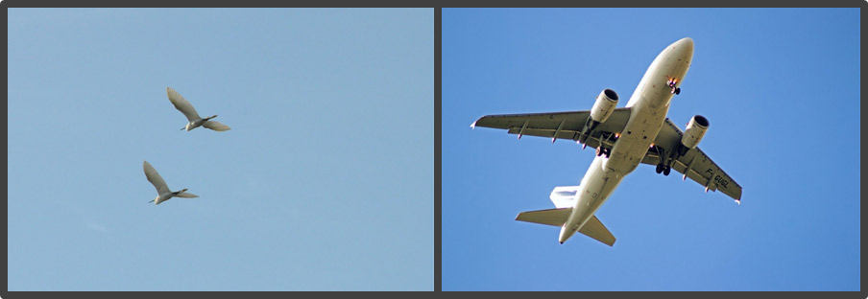

Adhesion of burrs on plants and Velcro
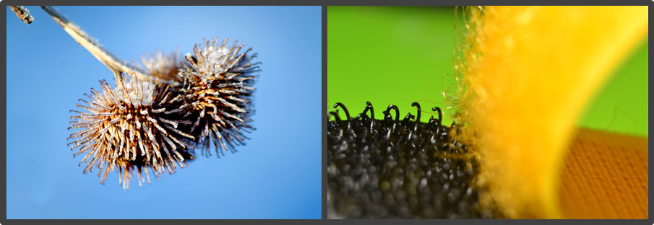

Harvesting water like a beetle
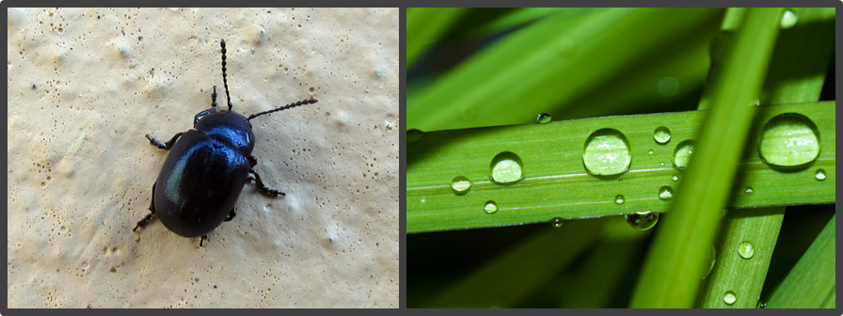

Ventilation systems inspired by termites
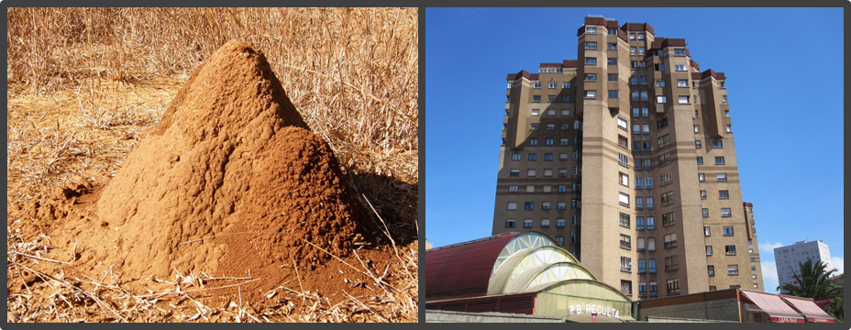

Swimsuits designed like shark skin
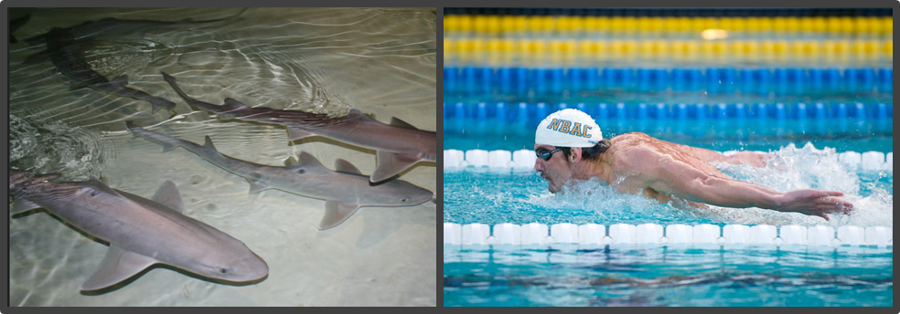

Rough paint to repel dirt and debris resembles the surface of a lotus flower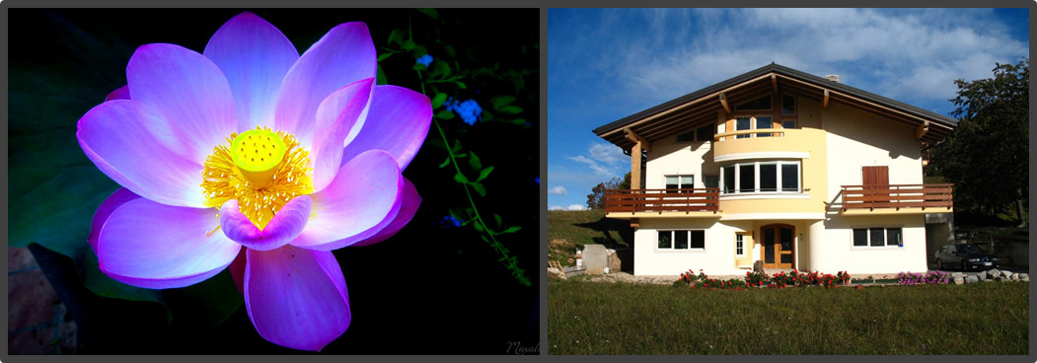

Bumps on whale skin are replicated on wind turbines
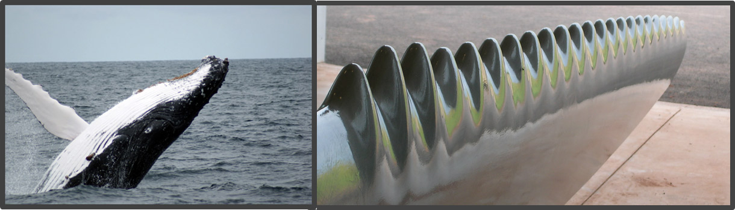

Shock absorbers mimic woodpeckers
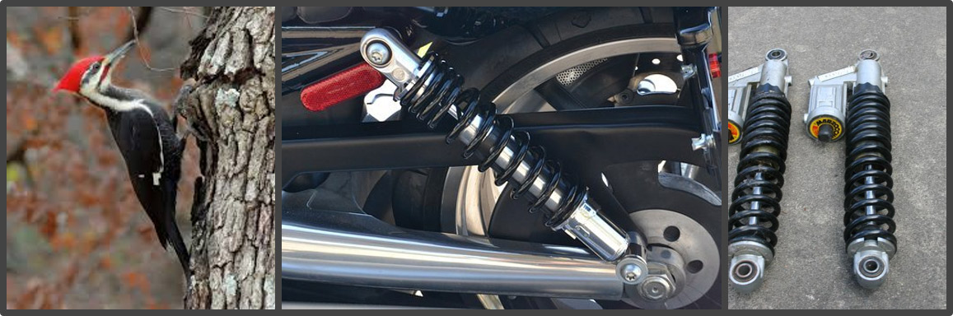

Aerodynamic similarities between a kingfisher and bullet train
