Design for swimming: the secrets of shark skin

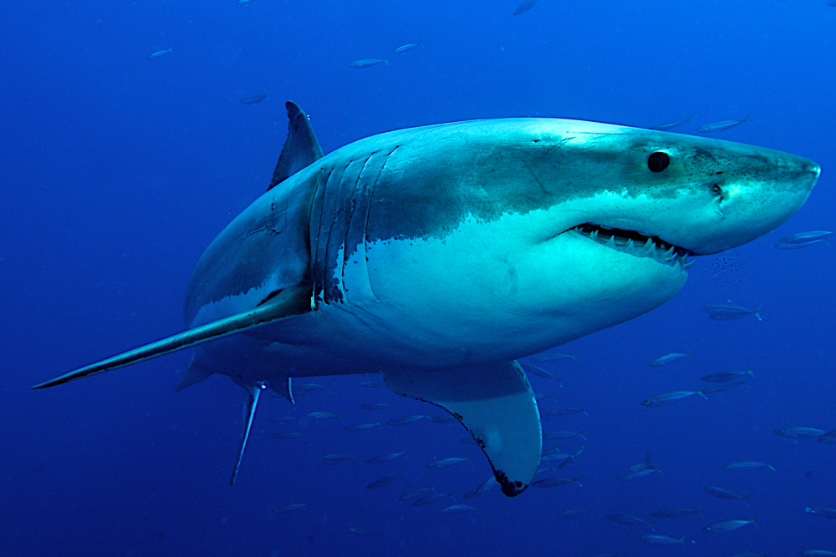
A great white shark, Carcharodon carcharias.
Image courtesy of Stefan Pircher/Shutterstock

Classroom activity: comparing shapes for streamlined movement
In the following experiment, students investigate the streamlined properties of different shapes – that is, how easily each shape moves through a liquid (or a gas) – by measuring the time required to fall the height of a water column. The activity takes around 90 minutes and is suitable for students aged 14–16, who can work in groups of 3 or 4.

Materials
For each group of students, the following materials are needed:
- 1 tall cylinder (height about 1.3 m, diameter about 15 cm)
- Tripod or clamp stand
- 2–3 m fishing line
- 200 g modelling clay
- 1 small metal hanger (such as used on the back of photo frames for hanging)
- 1 set of kitchen scales
- Stopwatch
- Tap water
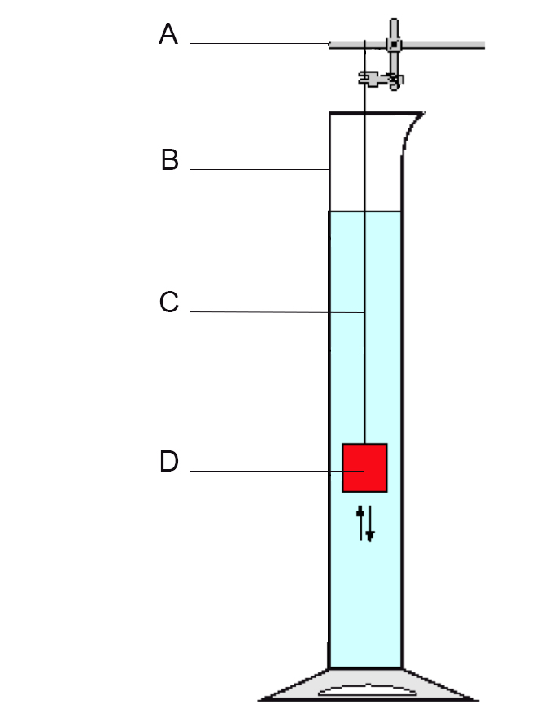

Figure 1: The experimental setup. A = clamp stand; B = cylinder filled with water; C = fishing line (must be long enough to allow the shape to fall to the bottom of the cylinder); D = clay shape

Procedure
- Fill the cylinder with water, if possible to a depth of 1 m.
- Tie the fishing line to the ring of the hanger. Attach the line to the tripod or clamp stand so that the end of the line is long enough to reach a little bit further than the bottom of the cylinder.
- Using the scales, divide the clay into four equal-sized pieces each weighing 50 g.
- Make one piece into a shark shape.
- Choose three more shapes from those below (cube, cylinder, sphere, cuboid). Try to choose at least one that you think is quite streamlined, and one that is not streamlined. Form the remaining clay pieces into your three chosen shapes.

- Attach the hanger (and thus the fishing line) to each shape by pressing it deeply into the clay.
- While one student holds one of the clay shapes directly over the water surface, another student operates the stop watch. Release the clay shape, and time how long it takes to reach the bottom of the cylinder. Record the time in the table below.

Shape | Time: test 1 (s) | Time: test 2 (s) | Average velocity (m/s)
Shark

- Carry out the test twice for each shape, recording each time and the shape type.
- Finally, measure the exact distance of the fall (the depth of the water column), and calculate the average velocity in metres per second (m/s) for each shape.

Discussion
Students should then discuss the following questions, in their groups or as a class:
- From the results, which shape seems to be the most streamlined?
- Which shape seems to be the least streamlined?
- What conclusions can you draw about what makes a shape streamlined?
- What are the upward and downward forces on the clay shapes as they fall? Draw a diagram to show this. Are the upward and downward forces the same for each shape?
- How is the average velocity related to the upward and downward forces?

Extension activity: calculating the Reynolds number
For more advanced physics students, the results above can be used to calculate the Reynolds number for each shape. This dimensionless quantity is used to predict flow patterns in different fluids by relating the frictional force of a body to its own inertia of mass.
The formula for the Reynolds number, Re, is:
Re = 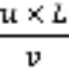
where:
u = flow velocity (the average velocity calculated in the activity above, in m/s)
L = characteristic length (of the surface, in m)
v = kinematic viscosity (for H₂O at 20 °C, v = 1 x 10⁻⁵ m²/s)

Procedure
- For each shape, measure L, the length of each clay shape along the direction of flow (that is, its vertical length as it falls through the water).
- Using the formula above, calculate the Reynolds number for each shape.

Discussion
The Reynolds number helps to indicate when flow around a body changes from laminar to turbulent. In turbulent flow, the transverse movement of particles uses up energy, increases the drag force and decelerates the moving body.
If the Reynolds number of a body in a fluid is higher than the critical Reynolds number (approximately 3 x 10⁶), the flow is turbulent. A body with these flow properties consumes more energy to accelerate – and a shark would need more food to provide the increase in energy needed for acceleration.
Students can then discuss the following questions:
- What does the Reynolds number tell you about a shape?
- Can you draw any conclusions about the type of shape that has a high Reynolds number?
- What could be done to reduce the Reynolds number of a body in a fluid?

