Energy drinks and the brain
By Emmanuel Thibault, Kirsten Biedermann and Susan Watt
Our bodies need water, sugar and minerals to work well. During the marathon at the Los Angeles Olympics in 1984, the athlete Gabriela Andersen-Schiess failed to take a drink at the last water station. This severely affected her performance and even her ability to walk in a straight line for the last few metres of the race, as you can see from videos of this event on the Internet.
Energy drinks, of course, contain more than just water, and are promoted with the idea that they can boost our physical and mental performance beyond what can be achieved just by proper hydration. And while performance on the running track is one good measure of how well our bodies are working, how might we assess whether our brains are up to speed? A good test would assess how agile our brains are, not how much we know.
One plausible way to do this is to measure how fast we can think – that is, our reaction times. Here we describe two experiments that measure reaction time: one on a mental task, the other on a physical task. These tests could form the basis of assessing whether energy drinks really can boost our mental powers. They are also interesting activities that are fun for students to try, to see how they compare to others in their class.

Test 1: The number–symbol test
Suitable for: students age 13 and over
This test, which forms part of many IQ assessments, is also known as the digit–symbol substitution test (DSST). The test helps clinicians to assess whether someone has a normal level of brain activity, especially cross-sensory co-ordination – in this case, between vision and movement.
The test involves writing down a specific symbol, from a given code, in response to a number. The faster and more accurately someone can do this, the better their brain activity.
This activity can be done in student pairs, with one student taking the test and the other timing it; then they swap over.

Materials
For each student pair, you will need:
- One test paper (these can all be the same for every student)
- Pen or pencil
- Stopwatch or other accurate timer

Procedure
- Prepare the test papers, using lined paper or on a computer. This is done as follows:
- Write (or type) the numbers 1 to 9 in ascending order to form the top line.
- On the next line, write nine symbols which in themselves have nothing to do with the number (e.g. & < % etc.), so that there is one symbol directly below each number. This forms the required code, where each single-digit number is associated with a specific symbol.
- Below, fill a line with single-digit numbers 1–9 in random order. Leave the next line blank, then repeat this until you reach the bottom of the paper.
- The blank lines are where students fill in the symbols corresponding to the numbers directly above, according to the required code – as fast and accurately as possible.
A partly worked paper is shown in figure 1.
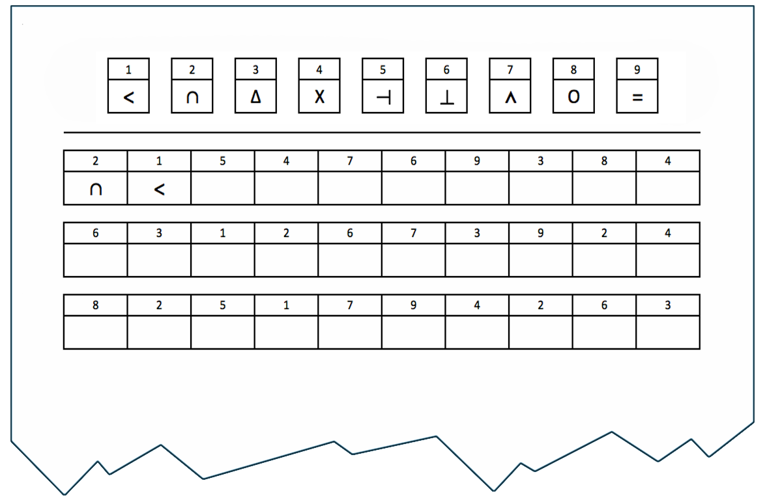
Fig.1: Example of a partly worked test paper for the digit–symbol substitution test
Image courtesy of Emmanuel Thibault and Kirsten Biedermann
- Divide the students into pairs and ask them to agree who will time first and who will take the test.
- Give out the papers, pencils and timers. Explain the task using an example (a different pairing of a number with a symbol from any in the test).
- At ‘Go’, the student starts the test while the other starts timing.
- After 90 seconds, there is a break of 30 seconds with no writing or looking at the paper.
- Then the same student continues the test for another 90 seconds.
- After this, the students swap roles.
- At the end, the students count how many right answers their partners scored in each 90-second half and in total.

Discussion
A higher score means better mental agility. But while some people are naturally better at this task than others, it’s also possible to improve on any task through learning. So if someone did better in the second half of the experiment than the first, making faster and more accurate associations between the numbers and symbols, this means that learning has occurred.
Students can also be asked 5 minutes later to write down the correct symbols associated with the numbers, to see how much they remember. This kind of learning is called long-term memory.

Test 2: The ruler-drop test
Suitable for: students age 13 or over
In this test, students again work in pairs. One student lets a ruler fall down between the open thumb and forefinger of the other student, who tries to catch it as fast as possible. The distance that the ruler falls is shown by the point at which it is caught – which is therefore a measure of reaction time. Students then calculate the elapsed time using standard equations from physics.

Materials
For each student pair, you will need:
- One 30 cm ruler
- Notebook for writing down results

Procedure
- First, the students practice in pairs a few times with dropping and catching, as shown below. It is best to start with the zero mark on the ruler at the catching student’s thumb when their hand is open, so that the distance of the fall can be read directly from the ruler’s scale.
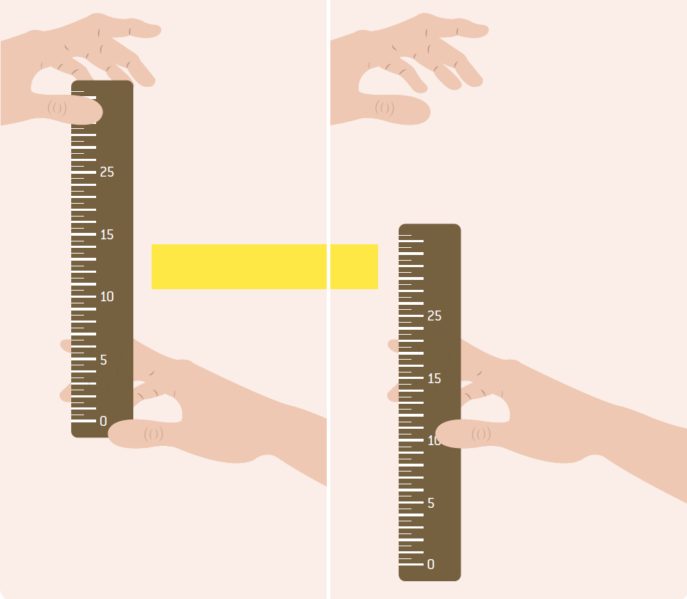
Fig.2: Set-up for the ruler-drop reaction time test
Image courtesy of Emmanuel Thibault and Kirsten Biedermann
- When they are ready, the students start. One person drops and the other catches. The person dropping records the distance of the fall for their partner each time.
- Then the students swap roles. Each student pair can decide how many times each person catches before they swap over. The more results they have, the more representative the average will be. We suggest a minimum of 10 times each.
- Once all the data have been collected, students need to calculate their own reaction time, as follows.
- First, each student should calculate their own mean distance of fall. This is found in the standard way, by totalling all the fall distances and dividing by the number of falls.
- Then, they use the standard equation of falling (with zero initial speed) to work out the average time elapsed:
d = ½ a t²
where
d = distance of fall
a = acceleration due to gravity (9.81 ms⁻²)
t = time elapsed

So t² = 2d/a
t = √2d/a
So the reaction time (elapsed time), t, can be calculated using the equation:
t = √2d/9.81 ms⁻²
where d is the average distance of fall (for an individual student).

Discussion
Students can compare their results to see who is the fastest at each task. If there are enough students, it is interesting to plot the results on a graph. This allows the range, modal class and median to be found for each test.
The class can also consider the following questions:
- Would you expect the graphs to be a normal distribution? If so, why?
- If these tests were to be used to assess the effects (if any) of an energy drink, what experimental design should be used? (Perhaps discuss the idea of randomising here.)
- What would the control group(s) be in each case?
- How could the design be adapted to compare different drinks?
Students may also be interested to find out more about psychological tests, or to think of other effects that these tests could be used to compare.

Resources
Try this online reaction time test and compare the results with those from the ruler-drop experiment: www.humanbenchmark.com/tests/reactiontime

