Instructions and worksheets: Who murdered Sir Ernest? Solve the mystery with spectral fingerprints

Acoustic spectra

Instructions for using Audacity
- Download the programme from www.audacityteam.org
- If you are analysing an audio file, open the audio file in Audacity.
- If you want to record your own sounds, set the ‘Project Rate’ (at the bottom left of the window) to 8000 Hz and record the sound of the glass using the record and stop buttons (circled).
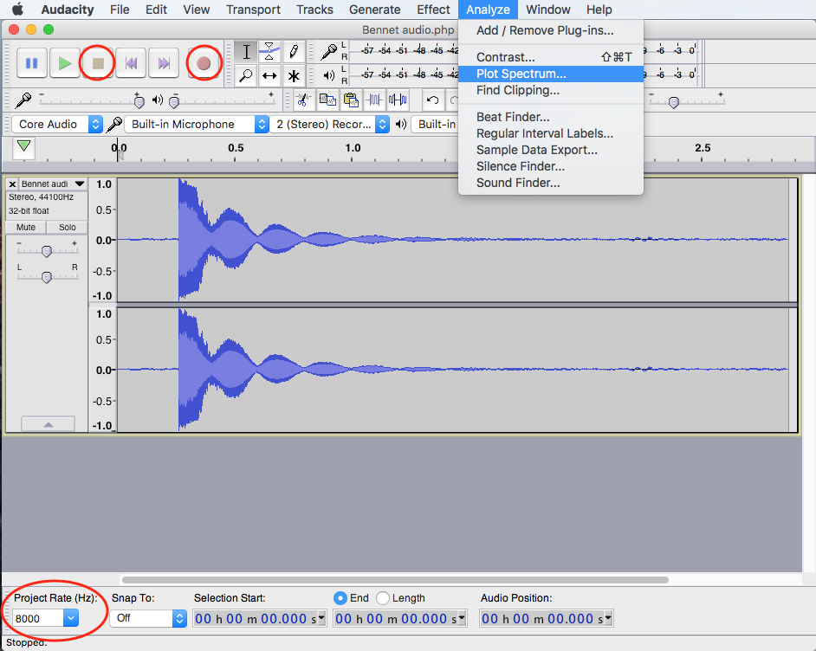
- Highlight the area you want to analyse, and under the ‘Analyze’ menu, select ‘Plot Spectrum’.
- Set the size (accuracy) to 2048.
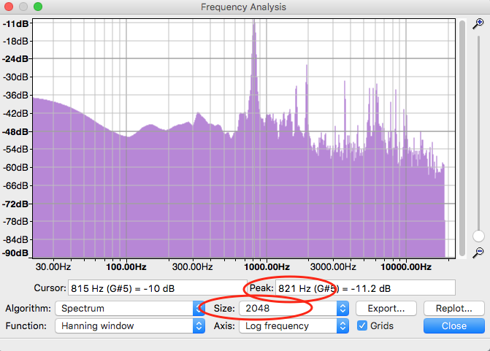
- Read the frequencies of each peak with the help of the cursor.
- Draw the simplified frequency spectrum on your group poster.

Chemical detectives
Record the wavelength and colour of each cation from the flame tests.

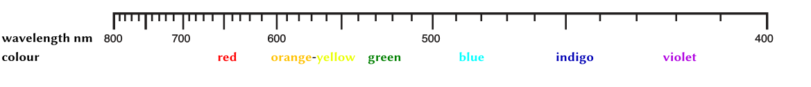

Fill in the gaps:
Metallic cations and metal atoms emit ___________ with a characteristic __________ when _____________ (or electrically excited). Shortwave light (e.g. blue) is more energetic than __________________ light (e.g. red). An electron of the atomic shell is raised (‘excited’) by the conversion of heat energy from its ________________ into an excited state. Then the electron reverts to the ground state with the emission of light energy. The ____ion of the salt can be detected by spectral analysis of the flame colour.

Record your results of the flame test in the table:
Salt | Cation | Anion | Chemical formula | Flame colour
Lithium chloride
Sodium chloride
Potassium chloride
Calcium carbonate

Use your results from the table above to determine the salts used in the mixed solutions:
- _____________________________ 2. _____________________________

LEDs and voltages
Determine the minimum voltage for the operation of each LED and note the colour of the LED.

Colour of LED | Minimum voltage required

Answers

Chemical detectives
Metallic cations and metal atoms emit light with a characteristic color when heated (or electrically excited). Shortwave light (e.g. blue) is more energetic than longwave light (e.g. red). An electron of the atomic shell is raised (‘excited’) by the conversion of heat energy from its ground state into an excited state. Then the electron reverts to the ground state with the emission of light energy. The cation of the salt can be detected by spectral analysis of the flame colour.

Salt | Cation | Anion | Chemical formula | Flame colour
Lithium chloride | Li⁺ | Cl⁻ | LiCl | Carmine
Sodium chloride | Na⁺ | Cl⁻ | NaCl | Yellow
Potassium chloride | K⁺ | Cl⁻ | KCl | Violet
Calcium carbonate | Ca²⁺ | CO₃²⁻ | CaCO₃ | Brick red

- Sodium chloride and calcium carbonate 2. Lithium chloride and potassium chloride

