Construction bionics: activities and worksheets

Activity 1: Testing the stability of bamboo and wood
In this activity, the students investigate which of two materials – bamboo (a giant grass) or wood (from trees) – deflects less under an applied force. The lower the deflection, the more rigid the material is.
Safety note: This activity uses weights of up to 1 kg, which can cause damage or injury if dropped, so suitable supervision is needed. See also the general safety note on the Science in School website (www.scienceinschool.org/safety) and at the end of this print issue.

Materials
The following materials are needed for each group of students.
- One wooden stick (e.g. beech) of diameter about 6 mm, length 30 cm, with a hook at one end
- One bamboo stick of diameter about 6 mm, length 30 cm, with a hook at one end
- Mounting for the sticks: a small wooden block (5 cm x 5 cm x 2 cm) with two holes in the side, each with a diameter equal to that of a stick
- Screw clamp
- Weights with masses of 250 g, 500 g and 1 kg (these could be small sacks filled with gravel)
- Ruler
- Spirit level

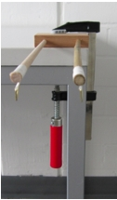
Figure 1: Bamboo and wooden sticks set up and ready to test
Image courtesy of Sabrina Pulka

Procedure
Students carry out the investigation as detailed below.
- Put the non-hook end of the sticks into the mounting block, then fix the block to the end of a table or bench top using the screw clamp. Use the spirit level to check that the sticks have been mounted exactly horizontally. Use the ruler to check that the distance from the table edge to the hook is the same for each stick (figure 1).
- Hang a weight on the hook at the end of each stick in turn, starting with the smallest mass (250 g).
- Measure the deflection of each stick by using the ruler to find out how far (in centimetres and millimetres) the tip of the stick bends down under the weight. Use the other stick as your horizontal reference line. Record these measurements in a table like the one below.
Mass | Bamboo stick deflection | Wooden stick deflection
250 g
500 g
1 kg
Table 1: Recording the deflection of each stick under different loads

- Now compare the deflections of the wooden and bamboo sticks. For each mass, which stick bends more?

Discussion
Students then discuss the following questions, in their groups or as a class:
- Which material bends less under the loads: bamboo or wood?
- The bamboo stick is hollow, while the wooden stick is solid. Why is the bamboo so strong?
We will look at the answer to the second question in the next activity.

Activity 2: Ropes and cylinders
In this activity, students take a close look at the structure of bamboo and then investigate one reason why it is so strong and yet light.

Materials
The following materials are needed for each group of students.
- One piece of bamboo, cut longitudinally to show at least two nodes and an internodal section (figure 1)
- Two cardboard tubes, about 30 cm long and 5 cm across (kitchen paper rolls are suitable)
- Paper
- Scissors
- Glue

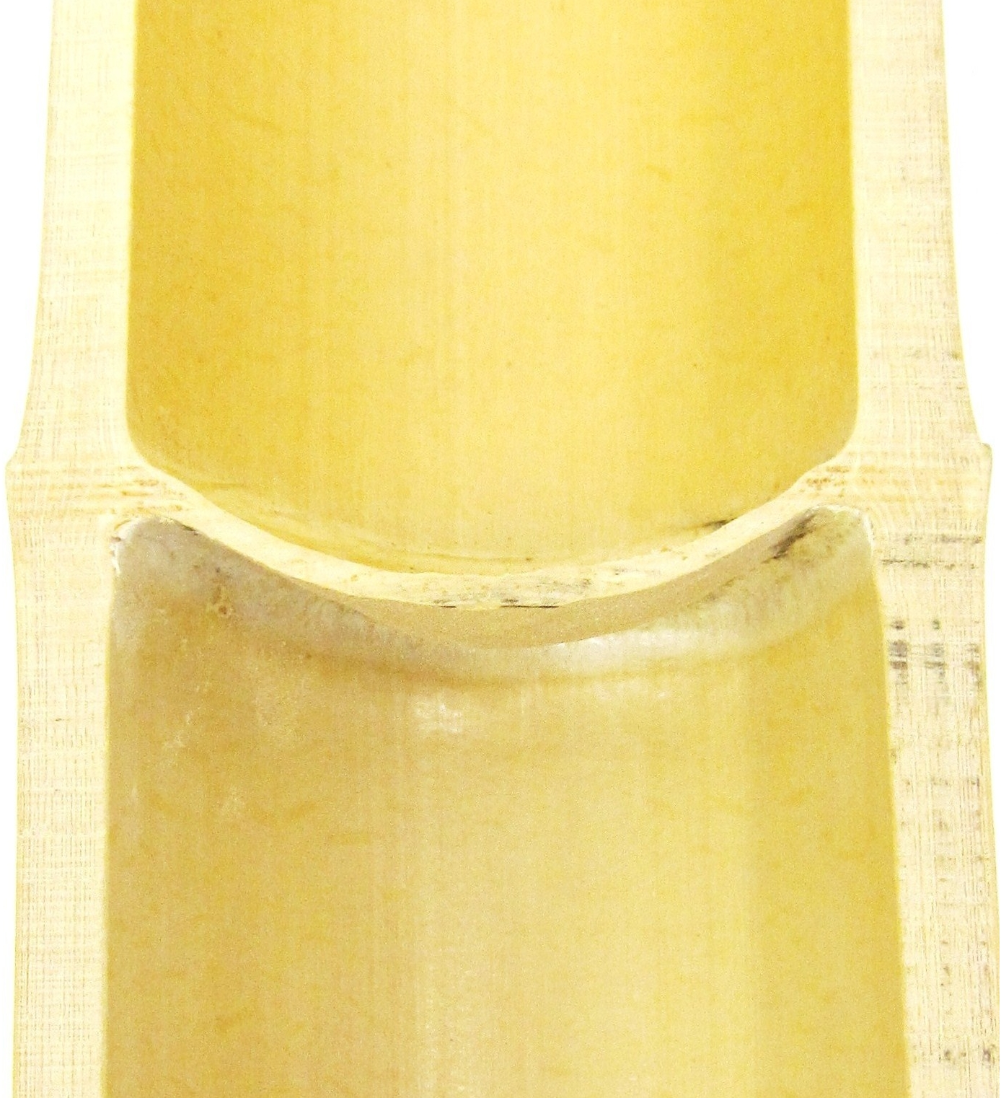
Figure 1: Section of bamboo, cut longitudinally
Image courtesy of Sabrina Pulka

Procedure
- Students look carefully at the longitudinal section of a giant bamboo, and note down or discuss their answers to the following questions:
- Why is bamboo so light and yet so strong?
- What is it about the structure of bamboo that helps to make it so mechanically stable?
The answers here are that the bamboo is a hollow tube, with nodes that go across the tube and provide added strength.
By carrying out the following experiment, students can then investigate how a thin structure that spans the interior of the tube can greatly increase the tube’s strength.
- Take the cardboard tube and gently press it between your fingers. What happens? How easy would it be to flatten it? Note down your answer.
- Cut the paper into two strips, each about 1 cm wide. Each strip should be at least 2 cm longer than the diameter of the cardboard tube.
- Using the glue, stick one of the strips across the diameter of the opening of an intact tube (see figure 2).

- Then, press the tube gently inwards at right angles to the strip (vertical pressure) and along the strip (horizontal pressure). What did you notice? In which direction does the tube squash more easily? Note down your answers.

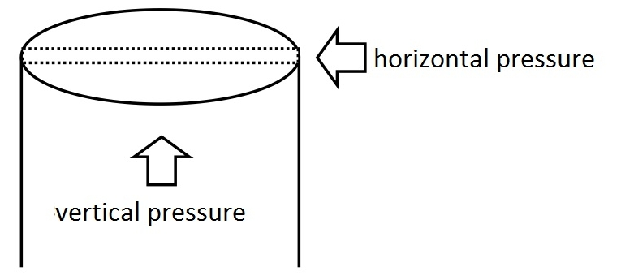
Figure 2: Testing the effect of one paper strip
Image courtesy of Sabrina Pulka

- Stick another strip of paper across the opening at right angles to the first strip. The two strips should now cross.
- Do the pressure test again. What do you observe?

Discussion
Ask the students to present their results. They should have found the following:
- With no strips: the cardboard tube can easily be flattened.
- With one strip: the tube can easily be flattened if pressed along the strip, but not at right angles to it.
- With two strips: the tube is much harder to flatten if pressed in any direction.
Then discuss how these observations relate to the bamboo and its strength. The paper strips have the same function as the nodes in the bamboo, stabilising it against being squashed. This is important in keeping the bamboo stem upright, as a hollow tube is hard to bend, but once it is squashed, it bends very easily.

