Finding the scale of space: derivation of the star distance formula
In the article ‘Finding the scale of space’, we calculated the distance of a ‘star’ in a classroom by using parallax distance measurements and a camera. The distance d of the star was calculated from the measured quantities using the following equation:
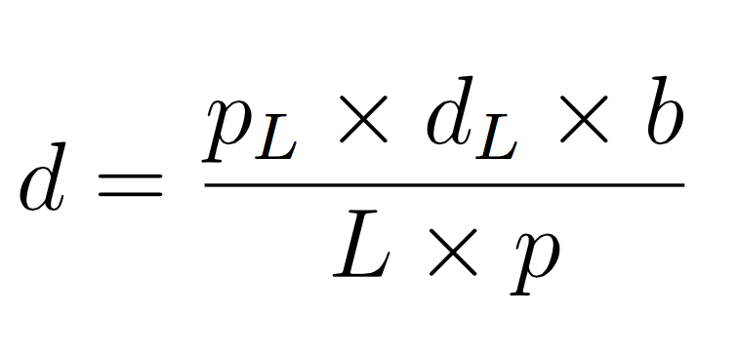
where:
d = distance to star
L = actual length of the calibration object
b = actual distance the camera was moved (which corresponds to the distance from C_{A} to C_{B})
d_{L} = actual distance of the calibration object from the camera baseline (along line OQ)
p = distance as the number of pixels between the star images (at D_{A} and D_{B})
p_{L}= length as the number of pixels of the image of the calibration object

In fact, it is quite straightforward to derive this equation using the mathematical idea of similar triangles. The steps below explain how.

Figure 1: Simplified model of the parallax setup (Image courtesy of HdA / M Pössel)

- Looking at the geometry in figure 1, we can see that the triangle C_{B}PC_{A} is similar to the triangle D_{A}PD_{B} (since their corresponding angles are equal). So if we use l to represent the distance between the star positions D_{A} and D_{B} (in the image plane, I), from similarity it follows that:
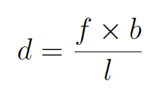
- The distance l is proportional to the distance between the two star positions in our photographic image, expressed as a number of pixels, p. If we use k to represent the constant factor (yet to be determined) that relates the number of pixels to actual lengths in the image plane, and set S = k × f, it follows that:
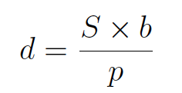

- We now apply the same reasoning to the calibration object, which we have placed parallel to the camera baseline at a distance d_{L} from it. This distance, which we measure directly, and the image length of the calibration object in pixels (p_{L}) are related by the equation below:
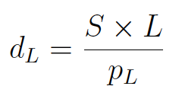

- We can eliminate S by combining the two equations above. First, we rearrange the equation in step 3 to isolate S, by multiplying both sides by p_{L} and dividing both sides by L:
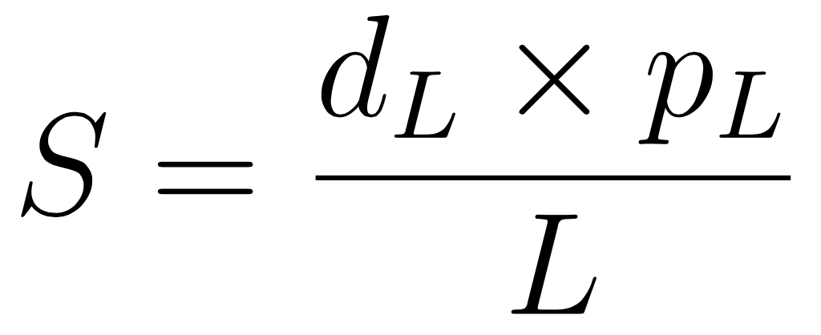

- We now substitute this expression for S into the equation derived in step 2, which yields a formula linking the distance d to the other known lengths b and f.
The formula, as we have seen, is:

