Grasping the resting potential – Experiment 1

Task 1
Please read the information below. Which part of the cell will be addressed in this session? Fill in your answer as the heading of the worksheet.

Information
Phospholipids are molecules which form what is known as the cell membrane. They have a hydrophilic head section and a hydrophobic tail end. ‘Like with like’ is the rule of thumb when it comes to mixing them with other liquids. If you mix them with water, the hydrophilic section of the oil molecules will face towards the water molecules, whereas the hydrophobic ends will face away. This is how cell membranes are formed: the hydrophilic polar heads of phospholipids are attracted to water and their hydrophobic non-polar tails align with each other, creating two lipid bilayers that form the boundary between intracellular and extracellular media (see figure 1). Although oils and phospholipids are different in structure, they are both lipids. If you have ever tried mixing water with oil, you might already have an idea about how distinct layers of different substances are formed.
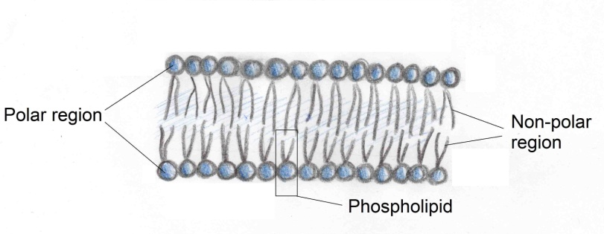
Figure 1: Illustration of a phospholipid bilayer

Experiment

Material | Hazards
Red cabbage
Olive oil
Dishwashing soap | 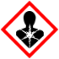  Hazardous to health. Do not swallow.
Knife
Kitchen sieve
4 Erlenmeyer flasks (250 ml) and plugs

Procedure
- Mark the four Erlenmeyer flasks with numbers from 1 to 4.

- Slice the red cabbage very thinly (1-2 mm) and rinse the slices with water in the kitchen sieve until the water no longer shows any blue colouring.

- Fill each flask with the reagents listed in the table below.

Erlenmeyer flask # | Reagents
1 | Water (150 ml) + oil (1 drop)
2 | Water (150 ml) + oil (1 drop) + dishwashing liquid (1 drop)
3 | Water (150 ml) + red cabbage (15 pieces)
4 | Water (150 ml) + red cabbage (15 pieces) + dishwashing liquid (1 drop)

- For each of the four flasks, insert a plug into the flask, shake it and wait for 10 minutes. What do you think will happen after you shake the flasks? Write your hypotheses in the table below.

Erlenmeyer flask # | Hypotheses
1

2

3

4

Task 2
Use the table below to record your observations after conducting the experiment. Discuss your results with your group and prepare to share them with the class.

Erlenmeyer flask Nr. | Observations
1

2

3

4

Conclusion
Think about how the dishwashing soap might affect the properties of oil and the red cabbage’s cell membrane. Compare your hypotheses with the results of the experiment and write your conclusion in the box below.

Conclusion

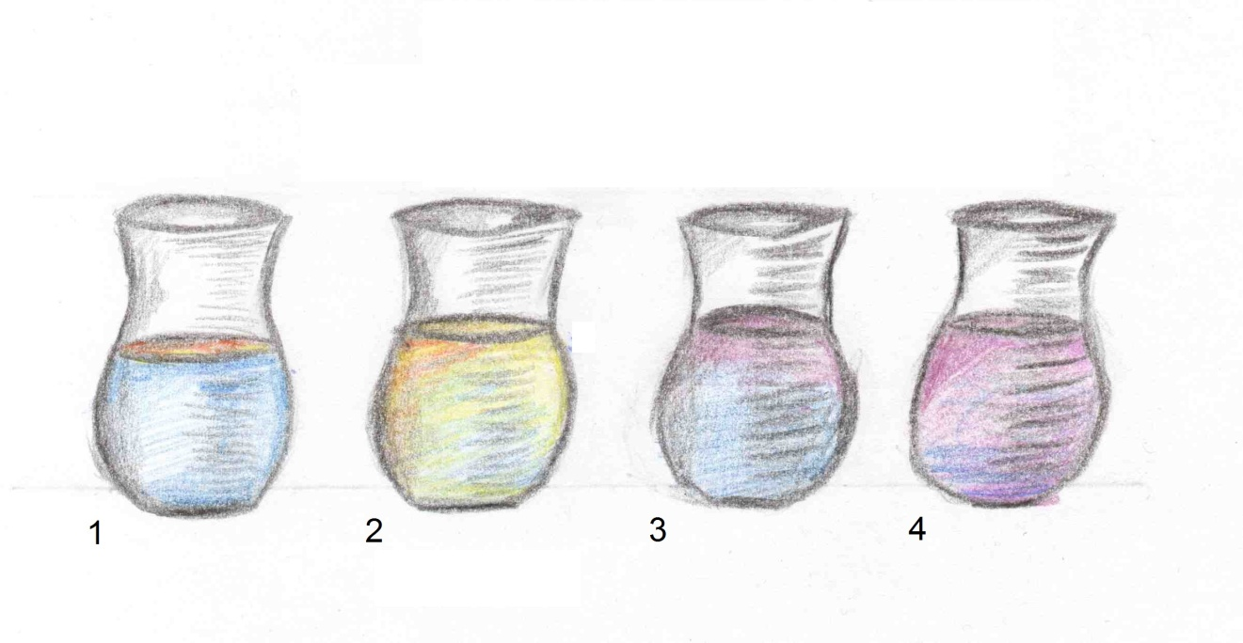
Appendix for teachers

Conceptual information

Erlenmeyer flask # | Reagents | Observations
1 | Water + oil | The oil floats on the surface of the water. The liquids do not mix because of the difference in their polarity.
2 | Water + oil + dishwashing soap | There is no sharp line that divides oil and water because the detergents cause it to vanish.
3 | Water +  red cabbage | The red cabbage causes the water to turn slightly blue. A few destroyed cells cause this effect.
4 | Water +  red cabbage + dishwashing liquid | The detergents in the dishwashing liquid heavily penetrate the cell membranes of the red cabbage pieces. The blue colouring leaks from the cells and turns the water deep blue.

