Grasping the resting potential – Experiment 3: The cellophane membrane potential

Task 1
Please read the information below and familiarise yourself with the resting potential.

Information
At rest, the cell membrane is almost exclusively permeable for potassium ions, and the difference between the voltages of the intracellular and extracellular media is known as the resting potential. Similarly, the cellophane wrapping used in this experiment is also selectively permeable. If a membrane is permeable to one type of ion and this ion has different concentrations on the intracellular and extracellular sides, the ion flow will always be directed towards the side with the lower concentration.

Experiment

Materials | Hazards
Potassium chloride solution (0.1 mol/l)
Potassium chloride solution (0.01 mol/l)
Purified water
Voltmeter
Glass bowl (200-300 ml)
Funnel
Cellophane wrapping, rubber band
Electrodes (chlorinated silver wire)
Stand and clamps, alligator clips
Pipettes, beaker
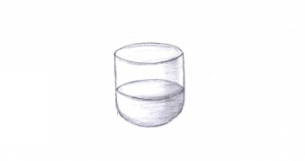

Procedure
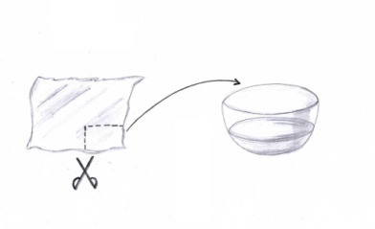
- Fill the glass bowl with the 0.01 mol/l potassium chloride solution. It represents the extracellular medium of the membrane.

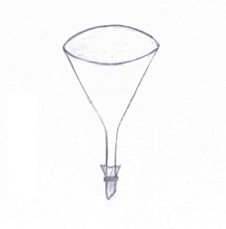
- Cut a piece of cellophane wrapping that is large enough to cover the opening at the bottom of the funnel. Put the cellophane into purified water to make it more flexible. The cellophane works as the semi-permeable membrane.

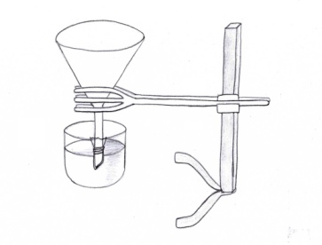
- Now take the cellophane sheet and use it to seal the bottom of the funnel by carefully and tightly wrapping it around and fastening it with the rubber band.

- Use your stand and a big clamp to lower the funnel into the glass bowl. Submerge part of the funnel’s bottom into the solution and fasten the clamp.
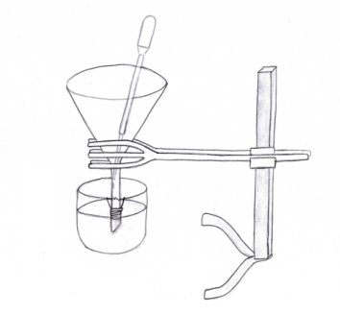
- Carefully pipette enough of the 0.1 mol/l potassium chloride solution into the funnel to fill only the submerged part. The solution inside the funnel represents the intracellular medium.

- Knowing that cellophane is selectively permeable, what do you think will happen now? Write your hypothesis in the box below.

Hypothesis

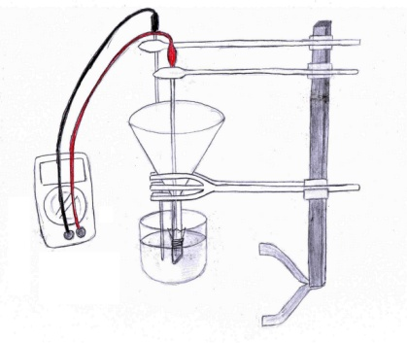
- Insert the two electrodes (chlorinated silver wire) into the alligator clips and connect them to the voltmeter. Use two additional clamps to place the first electrode (which is connected to the cathode of the voltmeter) into the solution in the glass bowl, and the second electrode (which is connected to the anode) into the solution in the funnel.

- Set the voltmeter to ±200 mV and observe.

Task 2
Use the box below to record your observations after conducting the experiment. Discuss your results with your group and prepare to share them with the class.

Observation

Conclusion
How and why does the voltage change? Try to include ions, membrane and concentration levels in your explanation, and write your conclusion in the box below.
Conclusion

Appendix for teachers

Preparations prior to the experiment
Before the experiment can take place, chlorinated silver wire is needed. It can be made in two ways:

- Chlorination via chlorine-containing cleanser or ferric chloride

This method is easier and faster, but the product is of lower quality. Silver wire is submerged in chlorine-containing cleanser or ferric chloride for 15 minutes. (Caution: corrosive!)

- Chlorination with electricity

This process takes more time and is more elaborate, but results in a product of better quality. Silver wire has to be sanded down and cleaned with alcohol, then connected to the anode of a 4.5V battery. The anode with the wire and the cathode of the battery are then submerged in a 3% potassium chloride solution for 15 minutes.

