Worksheet for Activity 1: Money to burn? 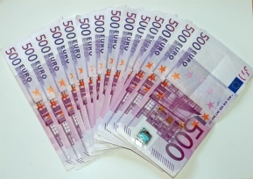

Name: Class: Date:

After the experiment, discuss the following questions in groups and then fill in your answers.
Question | Your answer
What is the role of alcohol in the experiment?

What is the role of water in the experiment?

Why does the flame go out?

Which substance is more volatile – alcohol or water?

Which substance prevents the banknote from being burned?

Although the banknote is on fire, it is unburned at the end of the experiment. Can you explain why?

