Exploring the physical properties of imaged objects
The resolution of the human eye is limited not only by the density of photoreceptors in the retina, as investigated in the first experiment, but also by the physical phenomenon of diffraction. Diffraction is observed when a light beam passes by the edges of an opaque object or through a narrow opening, resulting in the apparent deflection of the rays. It is caused by the wavelike properties of light. Diffraction imposes a fundamental lower limit to the resolving power of the eye. Understanding how this limit relates to the biological structure of the eye is crucial for the interpretation of the results obtained in the first experiment.
When light from a point source passes through a small circular aperture, such as the pupil of the eye, it is imaged not as a bright dot but as a diffuse disc surrounded by much fainter concentric rings. This diffraction pattern is caused by constructive and destructive interference of light waves. The central spot of the pattern produced is called the Airy disk, and the entire diffraction pattern, including the Airy disk, is known as the Airy pattern (named after the British mathematician and astronomer George Biddell Airy [1801–92]). By measuring the light intensity across the whole Airy pattern, we can plot a graph that describes the pattern in quantitative terms, called a point-spread function.
In this experiment, your students obtain point-spread functions by analysing Airy patterns published on the web, using the freely available Java-based software ImageJ.

Materials
- Computer
- Internet access

Procedure
- Download and install ImageJ^{w1}. This is a sophisticated software programme used by many scientists in the world and is available free of charge. It allows quantitative analysis of many properties of images, including the determination of the grey levels associated with individual pixels. We make use of this feature in the experiment described here.
- Download the full-resolution version of the file ‘Airy disk spacing near Rayleigh criterion.png’^{w2}.
- Start ImageJ and open the ‘Airy disk spacing near Rayleigh criterion.png’ file.
- Click on the Straight Line button in ImageJ and, using this function, draw a horizontal line through the centre of the Airy pattern shown in the upper image, starting near the left edge of the image and ending close to the right edge of the image.
- Plot the point-spread function by clicking on the Plot Profile command in the Analyze pull-down menu. The automatically generated graph displays the grey values associated with the individual pixels along the line drawn in step 4.
- Repeat steps 4 and 5 for the middle figure.
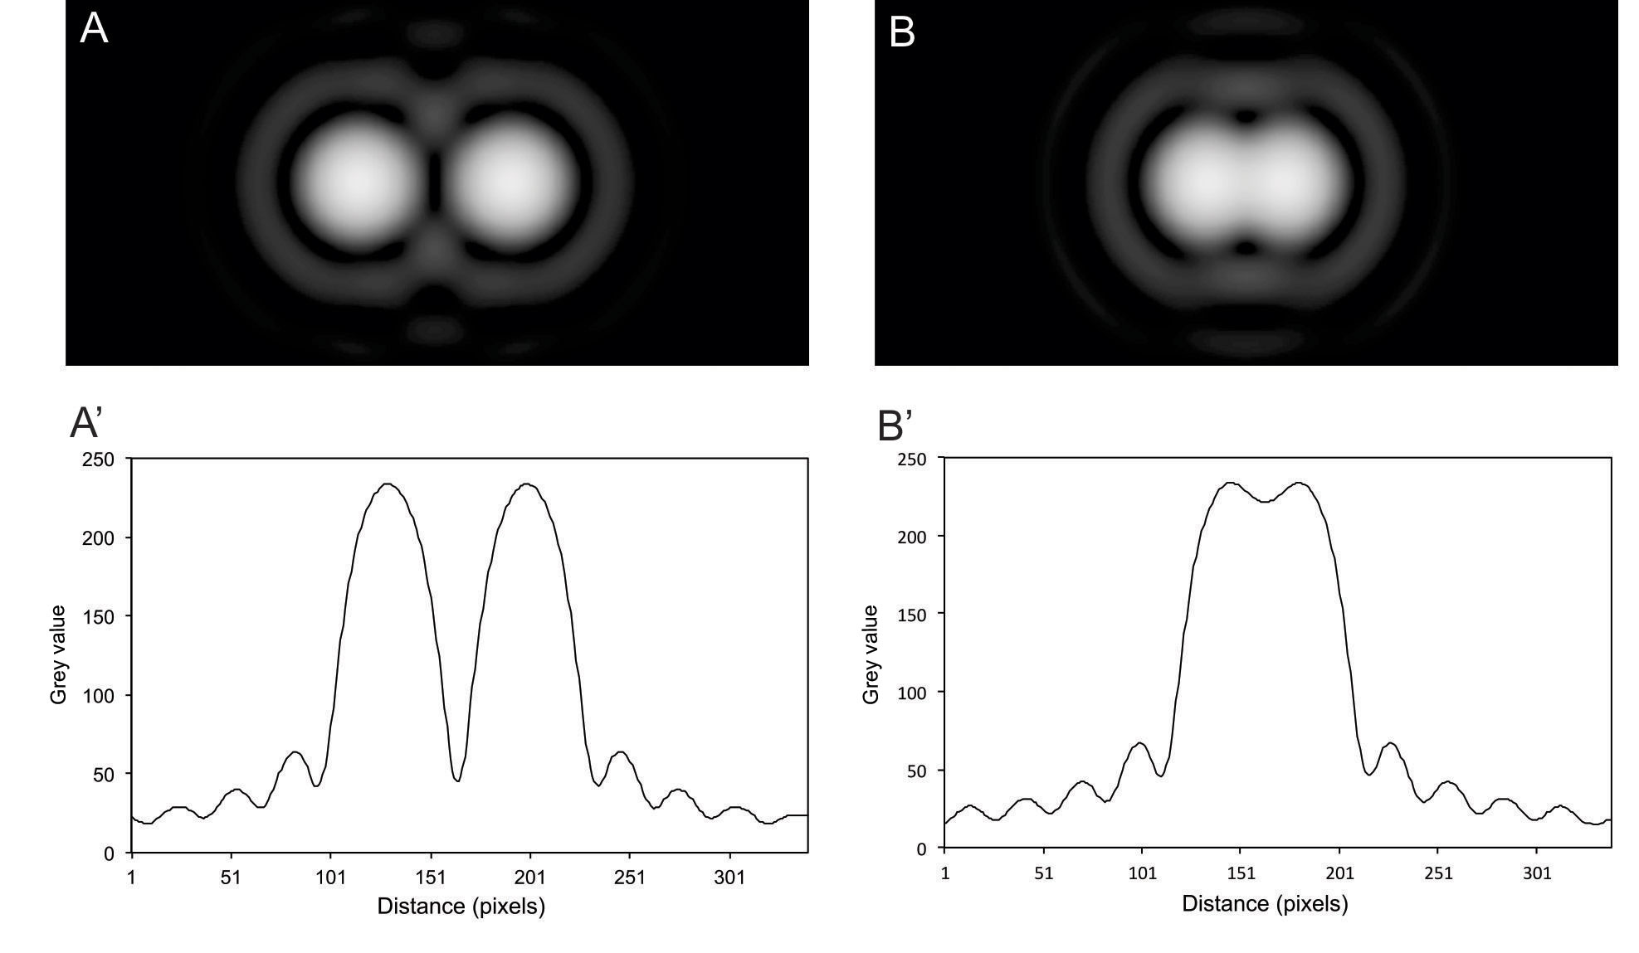
Figure 1: Airy patterns and point-spread functions. The Airy patterns were generated by light from two point sources passing through a circular aperture.
Images of Airy patterns courtesy of Spencer Bliven; plots of point-spread function courtesy of Günther KH Zupanc

What is happening?
The results should be similar to the plots shown in figure 1. The point-spread function in figure 1A' demonstrates that the central maxima of the graph, corresponding to the two Airy disks shown in figure 1A, are sufficiently far apart to be resolved as two separate light points. When these two light points are moved closer together (figure 1B), the dip between the two central maxima of the point-spread function becomes less pronounced (figure 1B') and the Airy disks are more difficult to distinguish.
In 1879, the English physicist Lord Rayleigh proposed, as a rule of thumb, that two points can be just resolved when the centre of one of the Airy disks (the maximum) coincides with the first minimum of the second Airy pattern. This distance has become known as the Rayleigh criterion and is commonly assumed to be the minimum resolvable distance (m) between two objects. By calculating the first minimum of an Airy pattern, m is defined by
m = 1.22λf / D
where λ = wavelength of light; f = focal length of lens; D = diameter of aperture.
When the centres of the two Airy patterns are m apart, the intensity difference between their maxima and the dip in intensity between them is approximately 26%. Although the human eye can distinguish even smaller differences in intensity, the Rayleigh criterion is useful as a conservative estimate of the minimum resolvable distance between two points on the human retina. For our calculations, we will use the focal length of the reduced eye, f = 20.1 mm, and assume that the wavelength λ of the incident light is 600 nm (perceived as an orange colour) and the diameter of the pupil, D, is 3 mm. Using these values and equation 3, we can calculate the minimum resolvable distance (remember that 1 nanometre (nm) is 10⁻⁹ m; 1 micrometre (μm) is 10⁻⁶ m), m, to be approximately 5 μm.
This means that, irrespective of the density of photoreceptors on the retina, the size of the eyeball and pupil and the properties of light dictate that the minimum resolvable distance on the retina is 5 μm, corresponding to an angular resolution of 50 arcseconds.

Web references
w1 – ImageJ can be downloaded from the website of the National Institutes of Health. See: http://imagej.nih.gov/ij
w2 – The file ‘Airy disk spacing near Rayleigh criterion.png’ can be downloaded from the Wikimedia Commons repository or the Science in School website. See https://commons.wikimedia.org (or http://tinyurl.com/j47nr9k) or http://www.scienceinschool.org/2016/issue37/vision

