Going fishing
In this drama activity, young pupils (aged 3–7) help teachers act out the story of how microplastics find their way into our food.

Materials
- Three adults (preferably) – one to tell the story and ask the questions, the other two to act as John and Mary
- 20–25 pupils aged 3–7. They should be divided into three groups: a large group of small fish, a smaller group of medium-sized fish, and one big tuna
- A classroom with: a couple of desks to represent John and Mary’s house; a chair for the fishing location near the seashore; some other desks and chairs for John and Mary’s dining room
- Some easy-to-make items:
  - a ‘big tuna fish’ outfit made from cardboard
  - a similar big cardboard tuna fish cut into pieces (one piece per pupil)
  - a rod and a rope with a rounded hook to ‘fish’ the tuna
  - 20–25 plastic balls made by taping together the bases of small (e.g. 0.5 l) plastic bottles.
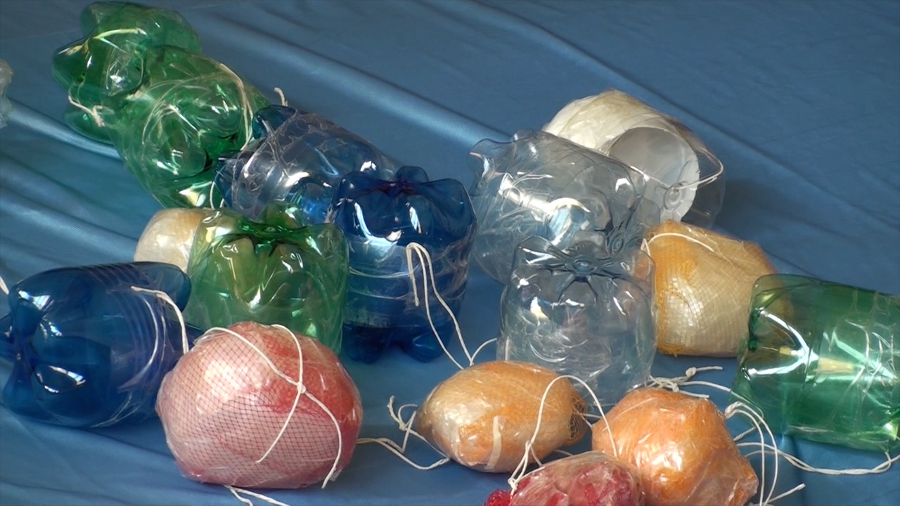
Plastic balls made from plastic bottles
Image courtesy of Marta Cucut
- Some easy-to-find objects:
  - Disposable plastic items (bottles, cups, trays and other containers, especially from food packaging)
  - 10–13 hula-hoops (one per medium-sized fish)
  - 27 plastic plates (one per pupil, plus John and Mary)
  - Two pieces of cheap blue fabric, each about 1.5 m x 2.5 m

Procedure

In John and Mary’s house
John and Mary live in a small house near the sea. They go fishing every day to find food to eat.
Ask your pupils: Where will they go? What will they need to go fishing?
When they get home, they do their housework. One day they have a big tidy-up: they collect lots of old objects they don’t want and dump them into the sea. The rubbish contains many plastic items. (Throw the plastic items onto a piece of blue fabric.)
Ask the pupils: Was John and Mary’s behaviour acceptable? What do you think will happen to the plastic objects? Will they disappear?
The sun, wind and waves break up the plastic objects into smaller and smaller pieces called microplastics. (Move the blue fabric to look like sea waves.) But microplastics don’t rot away. They stay in the sea for years and years, because they are not biodegradable.
Ask your pupils: Do you know what biodegradable means? (Explain the meaning of the word.)

Fish in the sea
(Remove the first piece of blue fabric with plastic objects and lay the other piece of fabric on the floor with the plastic balls on it.)
The sea is calm and John and Mary are fishing. In the water, some small fish are playing and swimming after each other. When they see some food, they eat it. (Every pupil takes a plastic ball.) Then they go to sleep. (The pupils lie on the floor.)
Some medium-sized fish come along. They are hungry too, so when they see the sleeping small fish, they eat them. (Each medium fish puts a hula-hoop around two small fish and takes their plastic balls.) Then they go to sleep too. (The medium fish lie down on the floor.)
Suddenly, a big tuna fish passes by, spots the sleeping fishes – and eats them! (The ‘big tuna’ pupil takes all the balls from the other pupils and swims away.)
Then the big tuna fish sees something else that looks tasty, but it doesn’t notice the hook – until too late! John and Mary feel a pull on the fishing rod; they pull with all their strength… and catch an enormous tuna fish!

Back at home
(All the pupils are now in the ‘dining room’.)
John and Mary take the big tuna fish home, happy with such a big catch. They decide to invite some children to share it with them. (Everyone gets a plate with a piece of cardboard tuna and a plastic ball.) They start eating, then they notice something strange….
Ask the pupils: What’s on your plate, as well as the fish? Then explain: the balls are the remains of the plastic objects John and Mary dumped in the sea.

Discussion
Have a discussion with the pupils about how to avoid microplastics polluting the sea. Ask some of the questions below:
- Do you like fish? What is your favourite fish meal?
- What happened to the plastic objects that John and Mary threw away – how did they turn into the balls that the fish ate?
- Do you think we should not eat fish – even thought it’s so tasty and good for us?
- How should we dispose of plastic objects in a better way? (Show the pupils a bin for collecting plastic waste separately. Explain that many plastics can be recycled.)

