Simulating aurorae at school: building instructions
For most schools, constructing the apparatus will require only a small investment, as most / all of the required materials are commonly available in school science laboratories (table 1). The construction should take about 1-10 hours, depending on how much preparation you need to do.

Materials
Figure 1 shows the basic experimental setup for activity 1; table 2 shows the variations for each activity. The key components are:
- A magnetised sphere to represent Earth, the Sun or another star (figure 1B)
- A second electrode (either a simple wire or another magnetic sphere; figure 1F)
- A vacuum plate with electric sockets (figure 1G)
- A vacuum chamber (figure 1E)
- A vacuum pump (figure 1D)
- A high-voltage power supply (figure 1H).
Table 1 shows the complete list of materials and prices.
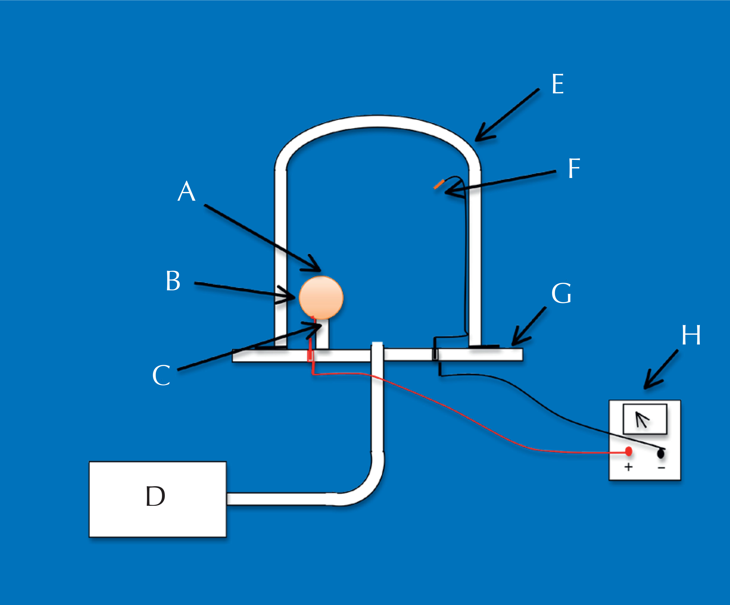
Figure 1: The experimental setup for activity 1. Inside the vacuum chamber (E), the sphere (B) lies on a plastic support. A magnet is placed inside the sphere, forming one electrode, and the second electrode (F) is suspended from the top of the vacuum chamber. A: north pole of the magnet; C: south pole of the magnet; D: vacuum pump; G: vacuum plate; H: high-voltage power supply.
Image courtesy of Philippe Jeanjacquot
The sphere itself does not need to be magnetic but it should be hollow, so that a magnet can be placed inside, and it should conduct electricity. For activities 3 and 4, you will need a second sphere to represent the Sun; ideally, this second sphere should be larger and have a stronger magnet.
For example:
- A Christmas tree ball covered with electrically conductive paint (10€ for the ball; 30€ for the paint)
This is the simplest and cheapest option.
- A hollow brass ball for a banister (cost varies)
- A custom-made, hollow brass ball (approximately 300€).
The simple electrode used in activities 1-3 can be, for example, an electrically conducting nail (e.g. made of iron or brass) or it can simply be the end of one of the wires leading from the power supply.
The vacuum pump and vacuum chamber are used to reproduce the rarefied air of the upper atmosphere. To see impressive aurorae, you will need pressures lower than 10 pascals; this requires a good and fairly new primary vacuum pump.
We used a high-voltage power supply that delivers a voltage of 0-6 kV and a current of 3.5 mA . However, 800V and few mA are sufficient for the experiment so you could use, for example, the high power supply from the electron beamer.

Part | Price per item (€) | Comments
A primary vacuum pump | 500
Vacuum chamber (around 30 l volume) | 200
Vacuum plate with electric sockets, complete with cables to attach it to the power supply | 200
Power supply (800V, 3mA) | 300
One or two spheres | 10-300 (see various options, below) | Activities 1-3 require one sphere; activity 4 requires two.
One or two strong permanent magnets, small enough to fit inside your sphere(s) | 5 | Only necessary if your sphere is not magnetic; activities 1-3 require one magnet; activity 4 requires two.
One or two supports: we used plastic kitchen funnels with the tube cut off | 5 | Activities 1-3 require one support; activity 4 requires two.
Two electric cables to attach the electrodes to the vacuum plate | 5
Reusable adhesive (e.g. Blu-Tack®) or sticky tape | 5
Electrically conductive paint (optional) | 30 | Only required if you are using a non-metallic sphere (e.g. a Christmas tree ball)
Table 1: Materials required; the approximate prices are for products sourced in France.

Procedure
For activity 1, follow these instructions. For activities 2-4, consult table 2 for the variations.
Safety note: Before you begin, check that the insulation on the electric wires is undamaged. This is important both for safety reasons and to ensure good results.
- Unless you are using a custom-made magnetic sphere, you will need to start by magnetising your sphere. Using adhesive (e.g. Blu Tack), attach the magnet to the inside of your sphere.
- Note the orientation of the magnet.
- Cut the tube off the plastic funnel, to create a support for your sphere
- Place the support on the vacuum plate.
- Balance the sphere on the plastic support, with the north pole uppermost.
- Using two cables, attach your vacuum plate to the positive and negative terminals of the power supply.
- Plug a further cable into the positive terminal of the vacuum plate, and use sticky tape or Blu-Tack to fasten the other end of the cable to the magnetised sphere. See table 2 for the variations for activities 2-4.
- Plug the last cable into the negative terminal of the vacuum plate, then using sticky tape or Blu-Tack, attach the cable to the inside wall of the vacuum chamber so that the end hangs down from close to the top of the chamber, on the other side from the magnetised sphere (see figure 1). See table 2 for the variations for activities 2-4 (e.g. a second magnetised sphere).
- Switch on the power supply and the vacuum pump. When the pressure is low enough, after 5-15 minutes, the aurorae appear.
To see the aurorae most dramatically, close the curtains and turn off the lights.
Activity | Anode | Cathode | Comment
1) Simulating the aurorae and the Van Allen belt | Magnetised sphere (Earth) | Simple electrode (Sun)
2) Demonstrating the Lorentz force | Simple electrode | Magnetised sphere (star) | The anode does not represent any particular astronomical body.
3) Creating an aurora on the Sun | Simple electrode | Strongly magnetised sphere (Sun) | Again, the anode does not represent any particular astronomical body.
4) Modelling the Sun and Earth simultaneously | Magnetic sphere (Earth) | Strongly magnetised sphere (Sun)
Table 2: The setup for activities 1-4

Suppliers
Below are examples of suppliers for some of the parts.
Strong permanent magnets can be ordered from Supermagnete: www.supermagnete.fr
Power supplies and electrically conductive paint can be ordered from Conrad: www.conrad.fr (product numbers 085192-62 and 813893-62)
Vacuum chambers, vacuum plates and vacuum pumps can be ordered from Jeulin: www.jeulin.fr (product numbers 71301584, 25104684 and 70106284)

