For the enthusiast: more details of SANS analysis
By Julian Eastoe, Paul Brown, Isabelle Grillo and Tim Harrison
A monochromatic neutron beam can be viewed as a stream of free particles moving in the same direction and with the same speed. Because of the de Broglie relationship linking particle speed (momentum) and the associated wavelength, the beam can be thought of as a planar monochromatic wave with a wavelength, λ, and an incident wave vector, k_{i}.
In SANS experiments, the interactions between free neutrons in the beam and bound nuclei in the samples cause the incident beam to be deflected through an angle, 2θ; simply put, the beam is knocked off course (figure 1). This change in direction defines the scattered wave vector, k_{s}. The resultant vector between incident and scattered beam is called the wave vector, q, and mathematically, q = k_{s} − k_{i}. The magnitude of q defines the spatial resolution, and hence the radius of the particle sizes that can be studied.
The intensity of the scattered neutrons is recorded on the position-sensitive detector. The intensity is proportional both to the concentration of particles and to a parameter, called scattering length density, that is directly linked to the chemical composition of the molecules in the sample. So if we know the chemical composition of our sample (from which we can calculate the scattering length density) and how concentrated or dense it is, we can use this information in mathematical models to determine the size, shape and structure of the particles.
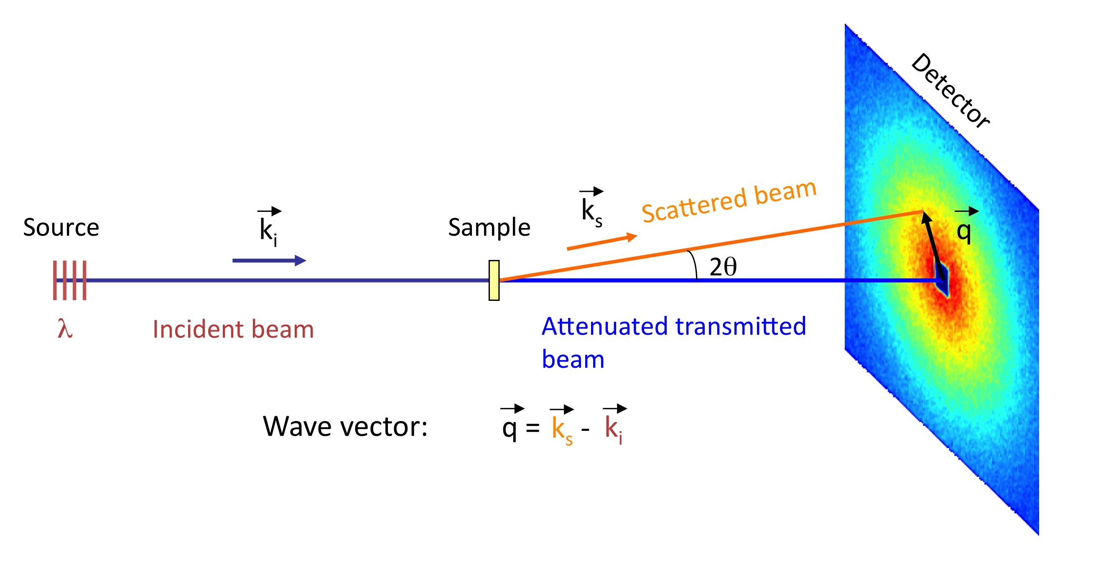
Figure 1: Schematic representation of a small-angle neutron scattering experiment. The incident, k_{i} and scattered k_{s} wave vectors are shown, along with the resultant scattering vector, q, which is in the plane of the detector.
Image courtesy of ILL
A major feature of neutron scattering is a notable difference in scattering length densities between hydrogen and its isotope deuterium (‘normal’ hydrogen has only one proton whereas deuterium contains one proton and one neutron). Surfactants, polymers and biological molecules have many hydrogen atoms, and if these molecules are dissolved in heavy water (D₂O) rather than normal water (H₂O), then the neutron beam is strongly scattered. Thus an easy way to boost the scattering signal is to replace the normal solvent with a deuterated solvent.
To draw a parallel with visible light, imagine that hydrogen and deuterium have different colours. A green lizard on a green leaf is almost invisible, but a green lizard warming up on a white wall becomes easy prey!
In fact, this idea can be extended: using modern chemical methods, it is possible to make not just deuterium-containing solvents, but also deuterium-labelled surfactants, polymers and even proteins. Just imagine the possibilities for SANS experiments.
This kind of isotopic substitution is now a powerful tool for looking at heterogeneous particles, for example surfactant micelles with oily cores. The water in which the micelles are dissolved contains three components: surfactant, oil and water. Specific deuteration allows us to selectively highlight the internal oily cores or, in a separate experiment, the surfactant-coated shells alone. These experiments give different forms of scattering patterns that can be readily distinguished by computer analyses. This gives us a detailed picture of the internal structure of the micelles (figure 2).

Figure 2: As the isotopic solution changes from left to right, different parts of the heterogeneous particles can be visualised. On the left, only the cores are highlighted, whereas on the right, only the shells are.
Image courtesy of ILL

