The principle of the watt balance
By Marlene Rau and Eleanor Hayes
The watt balance is an electromechanical instrument that measures the weight of a test mass very precisely. Teams of scientists around the world are competing to build a watt balance of unprecedented precision.
The measurement performed by a watt balance is done in two phases: a static weighing phase followed by a dynamic moving phase.
In the weighing phase, the test mass is suspended on one arm of the balance, while a coil immersed in a horizontal magnetic field is suspended on the other. When the coil is powered with a current, I, the interaction between current and magnetic field produces a vertical electromagnetic force:
F_{el} = ILB
where L is the total length of the wire constituting the coil and B is the magnetic flux density.
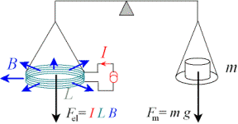
The static weighing phase
Image courtesy of the BIPM
As the weight of the test mass (F_{m}) is given as F_{m} = mg
where m: mass; and g: gravitational acceleration
when the balance is in equilibrium, we obtain:
mg = ILB.
We can determine g very accurately, but B and L are inherently imprecise. This is why the moving phase is used as a trick – a measurement that gives us a formula with which we can cancel out B and L.
In the moving phase, the test mass is removed, and the coil is moved at a constant (vertical) velocity through the same horizontal magnetic field as before. This will induce a voltage in the coil, which can be measured.
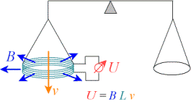
The dynamic moving phase
Image courtesy of the BIPM
The induced voltage (U) is given as:
U = BLv
where B: magnetic flux density of the horizontal magnetic field; L: wire length of the coil; and v: velocity of the coil being moved through the magnetic field.
We can now cancel out BL. We already know that:
mg = ILB
and we now know that:
U = BLv
Rearranging these equations gives us:
mg = LB
I
and:
U = BL.
v
By combining the two, we get:
UI = mgv.
In other words, electrical energy (UI) equals mechanical energy (mgv) or P_{el} = P_{mech}, which is the principle behind the watt balance.
For the purposes of determining mass
m = UI.
gv
Whereas v is also easy to determine accurately, a sufficiently precise measure of I and U requires the knowledge of quantum mechanics. Two phenomena, known as the Josephson effect and the quantum Hall effect, enable the scientists to determine resistance and voltage precisely, and thus also calculate the current (Ohm’s law).
The different metrology institutes each have their own instrumental designs, some of which are very large. With such a complex setup it is of course difficult to reach the required precision. One of the crucial elements of the watt balance is the magnetic circuit, because the magnetic field B and the coil length L must remain the same during the two measurement phases, the static and the dynamic one. It is not important to know their exact values, but it is important that they do not change, in particular due to temperature effects.
A collaboration between the Swiss Metrology Office (METAS) and CERN allowed scientists to design an ultra-stable temperature-compensated magnet which will be part of a new watt balance, designed to increase the accuracy of the present setup by about one order of magnitude.

