Building the seismograph
For your homemade seismograph, you will need a computer with a sound card (or sound chip), sound-editing software (we recommend Audacity, as it is free and easy to use) and a geophone. We built our geophone from a woofer (loudspeaker), using the main components shown below, which you may change and adapt according to the materials you have available.
To calibrate your seismograph, you will have to wait for some earthquakes to happen, and you will need either a commercial seismograph or the data from a nearby seismographic station to compare your readings to.

Main components of the woofer geophone
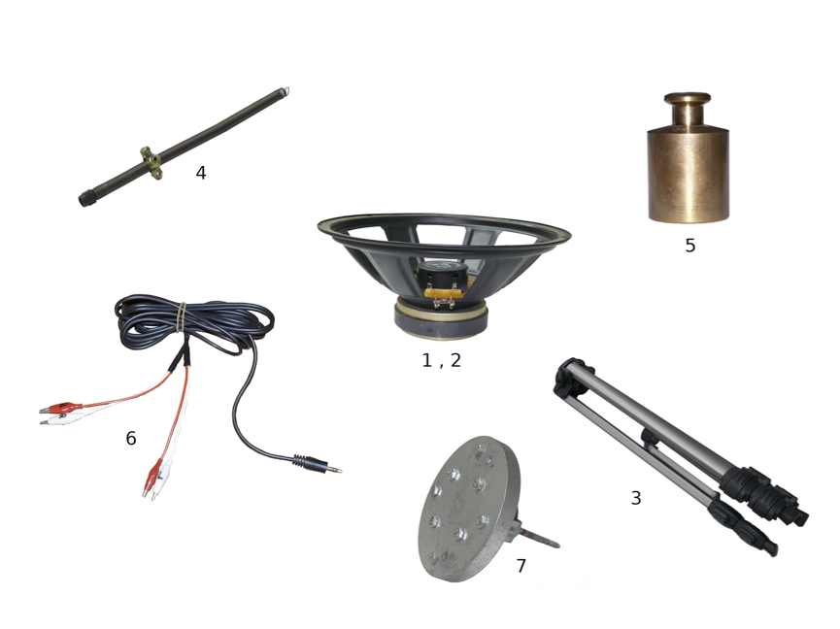Components of the woofer geophone; numbering corresponds to the list below
Image courtesy of Panteleimon Bazanos
- A woofer. You can buy one for about €20, or you can take apart an old loudspeaker from a hi-fi system. If you choose the second option, you will have to be careful not to destroy the coil while extracting the woofer. We used a commercially available 100 W / 8 Ω woofer. Most speakers today have 8 Ω resistance, and 100 W is a good and cheap choice. Stronger woofers will give stronger signals, but are more expensive.
- A plastic lid to cover the voice coil of the woofer without touching it or pressing down on it. We used the lid of a spray can.
- A camera tripod or other suitable stand.
- A spring, about 50 cm in length, with a spring constant (k) of about 2 cm/N. We happened to find a suitable spring in some roller blinds, but you can also just buy a spring.
If you use a different weight hanging from the spring (not 1 kg as suggested below) or setup, you may want a spring with different specifications. Spring and weight together must be able to oscillate, but the mass should not stretch the spring to the extent that the spring is deformed.
Note that the spring will need to fit through the central openings of the tripod (see image below).
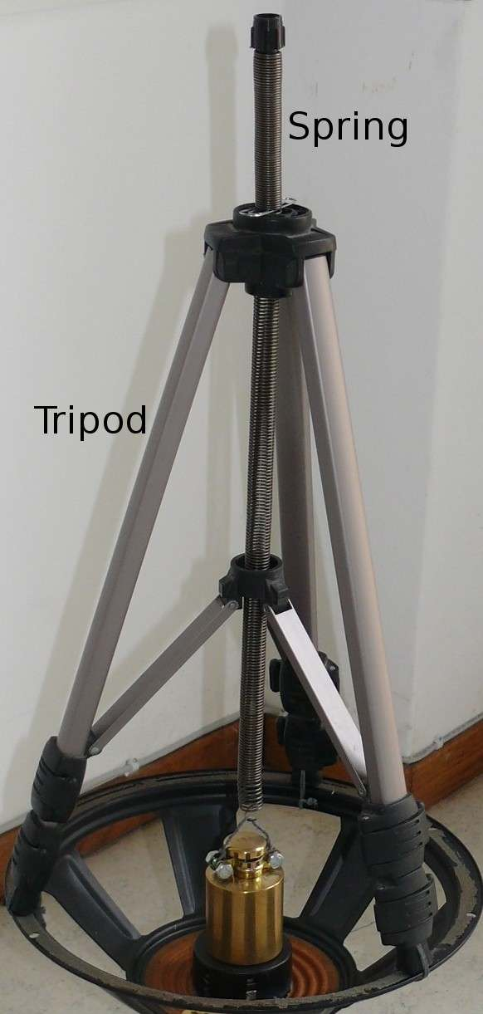
The spring must fit through the central openings of the tripod
Image courtesy of Panteleimon Bazanos
You will also need a metal collar or other means of keeping the spring firmly in place at a certain height, as well as a hook at one end of the spring to hang the weight from it (see image below). A paper clip threaded into the spring may do the trick.
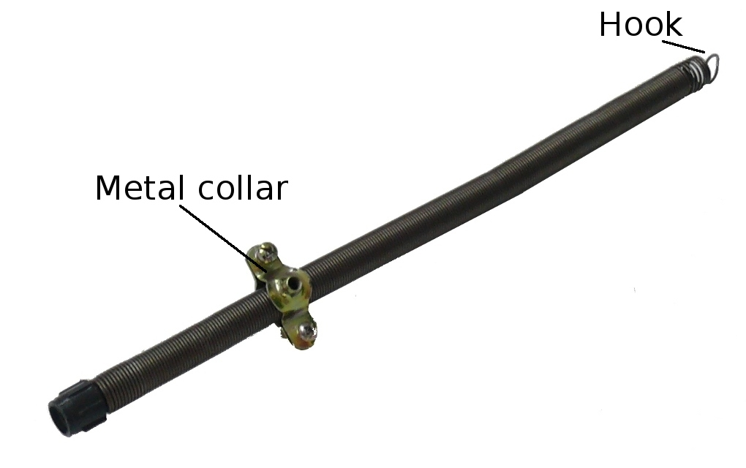
The spring with metal collar and hook
Image courtesy of Panteleimon Bazanos
- A 1 kg weight, e.g. a sinker from a fishing shop, which conveniently often has a loop already attached that can be used to hang it from the spring. Otherwise, you will have to devise a means of attaching the weight to the spring. We used a clamp, two nuts and bolts, wire and adhesive tape, a wrench and a wire cutter: (i) fasten the clamp around the neck of the weight with the bolt and nuts using a wrench; (ii) tie the wire around the bolts and make a loop from which to hang the weight; (iii) cover the sharp ends of the wire with adhesive tape to avoid injuries.
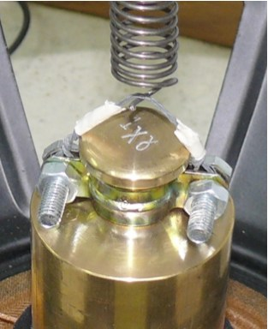
We used a wire loop tied to a clamp to hang the weight from the spring
Image courtesy of Panteleimon Bazanos
- A cable with a 3.5 mm jack lead at one end, and two crocodile clamps at the other for connecting the woofer to the sound card ports of a computer. We made this cable by cutting the cable from a computer loudspeaker at the end connected to the loudspeaker and connecting crocodile clips to the cut ends.
For our version, you need:
- A computer loudspeaker (you can find cheap speakers for about €2-3). A pair of computer loudspeakers will have a stereo cable with a 3.5 mm jack lead at one end and two channels, each of which contains two wires. After adapting it, you then end up with a cable with a 3.5 mm jack lead at one end and four (not two) crocodile clips at the other (see number 6 in the topmost image) – this means you can connect two woofers to the computer, one to each of the channels.
For one woofer, a mono cable with just one channel (and consequently two crocodile clips, not four) is sufficient.
- One or two cables with crocodile clips at each end (depending on whether you use a cable from a mono or stereo speaker, see above)
- A wire cutter
- A wire stripper
- Insulating tape
- Detach the ends of the speaker cable from the speaker (the opposite end to the one with the jack lead) and strip the wires at the ends.
- Cut in half the cable(s) with the crocodile clips at the ends and strip the wires at the cut ends.
- Connect each wire from the speaker cable to one wire with a crocodile clip at its end.
- Cover each connection with insulating tape. You should now have a cable with a jack lead at one end, and two or four crocodile clips at the other.
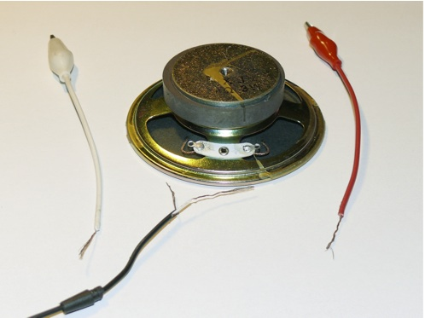
The components of the cable and the computer speaker
Image courtesy of Panteleimon Bazanos
- A base for fixing the geophone to the ground. It should be stable and rigid, and there has to be some way the woofer can be fixed tight onto it. We used an iron base, which has the advantage of allowing the woofer to be mounted firmly onto it through its magnet. Additionally, the base needs to attach the geophone firmly to the ground, which we achieved by screwing it into a hole in the floor. An alternative may be to use a very heavy base (e.g. a 50 kg concrete block).
For our version, you need:
- An iron plate with a diameter similar to that of the woofer’s magnet (see below), with holes pre-drilled into it. If you use a plate of different material, you can screw iron screws in so it can still be attached to the woofer’s magnet
- A set of two U-shaped pipe support brackets normally used to attach water pipes to walls. They are made of iron and very stable, and one of them has a long embedded screw (about 10 cm long and 0.5 cm thick)
- A metal drill
- A soldering iron and solder
- Four nuts and bolts
- A spanner
- Drill a hole into the centre of the bracket without a screw and thread the screw of the other bracket through this hole. Place the pipe holders at right angles so one crosses the other (see image below). Fix the brackets by soldering around the hole.
- Attach the pipe brackets to the iron plate with the help of four nuts and bolts, using a spanner.
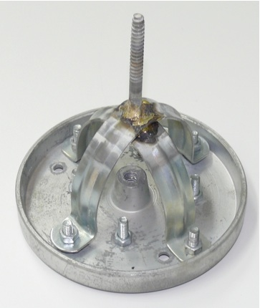
Our base
Image courtesy of Panteleimon Bazanos

Equipment
- Box cutter
- Cling film (if you remove the dust cap)
- Superglue
- Wire, pliers and a wire cutter (to attach the tripod to the woofer)
- A drill and wall plug (to screw the base to the floor)
- Something to attach the woofer to the base (in our case not required, as our base is magnetically attached to the woofer)
- Screwdriver
Depending on the specific materials you are using, you may need other tools and materials.

Procedure
- Carefully cut away and remove the cone and surround of the woofer using a box cutter. Some woofers have rather wide dust caps. In these cases you will have to cut and remove the upper part of the dust cap and leave only the narrow neck, so you can fit a rather narrow plastic cap on top. If the plastic cap has a diameter that is too wide, it will sit too far from the centre of the spider (see image), resulting in smaller oscillations. If you remove the upper part of the dust cap, protect the voice coil from dust by wrapping it cling film.
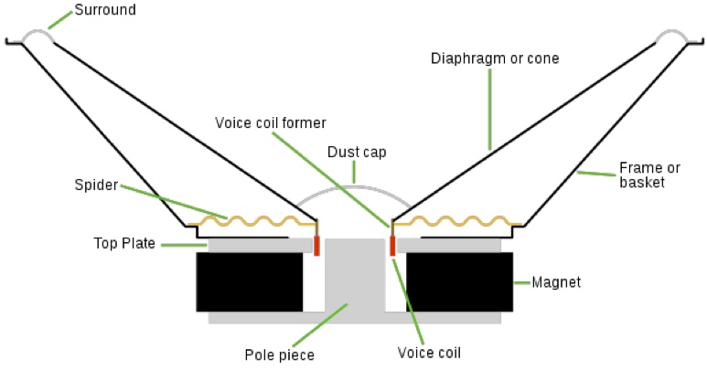
Cross-section of a woofer
Image courtesy of Iain Fergusson; image source: Wikimedia Commons
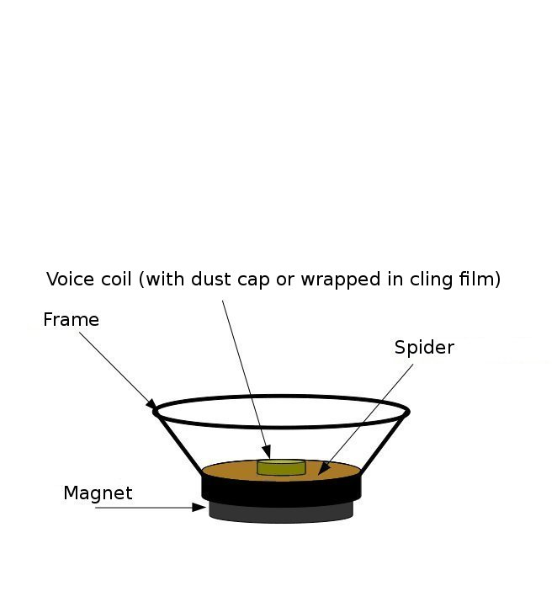
The woofer after the cone and surround are removed
Image courtesy of Panteleimon Bazanos
- Apply superglue to the rim of the plastic cap and glue the cap to the spider, covering the dust cap without touching it. Make sure the plastic cap is well centred (this is easy, because you can use the concentric circles of the spider as guidelines) or the voice coil may be deformed.
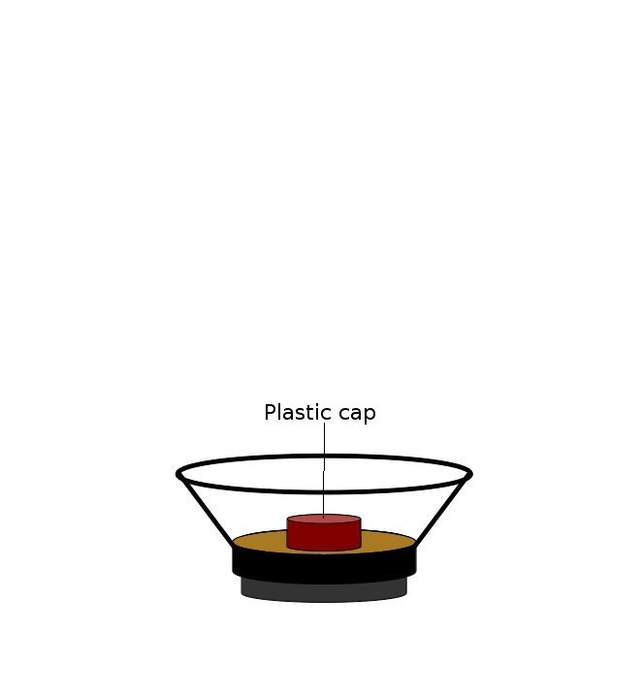
The woofer after the plastic cap has been added
Image courtesy of Panteleimon Bazanos
- Attach the tripod tightly to the woofer frame, for example using wire. Alternatively, you might drill holes in suitable places on the tripod and woofer frame, and use nuts and bolts to fasten them together.
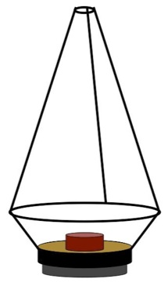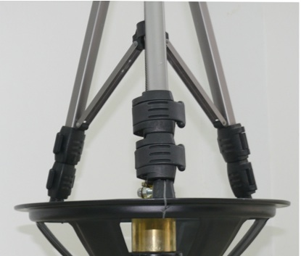
The woofer with the tripod attached to the frame
Images courtesy of Panteleimon Bazanos
- Screw the base firmly to the floor, bearing in mind that it should be somewhere quiet and free from vibrations. Ideally this would be in the school cellar, though we set ours up in the classroom, which is not ideal but keeps the students more interested.
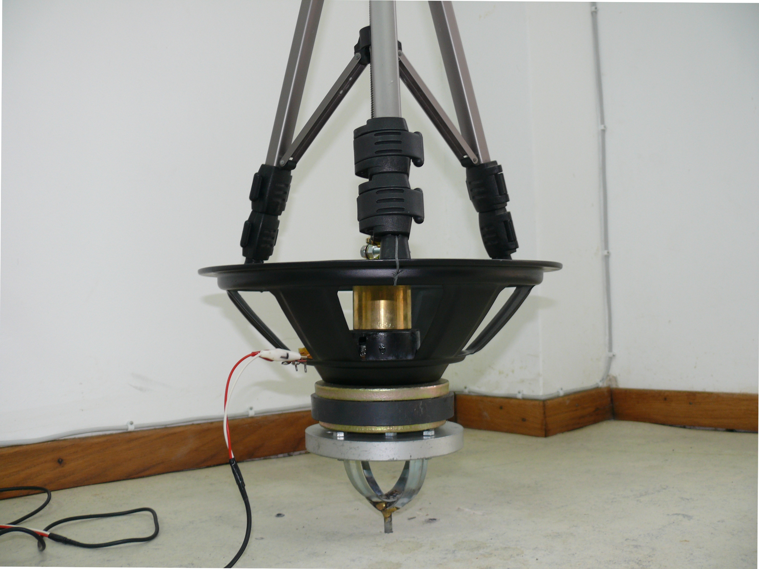
Image courtesy of Panteleimon Bazanos
- Attach the woofer to the base. If the base is made of iron, the woofer will be held firmly in place by its magnet. If not, you will have to think of another fastening method.
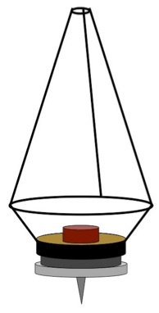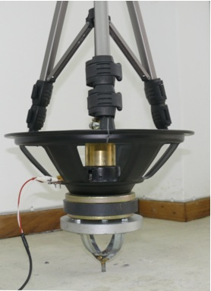
Images courtesy of Panteleimon Bazanos
- Thread the spring through the tripod. Once the position of the spring is determined (see step 7), you will have to fix it at a certain height so it cannot slip through. We used a metal collar for this (see image below), but a paper clip among the spirals can work as well.
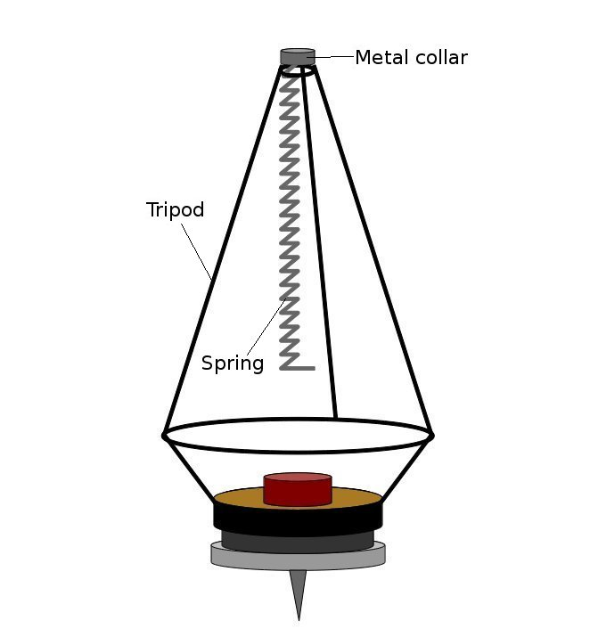 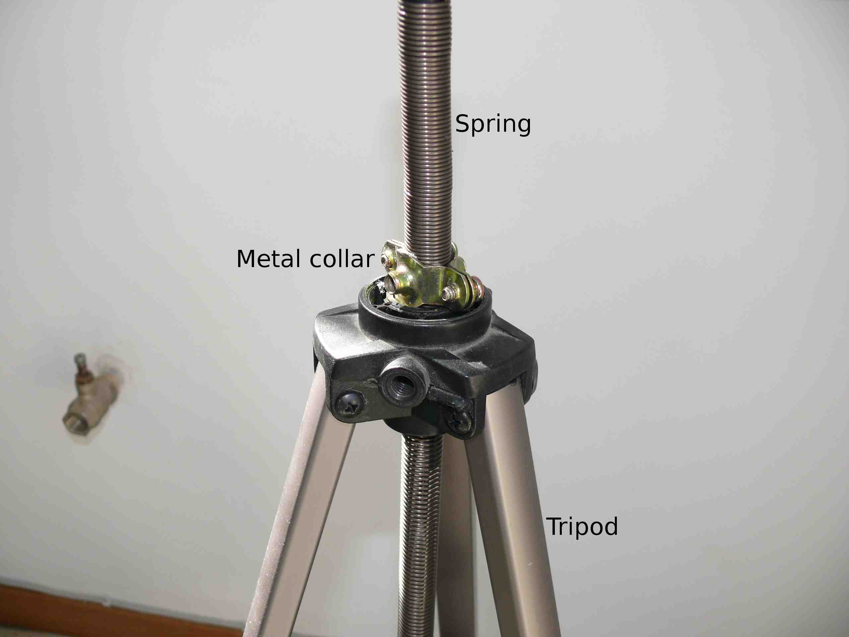
Images courtesy of Panteleimon Bazanos
This step is crucial. It must be performed carefully to avoid deforming the voice coil of the woofer, which would otherwise malfunction. You will have to repeat the following procedure until the final position for the spring is determined, which will hold the weight in just the right place.
- Using a screwdriver, tighten the metal collar around the spring, so the position of the spring is fixed. Hang the weight from the spring while holding it in your hand – do not let go of the weight! Now let the weight slowly extend the spring while still holding the weight in your hand. In its final position, when the spring is fully extended, the weight should just about touch the plastic lid, without exerting any pressure on the lid or the spider of the woofer.
Test different heights of the spring to find the right position.
When you have found it, apply superglue to the base of the weight, hang it from the spring and slowly let the spring extend until the weight just touches the plastic lid on its centre and can stick to it.
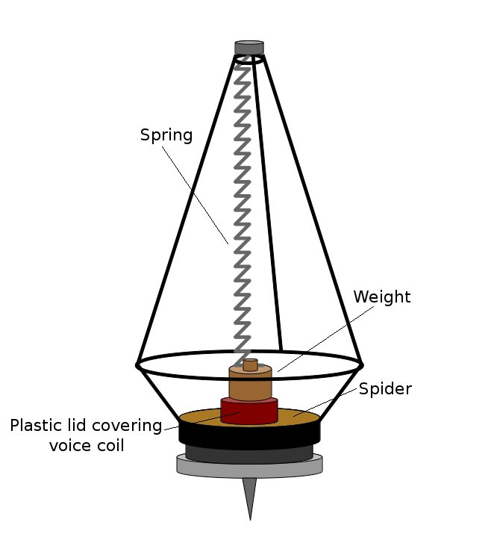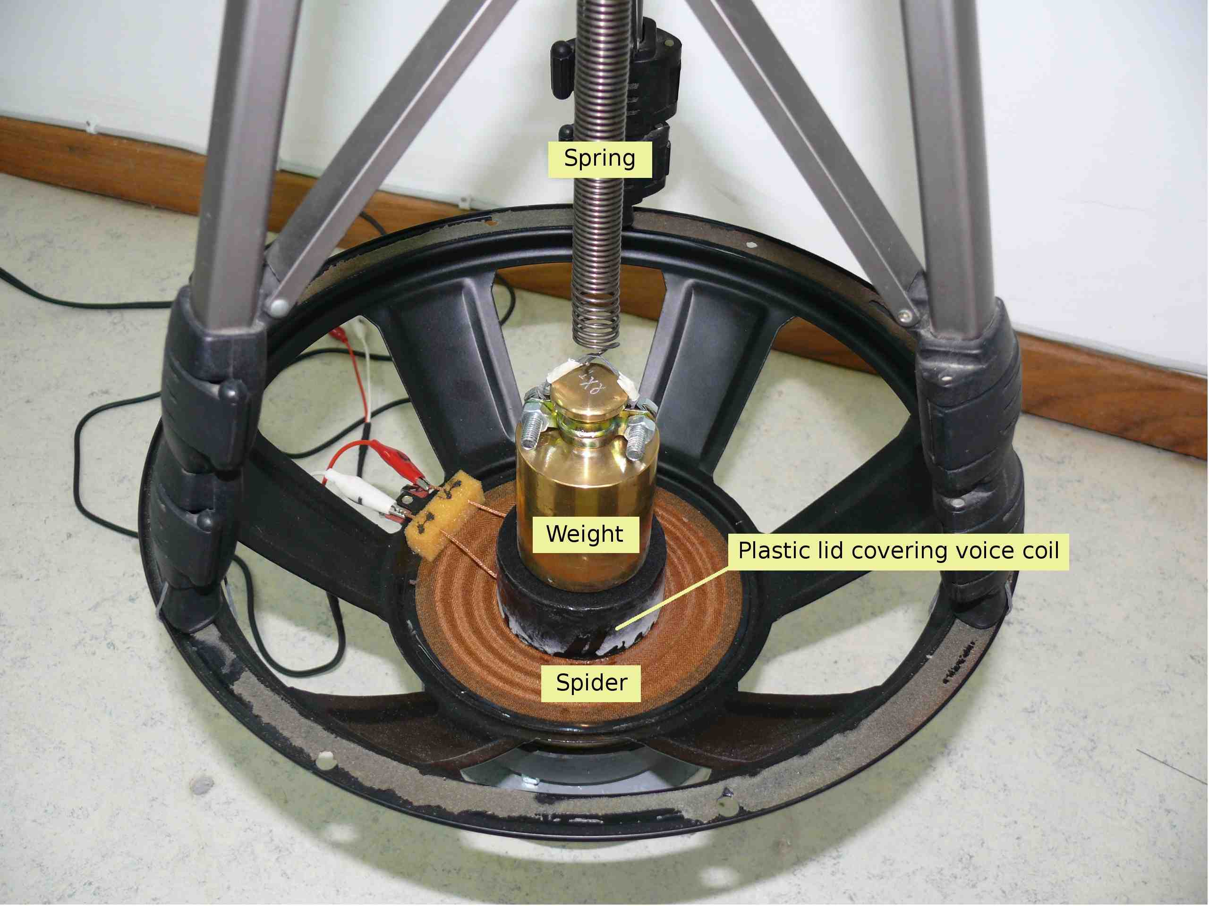
Images courtesy of Panteleimon Bazanos
- Connect your cable with the crocodile clips to the wires that connect the voice coil to the woofer connectors.
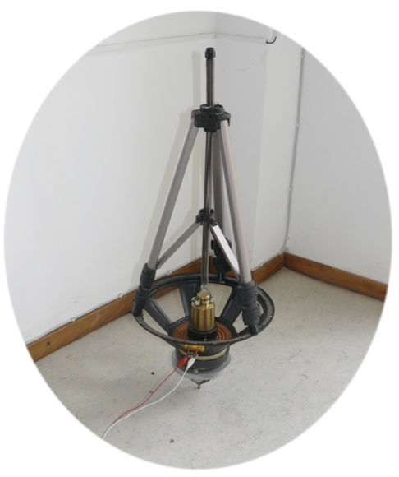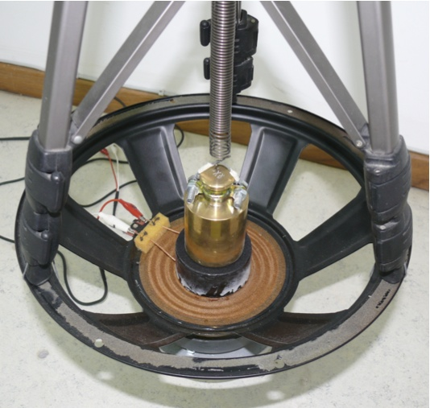
Connect the crocodile clips to the woofer
Images courtesy of Panteleimon Bazanos
- Connect the woofer to the sound card input ports of your computer by plugging the jack lead of your cable into the microphone or line-in socket. Using the microphone socket gives stronger signals.
Start recording. When the ground vibrates, the vibrations are transferred to the woofer geophone, and the spring-weight-coil system vibrates, producing electrical signals.
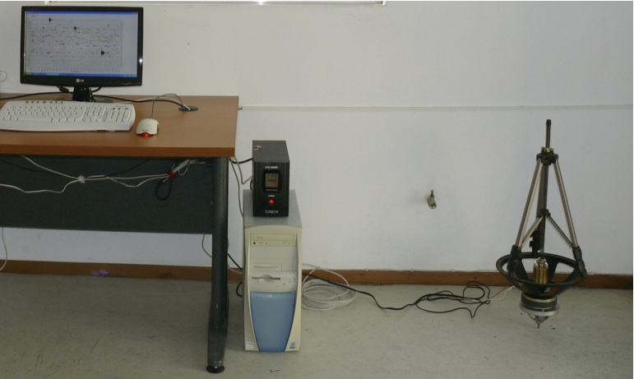
The geophone is ready. Note that the graph on the screen was taken with a commercial seismograph, not with the self-built one. The black box on the computer is an uninterruptible power supply
Image courtesy of Panteleimon Bazanos

Analysing your data I: detecting earthquakes
This step-by-step guide uses the Audacity recording software. If you are using different software, you will have to adapt the procedure.
I suggest recording data for 1-2 days and then analysing it to find out whether an earthquake happened during that time. The longer the recordings are, the longer the computer takes to process the data in the following steps, so analysing even longer recordings will keep your computer busy for a very long time.
Your recording will probably look like this:
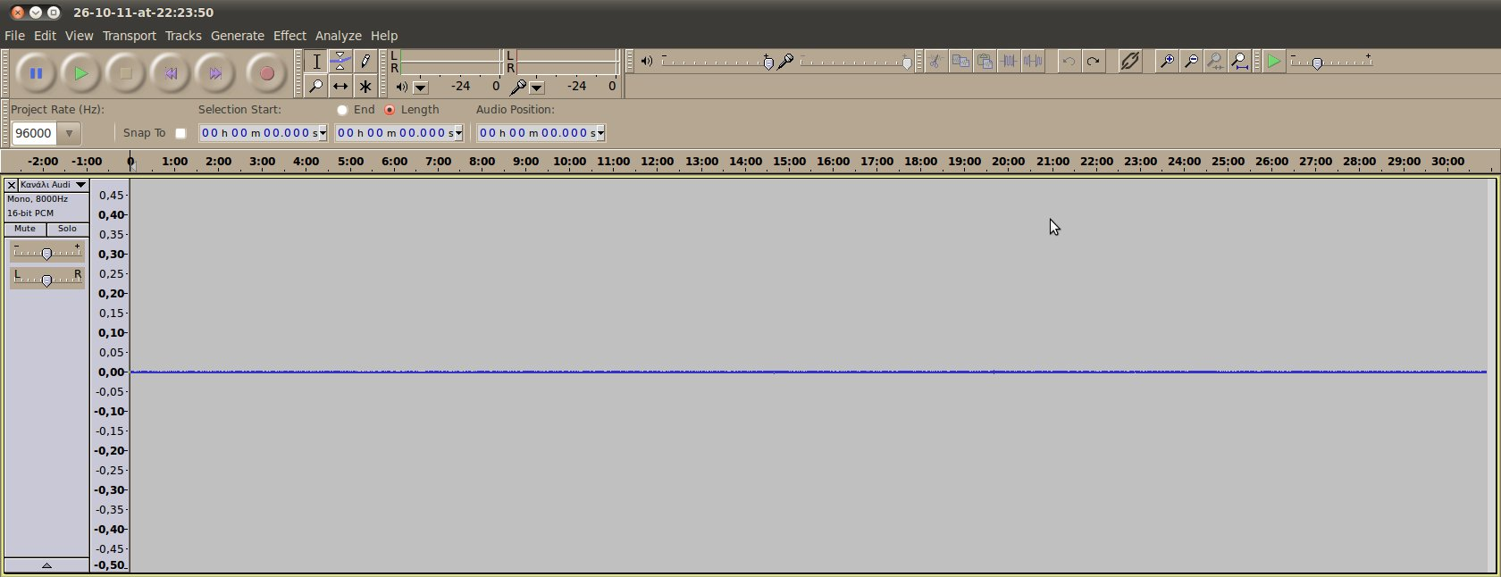Image courtesy of Panteleimon Bazanos

1. Remove DC offset
This step removes the contribution of any DC current to the signal. From the Effect menu, select the Normalize command. In the popup window, make sure that Remove any DC offset is ticked and Normalize maximum amplitude to is unticked and then click the OK button. This step is not crucial, but it is good to have the waveform positioned vertically in the middle of the window, so that when there are no earthquakes (or other vibrations), your signal will be at zero.
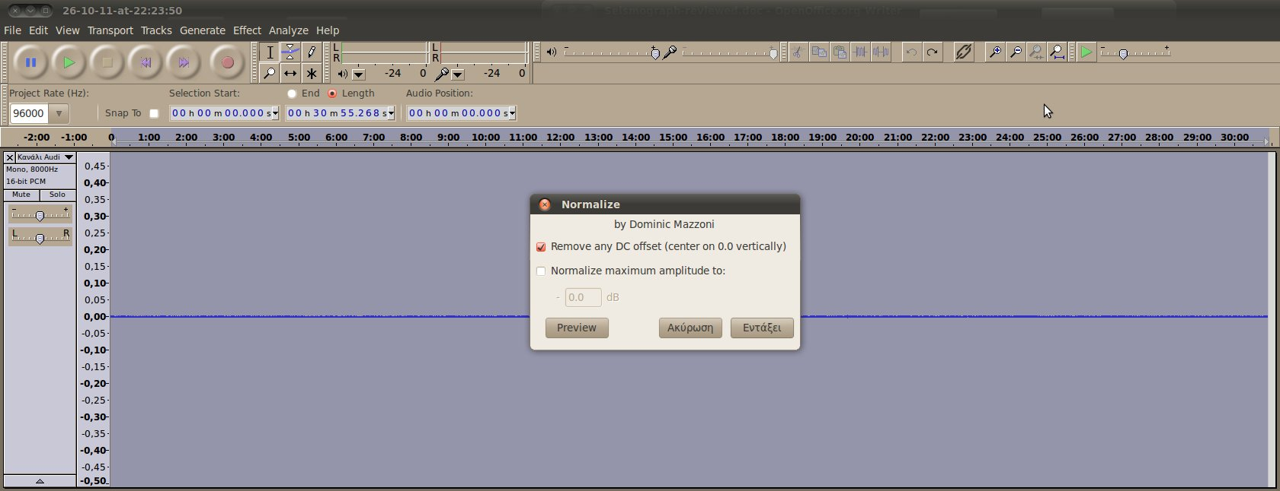
Images courtesy of Panteleimon Bazanos

2. Amplify low frequencies
This step amplifies the low frequencies, which is the range in which you will detect earthquakes, to favour these vibrations over vibrations in other ranges, which are caused by other sources (noise). Commercial seismographs based on geophones have filters to cut out undesirable frequencies. You can experiment with various cut-off frequencies to find the clearest signals. Generally, 100 Hz is a good starting point, but you may also want to try 50 or 200 Hz, for example.
From the Effect menu, select the BassBoost command. In the popup window, enter your chosen value for the Frequency (Hz) (e.g. 100) and 36 for Boost (dB). This means that all frequencies below 100 Hz will be amplified by 36 dB (about 64 times). Amplification of 36 dB is the maximum value in one step with this method. If you have a strong signal, you may choose to amplify it less (e.g. 20 or 30 dB). Bear in mind that stronger amplification will also amplify the noise more.
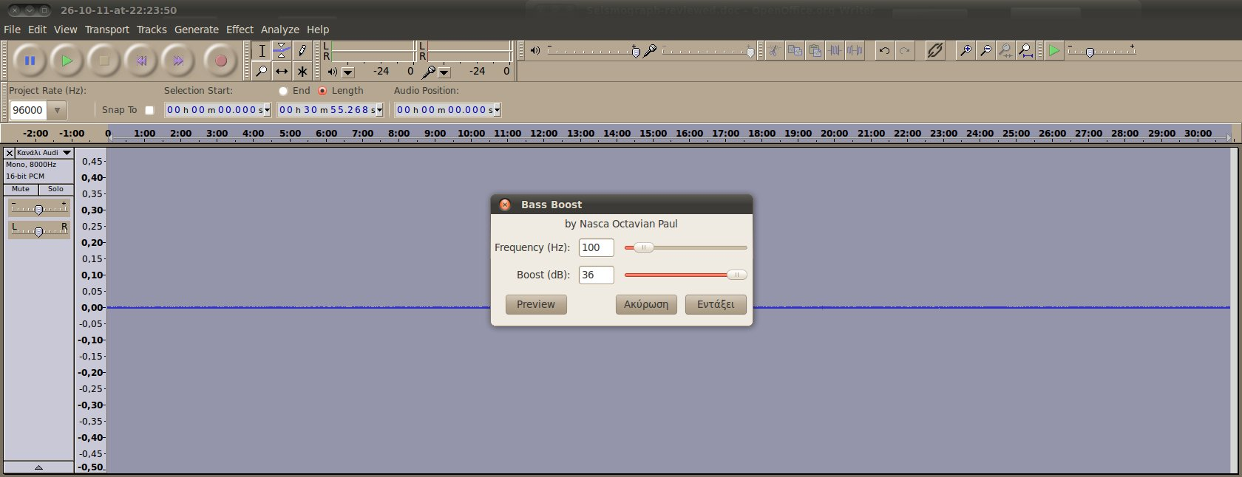
Image courtesy of Panteleimon Bazanos
You should now see a peak for each vibration that has been recorded.
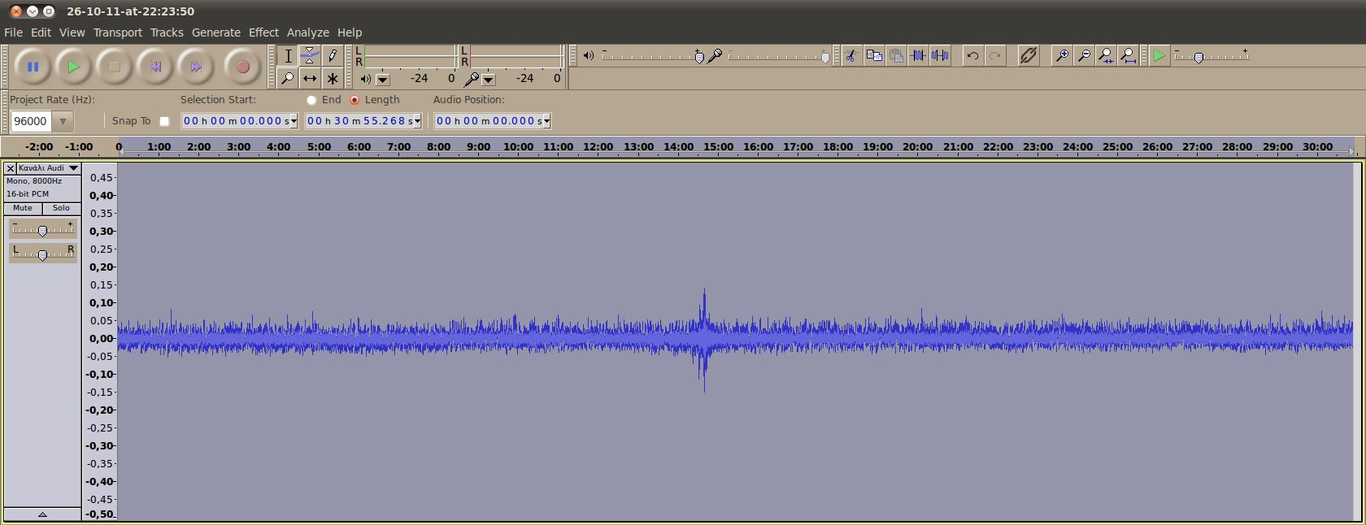Image courtesy of Panteleimon Bazanos

3. Remove noise
In this step, you remove background noise (such as thermal noise or electronic noise) to make the signal clearer. First, select a few seconds (2-5 are enough) of the recording that do not contain a signal (peak) by clicking and dragging.
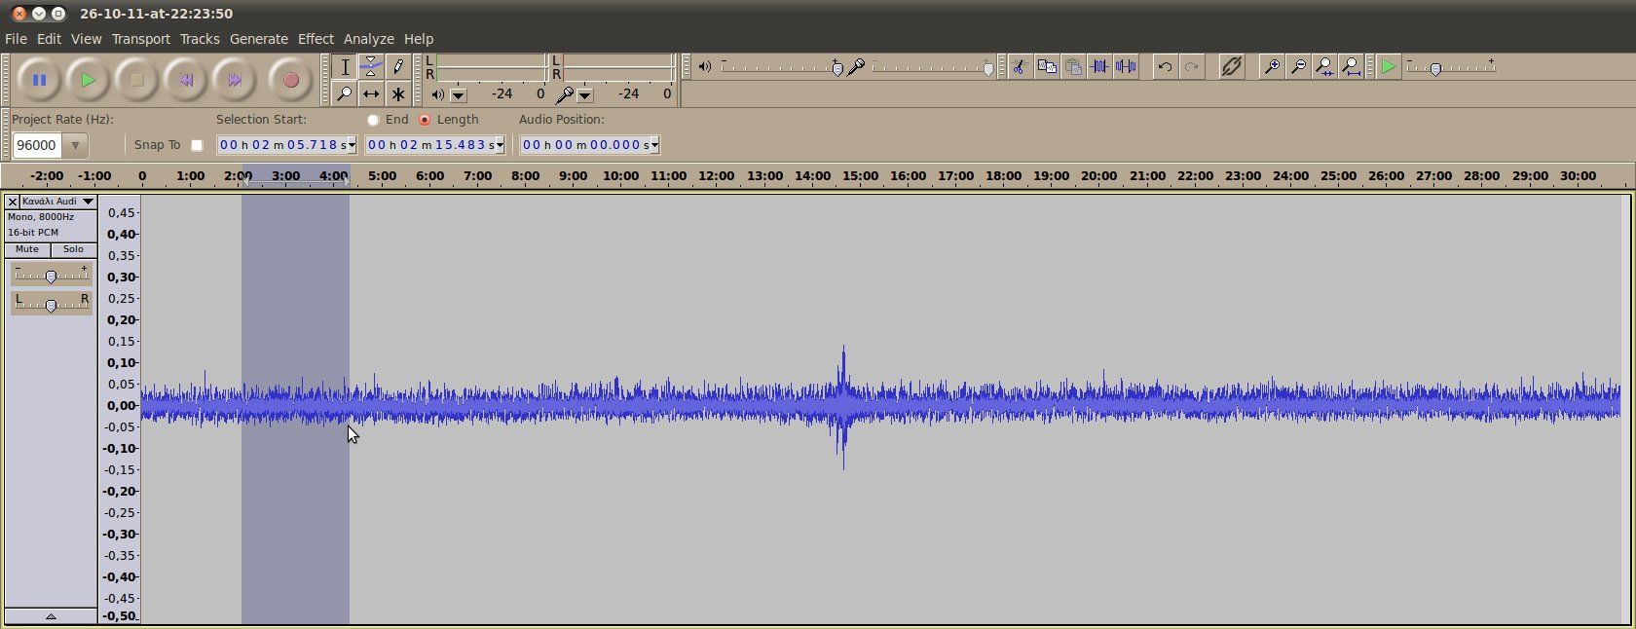
Image courtesy of Panteleimon Bazanos
Next, from the Effect menu, select the Noise Removal command. In the popup window, click on the Get Noise Profile button. This will determine which part of the signal is noise by analysing only the section you chose, which should contain noise only (no peak).
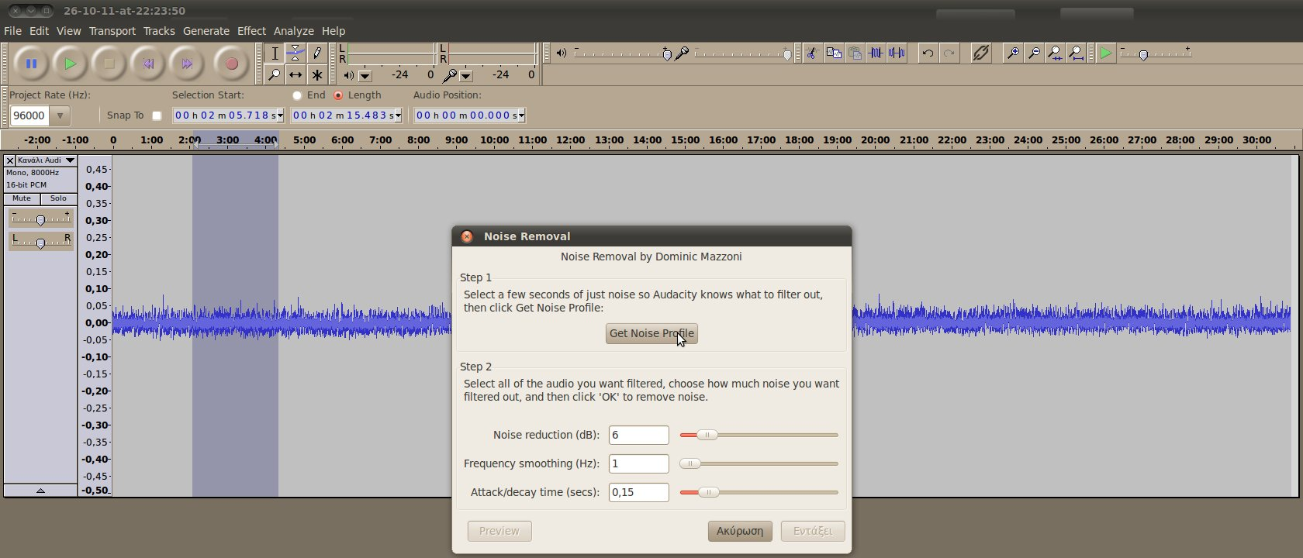
Images courtesy of Panteleimon Bazanos
Next, select your entire recording by clicking and dragging to remove noise everywhere. Again, from the Effect menu, select the Noise Removal command. In the popup window, enter 6 for Noise reduction (dB), 1 for Frequency smoothing (Hz) and 0.15 for Attack/decay time (secs). Then click on the OK button (you can experiment with other values or just use the default settings, but these worked well for us).
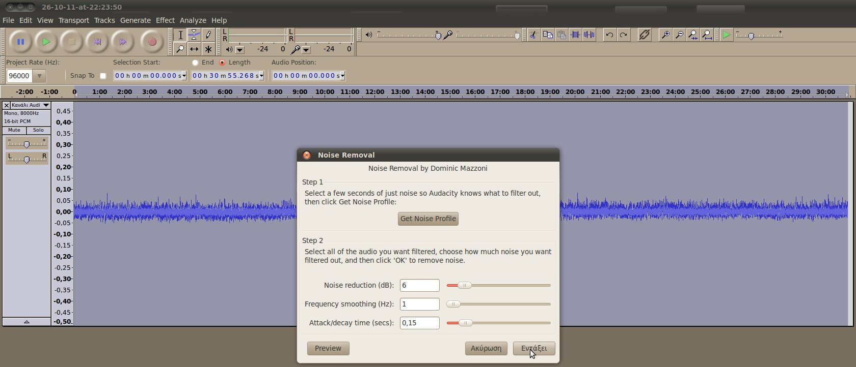
Images courtesy of Panteleimon Bazanos
The peak should now be clearer and you have to decide if it corresponds to an earthquake.
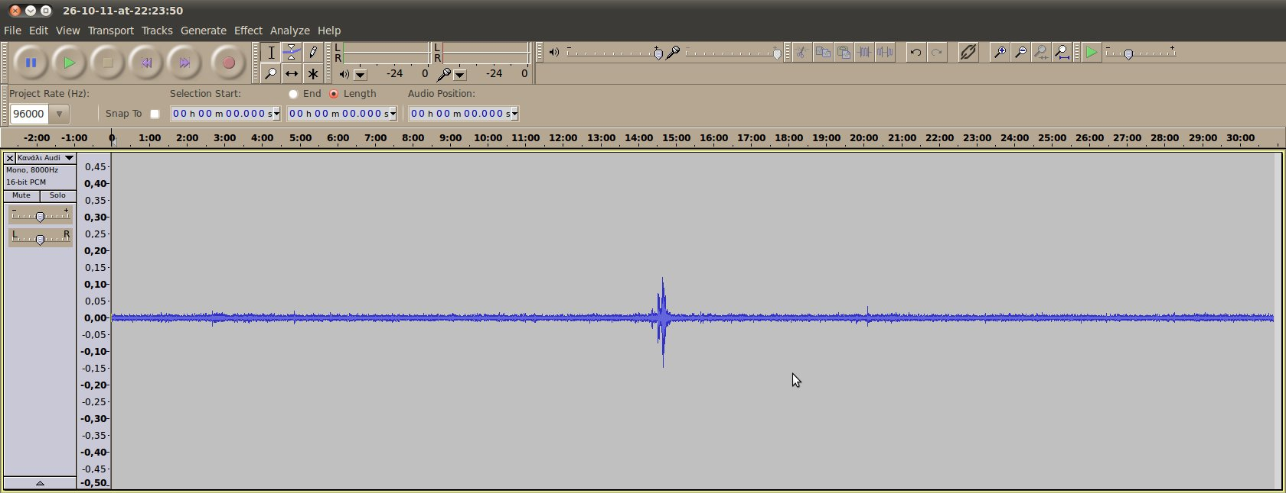
Image courtesy of Panteleimon Bazanos

Is it an earthquake?
You can now analyse your peak to find out whether it corresponds to an earthquake. Click on the peak and then click on the Zoom In tool to expand the peak. After zooming in with several clicks, an earthquake would reveal itself as a characteristic pattern with primary (P) waves and secondary (S) waves. If it is difficult to decide, you should do what professional seismologists do and compare your data with the recordings made at another seismographic station to confirm whether it was a local source (such as traffic, wind, explosions, opening and closing doors, etc.) or an earthquake. In fact, you should always confirm your findings by comparing them to those of others.
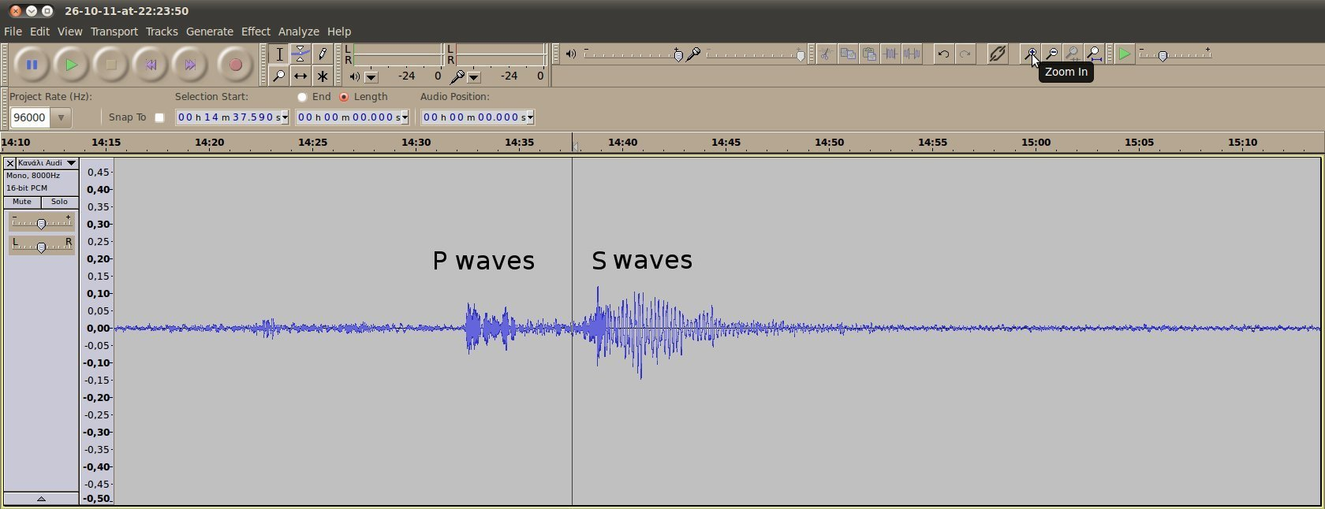
Image courtesy of Panteleimon Bazanos

Analysing your data II: determining the distance and magnitude of an earthquake
You can now enjoy the satisfaction of having built your own seismograph and recording earthquakes. If, however, you want to extract meaningful data in terms of the distance and magnitude of an earthquake you have recorded, you need to calibrate your seismograph by comparing your recordings to those made at an official seismographic station nearby.
You need some earthquakes and a general formula to be adjusted so the results of your seismograph are close to the results of the official seismographs. As your homemade seismograph will be unique, so will your calibration.

The formulae to start with
We adapted the formulae of our commercial seismograph as found in the manual by an empirically determined correction factor. This is justified as all magnitude formulae use empirical constants.
Our commercial seismograph uses the following formulae to calculate the distance and magnitude of an earthquake:
Epicentre distance (in kilometres) = p₁ · (t_{s} – t_{p})
Magnitude (in Richter) = p₂ · log10 (t_{c} – t_{p}) + p₃ · Epicentre distance – p₄
where p₁, p₂, p₃, p₄ are constants that depend on the type of rocks that the tremor passed through. According to the manufacturer, the values for our geological location are: p₁ = 7.6, p₂ = 2.31, p₃ = 0.0012, p₄ = 1.0. These values will be different for your location.
t_{p} is the arrival time (in seconds) of the earthquake’s P wave; t_{s} is the arrival time (in seconds) of the S wave; t_{c} is the time (in seconds) at which the vibrations stop.
The magnitude formula above is based on the official duration magnitude scale that has been modified to give the results on the local magnitude scale (Richter).
For more information, see:
http://en.wikipedia.org/wiki/Seismic_scale
http://en.wikipedia.org/wiki/Earthquake_duration_magnitude

Measure the t values with Audacity
Use the recording of an earthquake that has already been analysed as above.
To measure (t_{s} – t_{p}), click on the point where you think the P wave starts and drag to the point where you think the S wave starts. The time difference will be displayed in the middle box above the timeline bar. Note down the value (in this example it is 5.7 s).
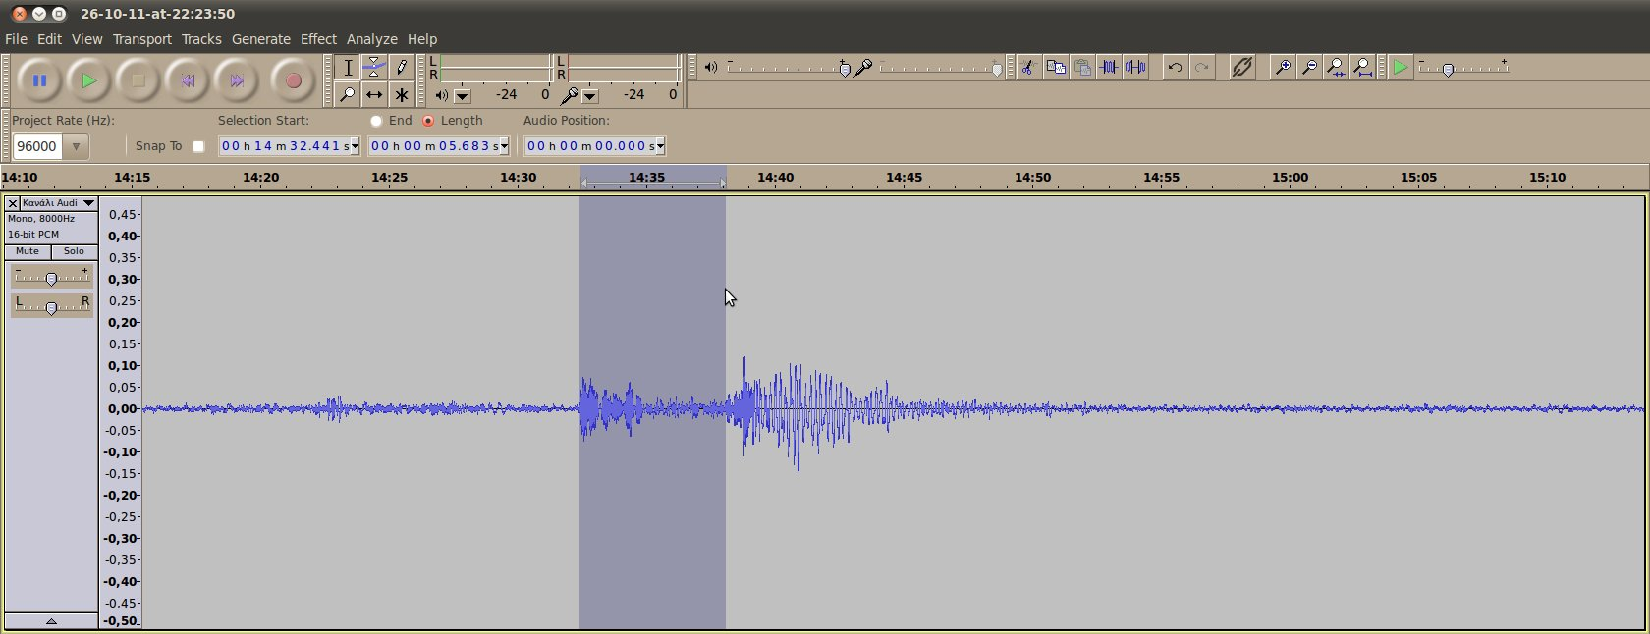
Images courtesy of Panteleimon Bazanos
To measure (t_{c} – t_{p}), click on the point where you think the P wave starts and drag to the point where you think the vibrations end. The time difference will be displayed in the middle box above the timeline bar. Note down the value (in this example it is 21.1s).
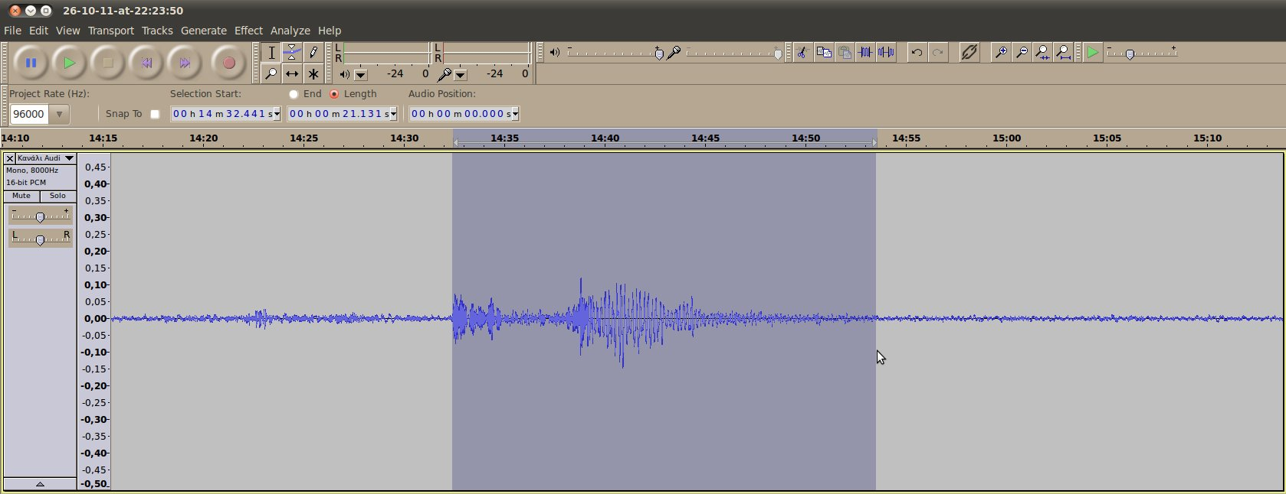
Image courtesy of Panteleimon Bazanos

Calculating the correction factor
The following is the method we followed – yours may be different.
We entered into our formula the t values that we determined above for the epicentre distance. In this example:
Epicentre distance = p₁ · (t_{s} – t_{p}) = 7.6 · 5.7 = 43 km
We compared this to the distance calculated by our commercial seismograph. As this was the same, we did not have to adapt this formula.
However, the magnitude calculated from our own data was different from the official one:
Magnitude = p₂ · log10 (t_{c} – t_{p}) + p₃ · Epicentre distance – p₄ =
2.31 × log10 (21.1) + 0.001 × 43 − 1 = 2.1 Richter
The official magnitude is 2.7 Richter. From this we empirically calculated our correction factor:
Correction factor = 10[[Official magnitude + p4 – (p3 * Epicentre distance)] / p2] / (t_{c} – t_{p})
In our case, this correction factor is 1.8. So our corrected formula for magnitude is:
Magnitude = p₂ · log10 [1.8 · (t_{c} – t_{p})] + p₃ · Epicentre distance – p₄ =
2.31 × log10 (1.8 × 21.1) + 0.001 × 43 − 1 = 2.7 Richter
NOTE: To identify the right correction factor, you should repeat this step with several earthquakes and then use the mean value of the individual correction factors for your general formula to be used in the future.
If you don’t have your own commercial seismograph for comparison, you can calibrate your homemade seismograph by using the epicentre distance and magnitude of the earthquake you recorded as given by a professional seismology centre nearby. Bear in mind that you will first have to determine your distance from the epicentre of the earthquake using a map, which will of course be different from that of the seismographic station.
You can now use your calibrated formulae to analyse any further earthquakes. In our case:
Epicentre distance (in kilometres) = p₁ · (t_{s} – t_{p})
Magnitude (in Richter) = p₂ · log10 [1.8 · (t_{c} – t_{p})] + p₃·Epicentre distance – p₄
with the above p_{i} values.

