Building the rocket launcher

Materials
- 3 union elbow fittings
- 1 union fitting (with a pipe coupling at one end, and an internal screw-thread to connect to the pipe plug at the other end)
- 1 ball valve
- 1 tyre valve
- 1 pipe plug
- 5 copper pipes Ø22 mm: 65 cm, 50 cm, 40 cm, 30 cm, 15 cm (200 cm in total)
- 1 low-cost air compressor or a bicycle pump with a built-in pressure gauge
It is not necessary to use these exact measurements, but it is important to check that all the parts fit together (see image).

Procedure
- Insert the copper pipes into the union elbow fittings (B, C and E) and the ball valve (D) and tighten the connections with a spanner.
Do not tighten the third union elbow fitting (E) fully, as you will need to adjust the elevation angle when launching the rocket.
- Screw the straight union fitting into the end of the launcher (A).
- In the pipe plug, make a hole with the same dimension as the tyre valve, and insert the valve; this is where you will attach the air compressor to the launcher. Make sure that it fits properly, so that pressure can be maintained within the launcher.
- Screw the plug, with the tyre valve inserted, onto the union fitting (A).
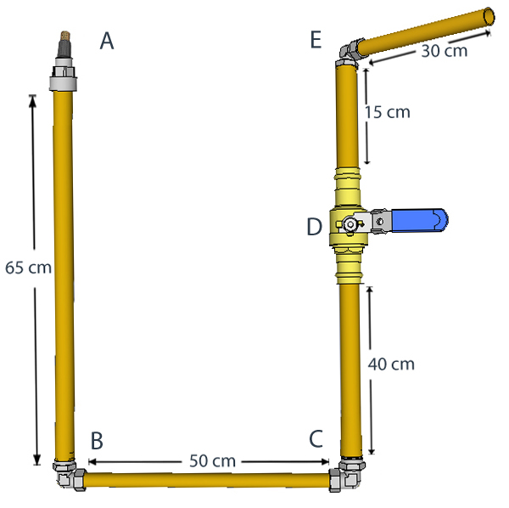
Figure 1: Assembling the rocket launcher. A: connection of the straight union fitting, plug and tyre valve; B: elbow union fitting (well tightened); C: elbow union fitting (well tightened); D: ball valve, to release the pressure within the launcher; E: third elbow union fitting (fairly tight but still easy to adjust)
Image courtesy of Frida Vestnes / Team Space Camp

Acknowledgement
These instructions were provided by the Norwegian Centre for Space-Related Education (NAROM), and translated by Team Space Camp.

