Genetic fingerprinting: a forensic story
The following story is not true, but it does reflect the way genetic fingerprinting is used in forensic investigations.
At the scene of a violent robbery, the scene of crime officers found a cigarette butt that they believe might have been left by one of the robbers. Forensic scientists found saliva on the cigarette butt and were able to generate a genetic fingerprint from the DNA in the saliva (Figure 1).
This fingerprint immediately revealed one thing: the person who smoked the cigarette was a woman. This is shown by the fact that the fingerprint has only a single peak for the amelogenin short tandem repeat (STR). The amelogenin gene is found on both the X and Y chromosomes, but the sequence found on the Y chromosome is slightly longer. The genetic fingerprint of a man (with an X and a Y chromosome) would thus show two peaks at the amelogenin site.

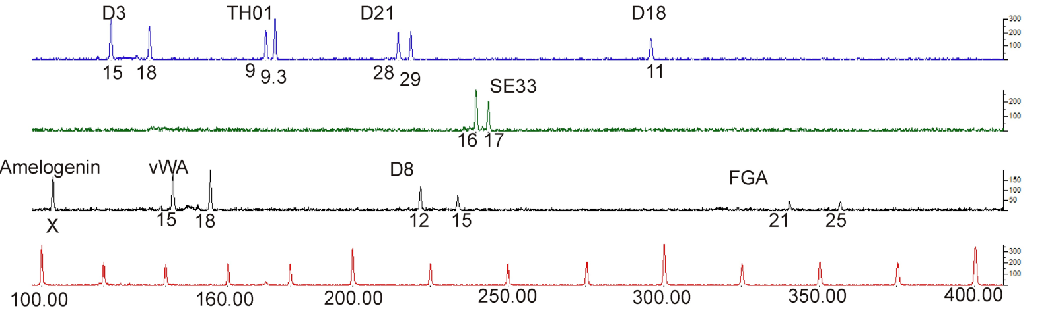
Figure 1: Genetic fingerprint taken from a cigarette butt at the scene of the crime
Image courtesy of Sara Müller

The police have arrested two women, Linda A and Maria B, whom they suspect of being involved in the crime. Each of the suspects has given a DNA sample, which has been used to construct genetic fingerprints (Figures 2 and 3). These can then be compared with the genetic fingerprint from the crime scene.

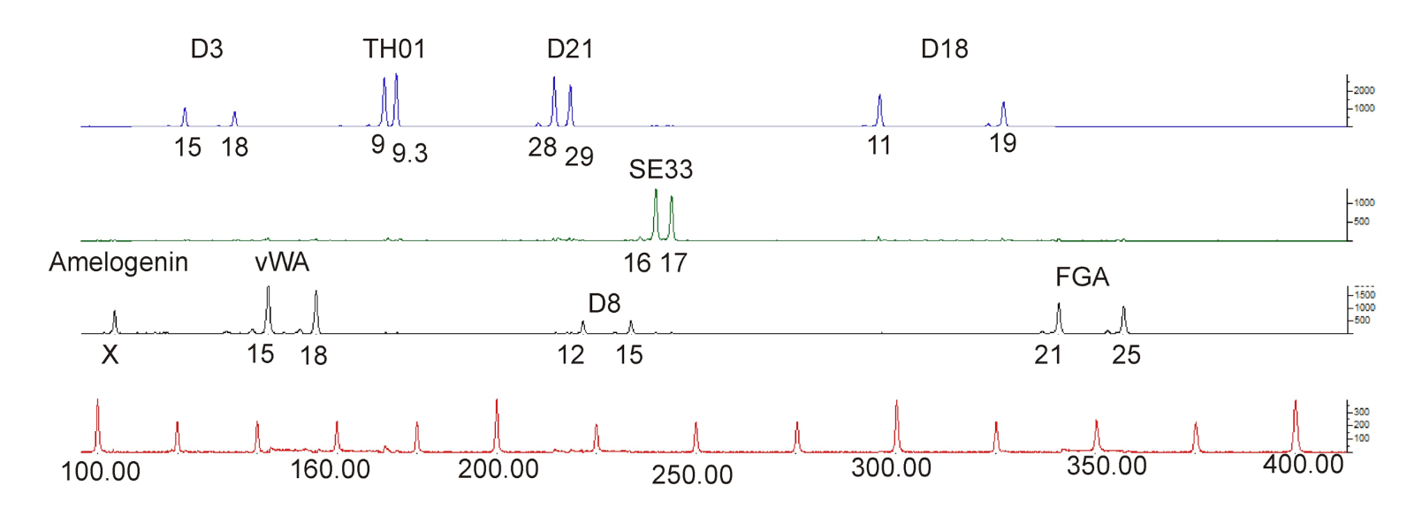
Figure 2: Genetic fingerprint of Linda A
Image courtesy of Sara Müller

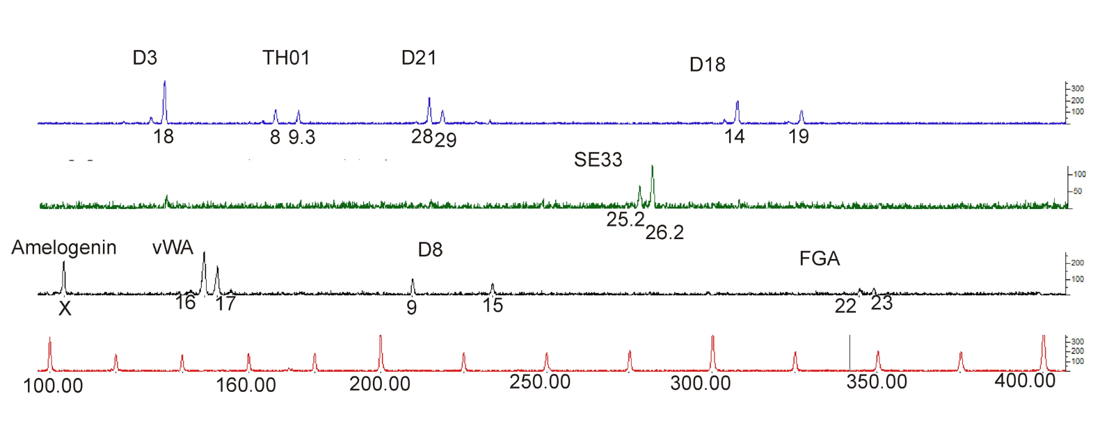
Figure 3: Genetic fingerprint of Maria B
Image courtesy of Sara Müller

At first glance, the three profiles look quite different, but the important thing to remember is that it is the position of the peaks that is informative rather than their height. Each peak represents an allele of one of the STRs being analysed (D3, TH01, D21, D18, SE33, amelogenin, vWA, D8 and FGA). Take another look, also noting the numbers (below the lines) that are associated with each of the alleles.
The positions of the peaks in Maria B’s genetic fingerprint differ substantially from those in the fingerprint taken from the cigarette butt. In contrast, Linda A’s genetic fingerprint is nearly identical – but not quite. The DNA retrieved from the scene of the crime shows only one peak for the D18 STR (11 tandem repeats), whereas Linda A’s genetic fingerprint has two peaks (11 and 19 tandem repeats).
The chance of anyone else having a profile that was identical to all of the other STRs analysed is 1:8.5 billion (more than the current population of the world). It is therefore as good as certain that it was Linda A who smoked the cigarette found at the scene of the crime. If there is additional evidence that she was involved in the robbery, the genetic fingerprint could secure her conviction.
But why weren’t the genetic fingerprints identical? How can we explain the ‘missing allele’ (or allelic drop-out phenomenon)? The most probable explanation is that only a very small amount of DNA could be retrieved from the cigarette; this sometimes causes inaccuracies in the analysis. When the polymerase chain reaction (PCR) is started, the primer may find only one of the alleles, with the result that that one allele is strongly amplified, thus reducing the chance that the other allele is found by the primer.
Clearly, although genetic fingerprinting is a powerful technique in forensic investigations, interpreting the results is not entirely straightforward but involves a good understanding of the processes involved.

