The chemistry of fireworks

The composition of fireworks
The main part of fireworks is concerned with pyrotechnics – it is a mixture of substances designed to produce an effect by heat, light, sound, gas, smoke or a combination of these through self-sustaining exothermic reactions that do not rely on oxygen from external sources. In fireworks, five basic ingredients are usually combined.
- A fuel that allows the so-called ‘star’ to burn, typically based on metal or metalloid powders, or black powder, a form of gunpowder (a mixture of sulphur, charcoal and potassium nitrate);
- An oxidiser that produces (usually) oxygen to support the combustion of the fuel. These are most often perchlorates (ClO₄⁻), chlorates (ClO₃⁻) or nitrates (NO₃⁻), but can also comprise chromates (CrO₄²⁻) or oxides (e.g. Cu₂O, Fe₃O₄, ZnO₂);
- Colourants, usually chloride salts of suitable metals such as strontium, sodium or copper (see Table 1);
- A binder that holds the pellet together, such as a gum or resin;
- A chlorine donor to react with the colour-imparting metals, which will enhance the colour intensity. Unusually for the Group II metals such as strontium, it is thought that the metal (I) chloride (e.g. SrCl) rather than the more usual divalent ion (e.g. SrCl₂) produces the colour.

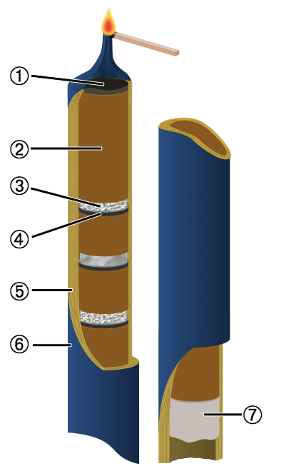
The internal structure of a Roman candle firework. (1) Ignition charge (easily ignited explosive powder); (2) delay charge (slow-burning powder); (3) pyrotechnic star (colourfully burning metal, multiple stars of different kinds); (4) lift charge (explosive to launch the star out of the tube); (5) cardboard tube; (6) wrapping paper (also acts as ignition fuse); (7) sealing clay
Public domain image; image source: Wikimedia Commons

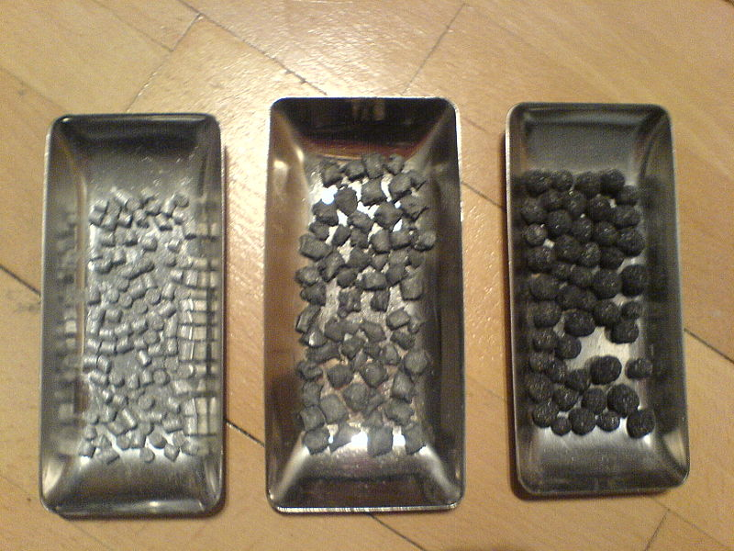
Pyrotechnic stars, from left to right: pumped, cut and rolled types of pellets
Image courtesy of Nicolaj Ma; image source: Wikipedia

Chemical element | Use in fireworks
Al | Aluminium is used to produce silver and white flames and sparks. It is a common component of sparklers and is often alloyed with magnesium into magnalium for extra-bright fireworks.
Ba | Barium salts are used to create green fireworks (e.g. barium chloride, BaCl₂), and barium carbonate is added as an acidity buffer.
C | Carbon is one of the main components of black powder, which is used as a fuel in fireworks. Common forms of carbon as fuel include carbon black, sugar and starch.
Ca | Calcium salts are used to deepen colours, e.g. calcium chloride (CaCl₂) produces orange flames.
Cl | Chlorine compounds an important component of many oxidisers. Several of the metal salts used as colourants are chlorides.
Cs | Caesium compounds help oxidise firework mixtures. Caesium compounds such as caesium nitrate (CsNO₃) produce an indigo colour; caesium nitrate is also used in black light composition, as it contains no sodium or potassium, which emits in the visible light spectrum.
Cu | Copper produces blue-green colours, and halides of copper such as copper chloride (CuCl₂) are used to create shades of blue.
Fe | Iron is used to produce sparks. The burning temperature of the metal particles determines the colour of the sparks.
K | Potassium nitrate (KNO₃), potassium chlorate (KClO₃) and potassium perchlorate (KClO₄) are all important oxidisers. Potassium ions can also impart a violet-pink colour.
Li | Lithium salts are used to impart a medium red colour. Lithium carbonate (Li₂CO₃) is a common colourant.
Mg | Magnesium burns a very bright white, so it is used to add white sparks or to improve the overall brilliance of a firework. Due to its propensity to form a protective cover of magnesium oxide, it is normally used in the form of the alloy magnalium.
Na | Sodium compounds impart a yellow colour, using for example sodium nitrate (NaNO₃). However, the colour is often so bright that it frequently masks other, less intense colours such as those produced by potassium salts.
O | Fireworks include oxidisers, which are substances that produce oxygen in order for burning to occur. The oxidisers are usually nitrates, chlorates or perchlorates. Sometimes the same substance is used to provide oxygen and colour; for example, Sr(NO₃)₂ provides a red colour as well as oxygen to sustain the combustion reaction.
P | White phosphorus burns spontaneously in air and is also responsible for some glow-in-the-dark effects. It may be a component of a firework’s fuel.
S | Sulphur is a component of black powder, and as such, is found in a firework’s fuel.
Sb | Antimony is used to create firework glitter effects.
Sr | Strontium salts such as strontium carbonate (SrCO₃) impart an intense red colour. Strontium compounds are also important for stabilising fireworks mixtures.
Ti | Titanium can be burned as powder or flakes to produce long-lasting silver sparks.
Zn | Zinc is a bluish white metal that is used to create smoke effects for fireworks and other pyrotechnic devices.
Table 1: Usage of chemical elements in fireworks
Adapted from http://en.wikipedia.org/wiki/Firework, accessed on 13.09.2011
Depending on the exact composition of the firework, gases, smoke and dust that contains sulphur compounds or low concentrations of potentially toxic chemicals may be formed, leading to air pollution. Fireworks that produce large amounts of smoke are more harmful than, for example, the smokeless indoor fireworks.

Acknowledgements
The assistance of Professor Jacqueline Akhavan, Dr Alex Contini and Dr James Padfield at the Centre for Defence Chemistry at Cranfield University, UK, is gratefully acknowledged.

Air pollutants cause by fireworks
Sulphur oxides (SO_{x}) such as sulphur dioxide (SO₂) and sulphate ions (SO₄²⁻) are formed in the combustion of sulphur-containing compounds and are oxidised to sulphuric acid (H₂SO₄) in the atmosphere. These oxides are released by fireworks, but also by volcanoes and a variety of industrial processes – largely in power stations. They are precursors to particulate matter in the atmosphere: the sulphuric acid formed by their oxidation is an excellent site on which water can condense and will lead to acid rain.
Nitrogen oxides (NO_{x}) such as nitric oxide (NO), nitrogen dioxide (NO₂) or nitrate (NO₃⁻) are produced by high-temperature combustion, not only in fireworks but also in vehicle engines or power stations. Nitrogen dioxide is a reddish-brown toxic gas with a characteristic sharp, biting odour similar to chlorine gas. It is one of the most important air pollutants and also involved in the formation of tropospheric ozone (see Harrison & Shallcross, 2011).
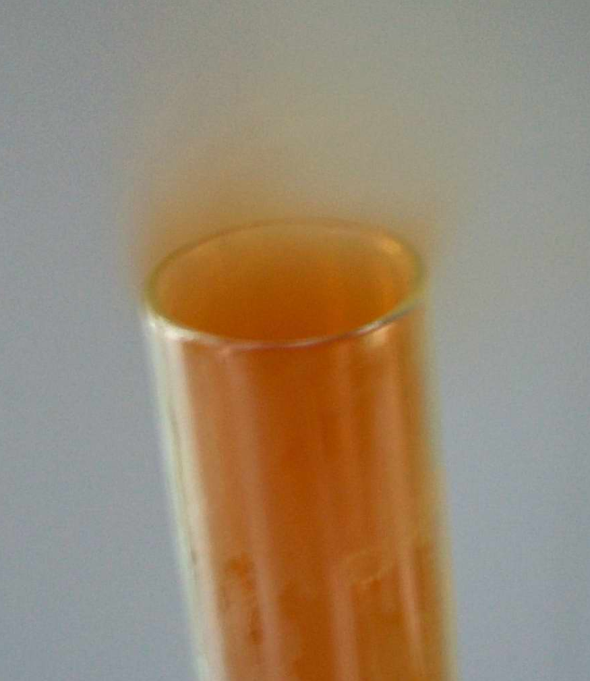
Nitrogen dioxide
Image courtesy of Fabexplosive; image source: Wikimedia Commons
Carbon monoxide (CO) is a colourless, odourless, very poisonous gas produced by incomplete combustion, in particular in petrol-fuelled vehicles. In fireworks, only trace amounts should be produced – unless the firework is badly constructed or the mixture is poorly incorporated, resulting in pockets of oxygen deficiency.
Many volatile organic compounds are released into the atmosphere by bonfires – the traditional accompaniment to fireworks on Guy Fawkes Night. The burning of plant-based material is known to produce a range of organic acids (e.g. methanoic acid, HCOOH), nitriles such as acetonitrile (CH₃CN), aldehydes (e.g. ethanal, CH₃CHO), ketones (e.g. propanone, CH₃C(O)CH₃) and alcohols such as methanol (CH₃OH). Fireworks themselves contain compounds such as sodium oxalate (giving a yellow colour to the firework), and the oxalate anion (C₂O₄²⁻) is found dissolved in aerosol particles as a result.
Particulate matter (PM) consists of tiny particles of solid or liquid suspended in a gas. They are categorised according to size as PM₁₀ (diameter 10 µm or less), PM_{2.5} (diameter of 2.5 µm or less), PM₁ (1 µm or less) and ultrafine (0.1 µm or less). Firework combustion produces a range of particle sizes but mainly smaller particles (e.g. PM_{2.5}) of soot, whereas bonfires can form larger particles. PM is also produced by the construction industry, and there are natural sources such as pollen, sea salt and wind-blown soil. Increased levels of particles in the air are linked to cardiovascular and respiratory diseases; smaller particles are particularly unhealthy because they can penetrate deeper into the respiratory system. PM also has a significant effect on the climate: soot particles warm the climate, whereas reflecting articles tend to cool it.
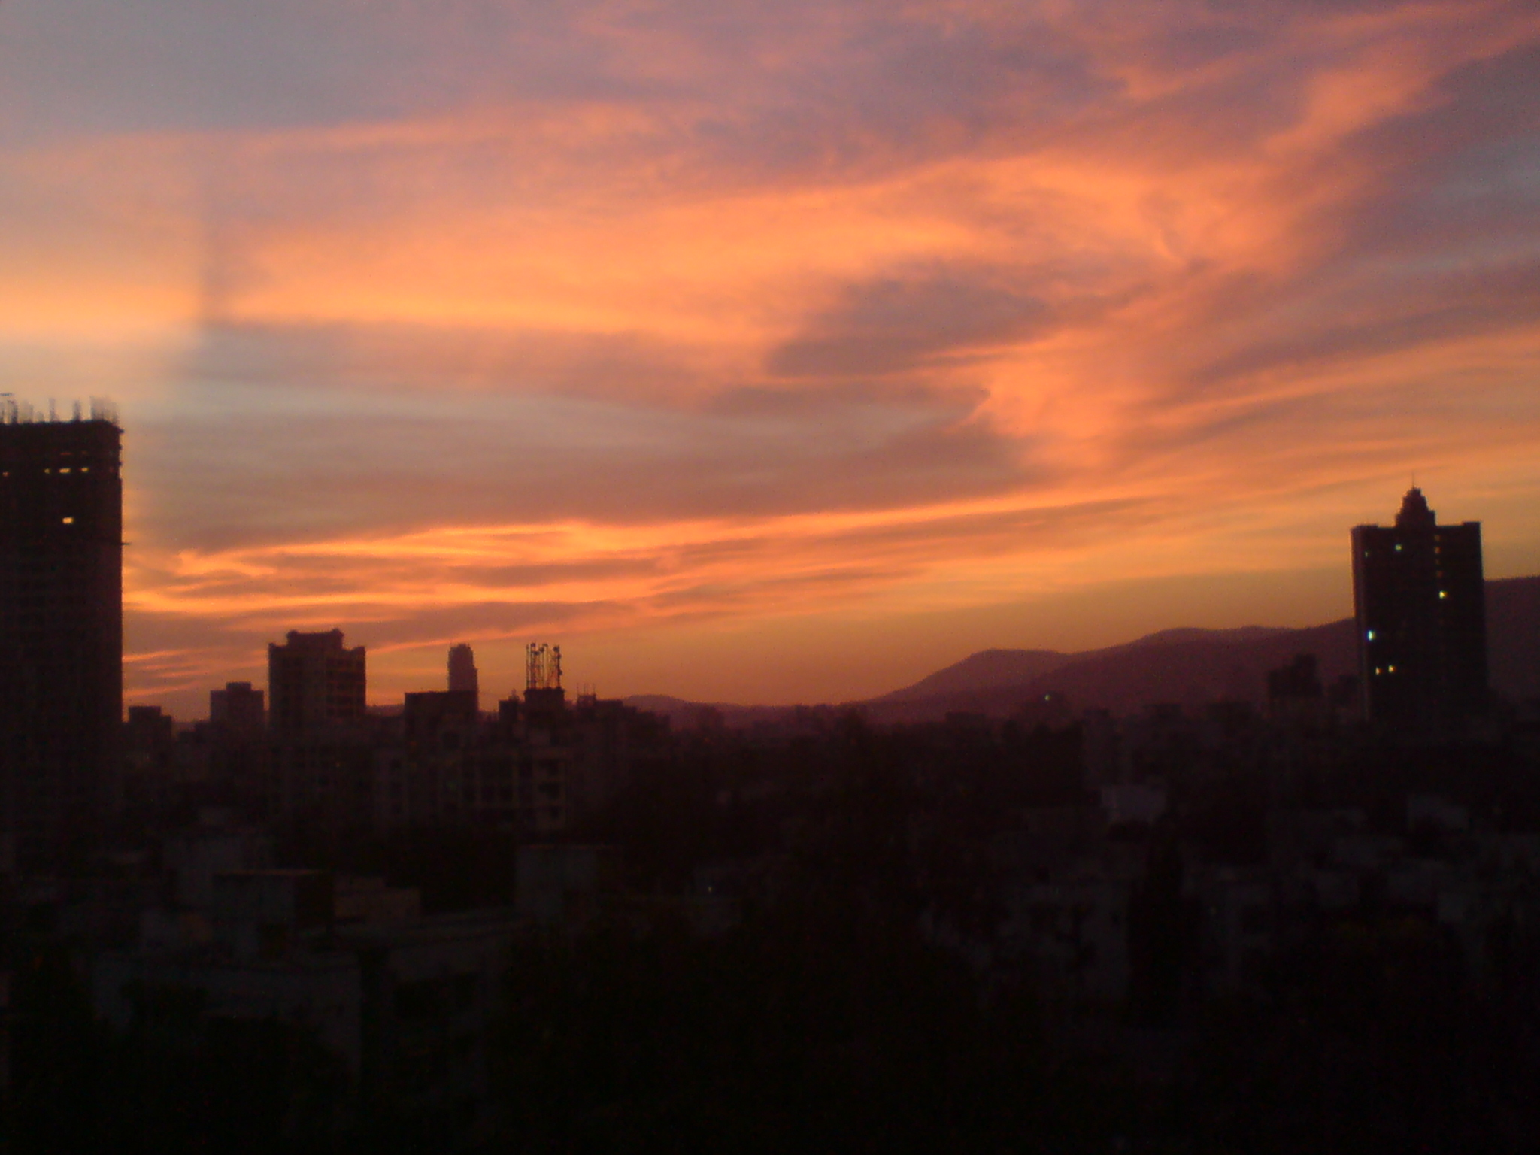
A beautiful sunset over Mumbai, India, caused by particulate matter in the air
Image courtesy of Bm1996; image source: Wikimedia Commons
Toxic metals such as lead (Pb²⁺) and copper (Cu²⁺) from the firework colourants also enter the air.

Reference
Harrison T, Shallcross D (2011) A hole in the sky. Science in School 17: 46-53. www.scienceinschool.org/2011/issue17/ozone

