Spring accelerometers
A spring accelerometer is a transparent plexiglass tube containing a small mass connected to two identical springs fixed to either end of the tube, with which we can measure the forces acting on this mass. As F(orce) / m(ass) = a(cceleration), with a constant mass, we measure a force per mass as a rough, but quick measurement of the instantaneous acceleration you are subjected to.
You can buy the instrument commercially^{w1} or build one yourself (see Unterman, 2001, page 54). Take a plexiglass tube, about 1–1.5 cm wide and 30–40 cm long (depending on the dimensions of the springs). Attach a small mass (lead or brass, ≈10 g) with rings at its ends to two equal springs. The elastic constant should allow the springs to expand 1–2 cm when you hang the mass vertically from them. Using a small hook with a ring, fix the other end of each spring to a plastic or rubber stopper. Attach a piece of elastic to one of the stoppers to fasten the accelerometer to your wrist.
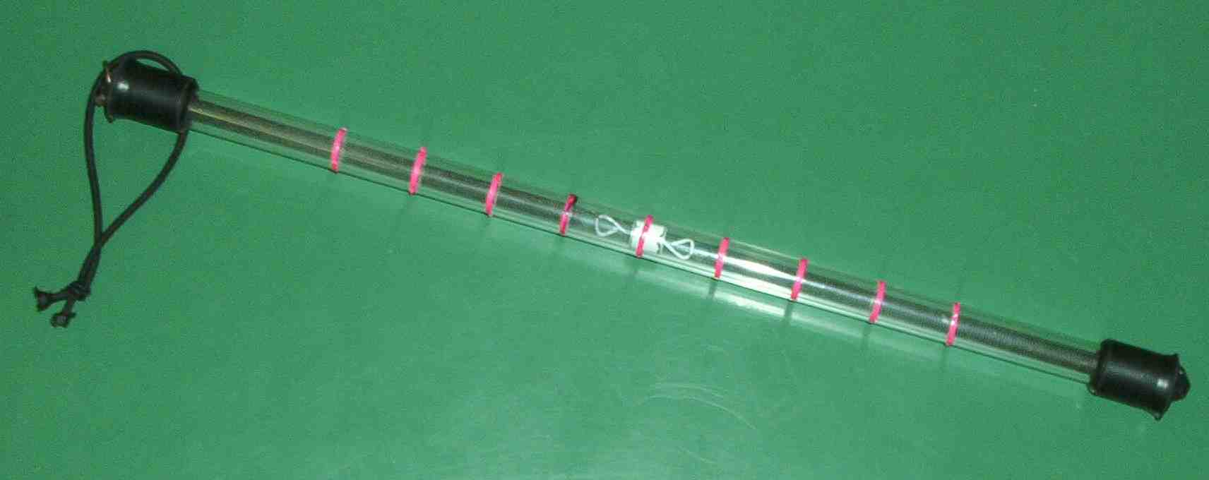
Image courtesy of Giovanni Pezzi
The instrument can be calibrated using the acceleration due to Earth’s gravity (g) as a unit. Hold the tube horizontally; the mass will be in equilibrium at the centre. We mark this position as 0 g (the red ring near the white mass in the image above).
Hold the tube vertically; now the position of the mass will correspond to the position of equilibrium between the force of gravity acting on the mass and the force of the upper spring, which is equal to the weight of the mass. So, in equilibrium, F/m = 9.8 m/s² or 1g. Again, mark this position with a red ring. Invert the tube, and mark the new symmetrical position; this will be -1g.
Measure the distance between 0g and +/-1g, and mark further equidistant positions along the tube, corresponding to +2g, -2g, +3g, -3g, etc.
You can use the instrument to measure acceleration in three directions: holding the accelerometer horizontally and perpendicular to the direction of motion, you can measure the centrifugal acceleration in bends; holding the accelerometer horizontally and parallel to the direction of motion, you can measure the longitudinal acceleration; holding the accelerometer vertically, you can measure the vertical acceleration on a slope or on a parabolic trajectory, where you experience weightlessness.

Handheld instruments
Handheld instruments^{w1} are important for real-time data collection, enabling students to measure atmospheric pressure and acceleration during the ride.
We have built a box containing a data collection kit. It contains a Calculator-Based LaboratoryTM system (CBL2, from Texas Instruments^{w2}), a portable, battery-operated data collection device, which we connected to a barometer and a low-g accelerometer for the measurements (both from Venier^{w1}), as well as to a TI graphing calculator (TI83, TI84 or TI89, from Texas Instruments^{w2}) for analysis.
The direction in which the acceleration is measured depends on the orientation of the accelerometer: on its cover there is an arrow indicating the direction of the acceleration being measured. To change the direction of measurement, simply turn the accelerometer around inside the box, which can then always be held with the calculator upright.
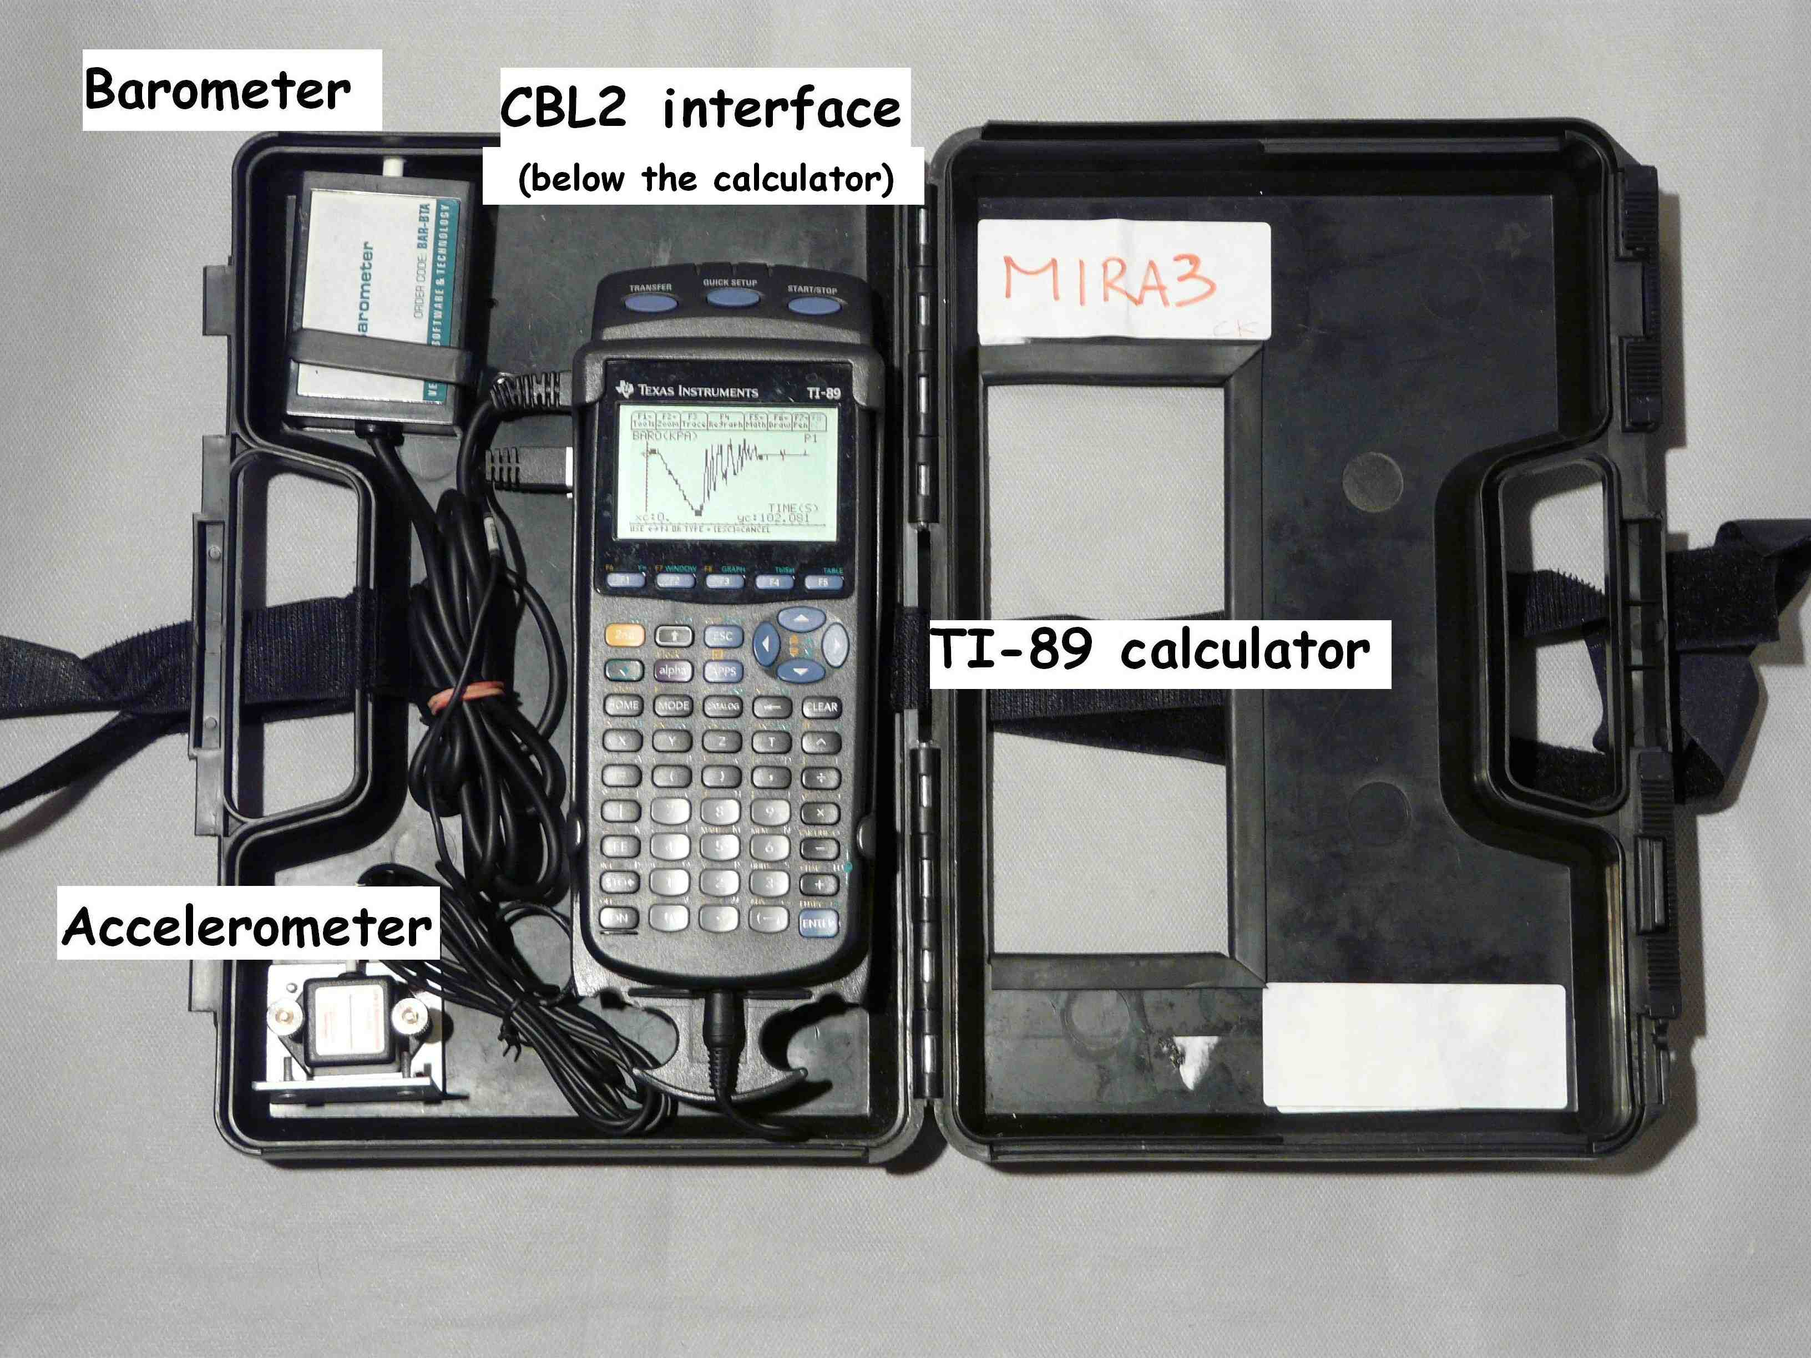
Our data collection kit
Image courtesy of Giovanni Pezzi
The instruments are placed inside a box that was the original container of the first CBL version, CBL1. We cut a rectangular hole into the box to be able to see and use the calculator even when the box is closed (see image below).
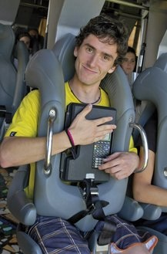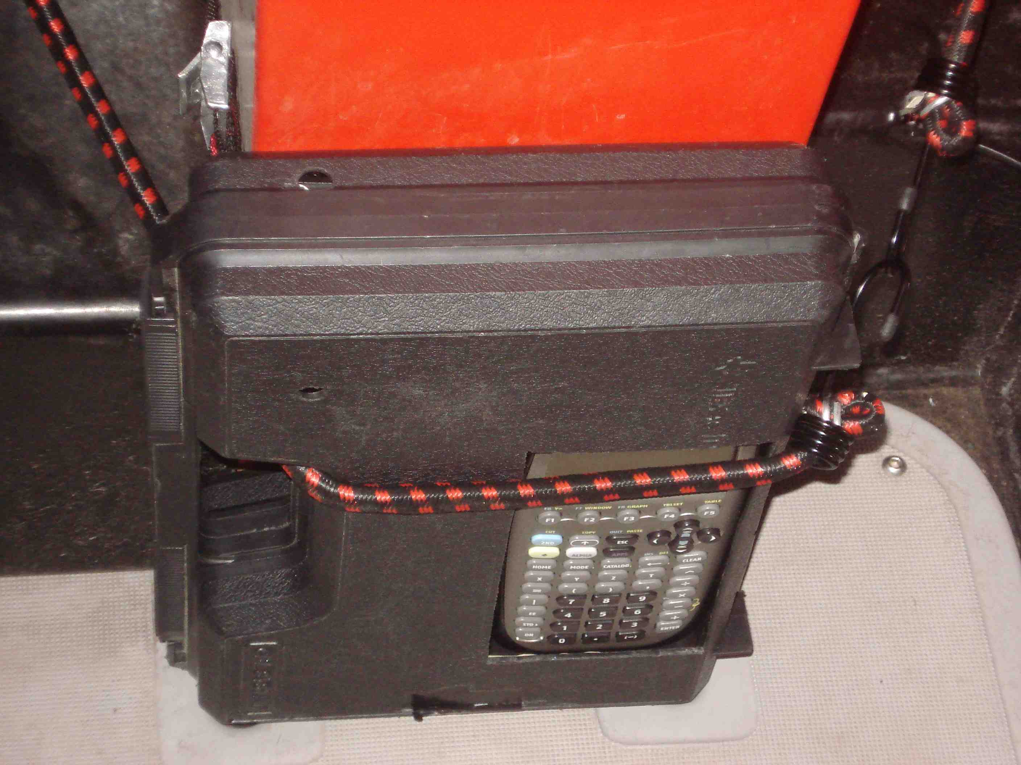
The data collection kit on board two different roller coasters, fastened either with Velcro straps (left) or elastic bungees (right)
Images courtesy of Mirabilandia (left) and Giovanni Pezzi (right)
Once the ride is over, observe and analyse graphs of the values recorded. The graphs allow you to link the effects you experienced on your body to measurements. Furthermore, by observing the graphs it is possible to better understand the structure of the roller coaster and how it works.
From the barometer we obtain a graph of pressure over time, which becomes, when reversed, a graph of altitude over time: every 0.1 kPa of pressure change corresponds to about 8 m of altitude change. For a more accurate description of the relationship between pressure and altitude, see the website of the atmospheric chemistry department of the Max Planck Institute for Chemistry in Mainz, Germany^{w3}.
Students are encouraged to observe the acceleration graphs to identify where the greatest forces are along the track and remember the effects they felt on their bodies.

Atmospheric pressure (blue) and altitude (red) over time on board the roller coaster Niagara, at Mirabilandia
Image courtesy of Mirabilandia

Longitudinal acceleration over time on board the roller coaster Ispeed, at Mirabilandia
Image courtesy of Mirabilandia

Vertical acceleration (blue) and altitude (red) over time on board the roller coaster Katun, at Mirabilandia
Image courtesy of Mirabilandia
The students then analyse the graphs further to identify different sections of the roller coaster (descents, loops), and connect these with the sensations they experienced (where they felt lighter or heavier during the ride).

Measuring the height of a drop tower or Ferris wheel
You can measure the height of the tower using various methods:
a) At a known distance from the base of the tower / Ferris wheel and while holding the instrument at a known height, use a sextant or a protractor to determine the angle between the ground and the top of the tower. Using trigonometry, you can calculate the height of the tower as h = d * tang α + p, where h: height of the tower; d: distance between the observer and the foot of the tower; tang: tangent; α: the angle measured; p: height at which the instrument is held.

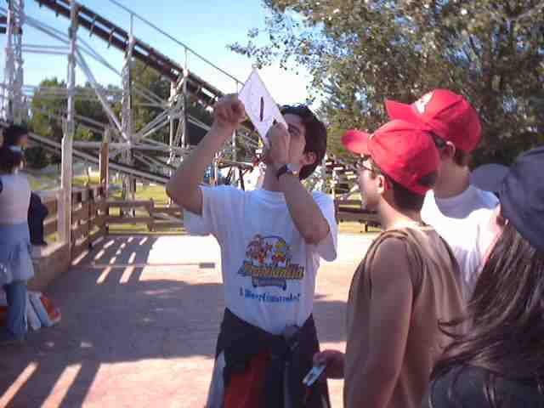
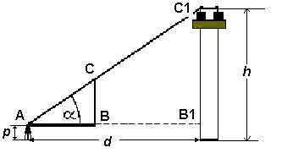
The height of a drop tower can be determined using a protractor
Images courtesy of Giovanni Pezzi (above) and Mirabilandia / Alessandro Foschi (below)
b) The same setup can be used to calculate the height of the tower / Ferris wheel geometrically. From the similarity of the triangles AB₁C₁ and ABC (see above), we deduce the proportionality of their sides which gives C₁B₁ = (AB₁ × CB) ÷ AB. Measuring the length of the sides AB and CB, we then get h = C₁B₁ + p, where h: height of the tower; p: height at which the instrument is held.

Foucault’s pendulum experiment on a carousel
Foucault first performed his experiment in Paris in 1851 to prove Earth’s rotation: the plane of the pendulum’s swing seems to rotate, completing a cycle in approximately 30 hours. In fact, it is Earth beneath the pendulum that is rotating. If we could observe its movement from a frame reference away from Earth, we could see that the plane of the pendulum’s swing does not rotate.
On a carousel, it is not only possible to recreate a similar experiment in about 30 seconds (the time it takes on the Mirabilandia carousel), but you can also leave the rotating frame of reference (the carousel).
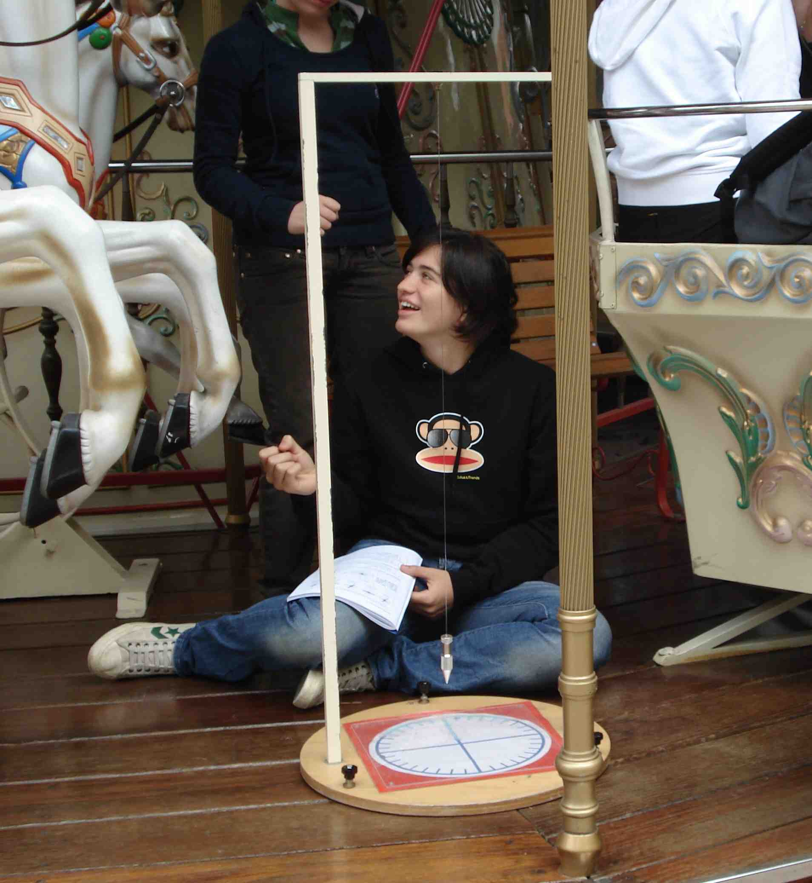
Image courtesy of Giovanni Pezzi
Let a pendulum swing on board the carousel that is turning – the plane of its swing will appear to rotate. A student on board, close to the pendulum, will observe the swinging; every quarter of a turn, he or she records the direction of the plane of the pendulum’s swing. After a complete turn, the sketch will look like this:
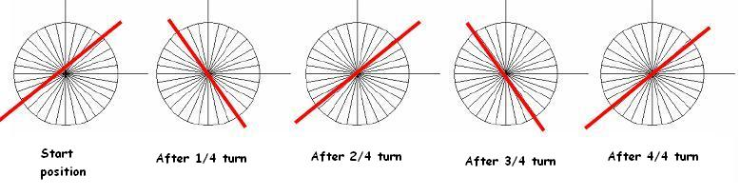
Image courtesy of Mirabilandia / Alessandro Foschi
At the same time, four other students (1-4) are positioned around the carousel, every 90° around the platform:
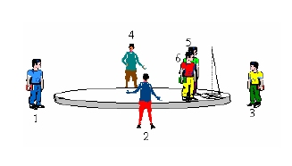
Image courtesy of Mirabilandia / Alessandro Foschi
When a student sees the pendulum passing in front of him / her, he / she observes accurately the direction of the swinging plane, and records it (only once). The sketch produced will look like this:
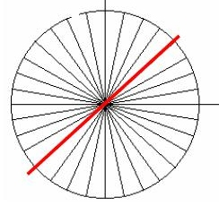
Image courtesy of Mirabilandia / Alessandro Foschi
When the carousel stops, the four students who were positioned around the carousel go to a table and position their sketches at 90° angles, just as they were positioned around the carousel:
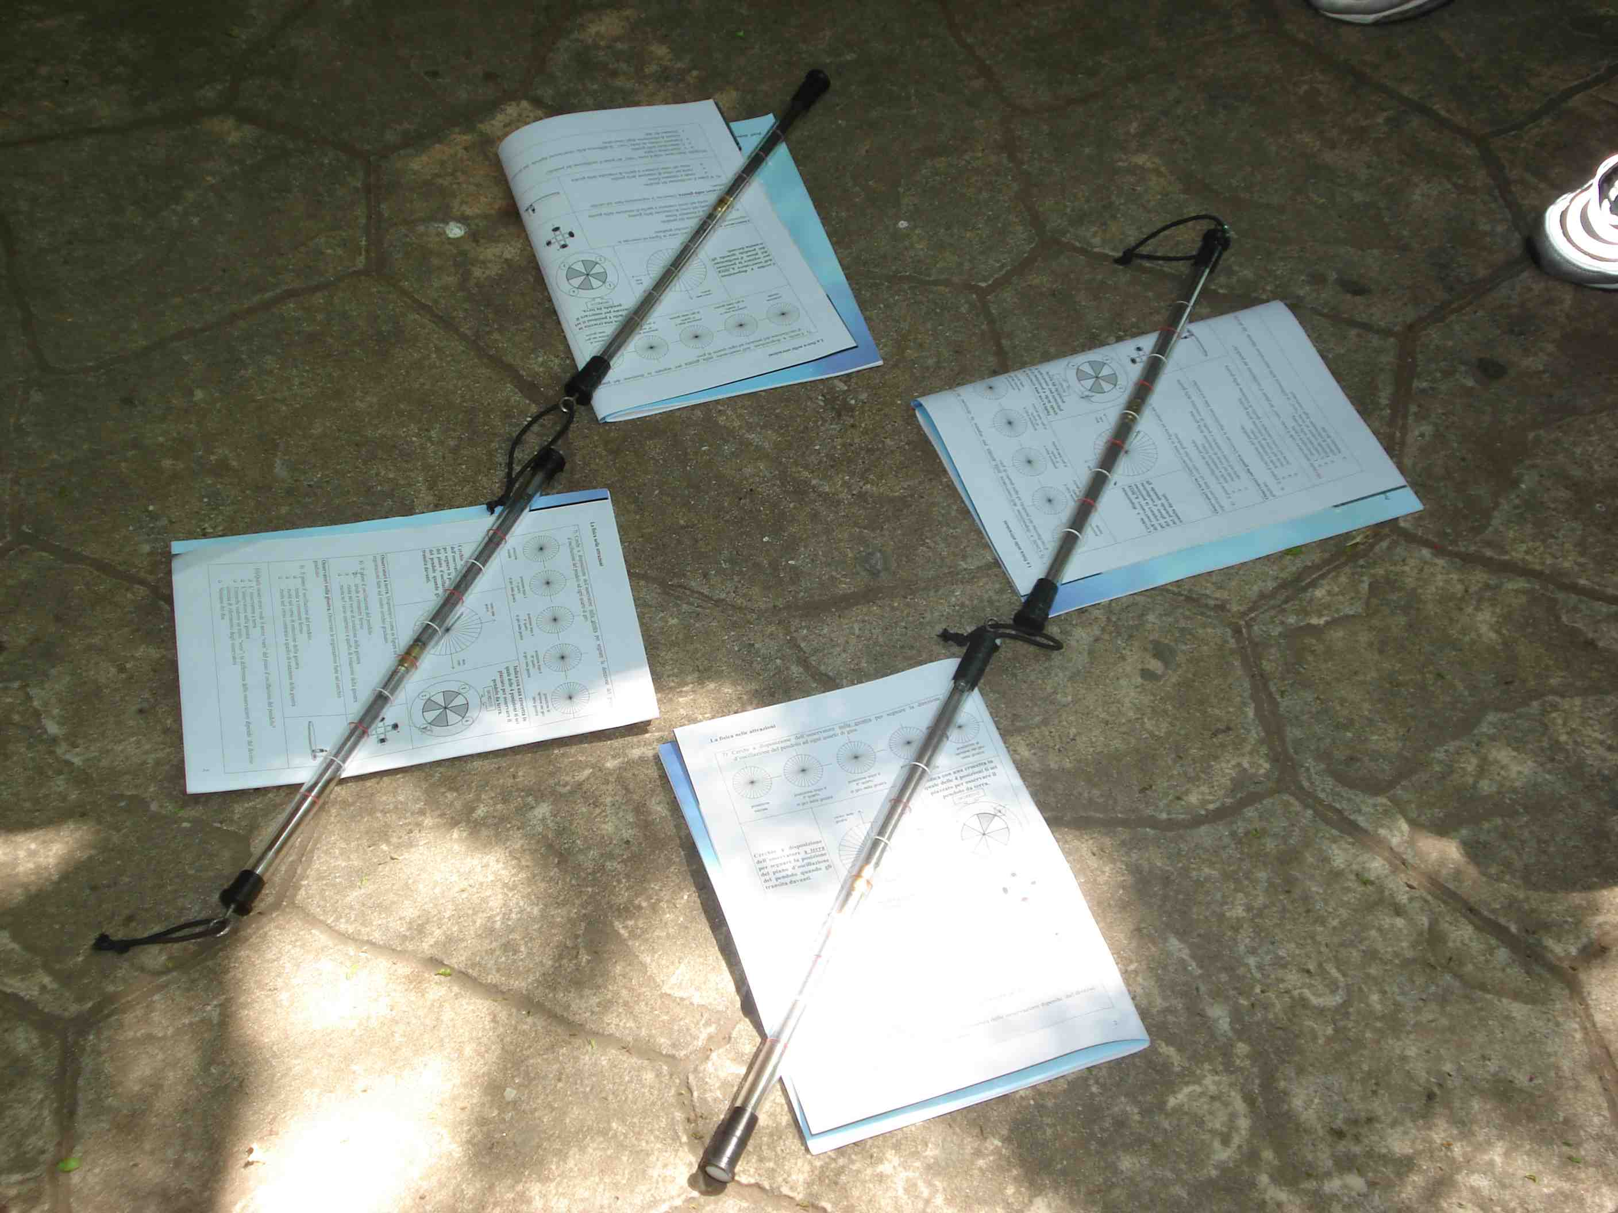
The workbooks indicate the direction in which each student faced; the accelerometers (sticks) indicate the recorded plane of swinging for the pendulum
Image courtesy of Giovanni Pezzi
You can now see that the direction of the swinging plane did not change during the rotation of the carousel.
To an observer on board the carousel the plane of the pendulum’s swing appears to rotate, as it does to an observer of Foucault’s original pendulum experiment in the Pantheon in Paris, France, who is ‘on board’ the rotating Earth. Observing the pendulum’s swing from outside the carousel is as if you were to observe Foucault’s experiment from a point outside Earth.

Demonstrating the Coriolis effect on a carousel
To demonstrate the Coriolis effect, you will need to build a small fountain: mount a transparent cylinder on a wooden box, attach a tap at the bottom, and fill the cylinder with water.
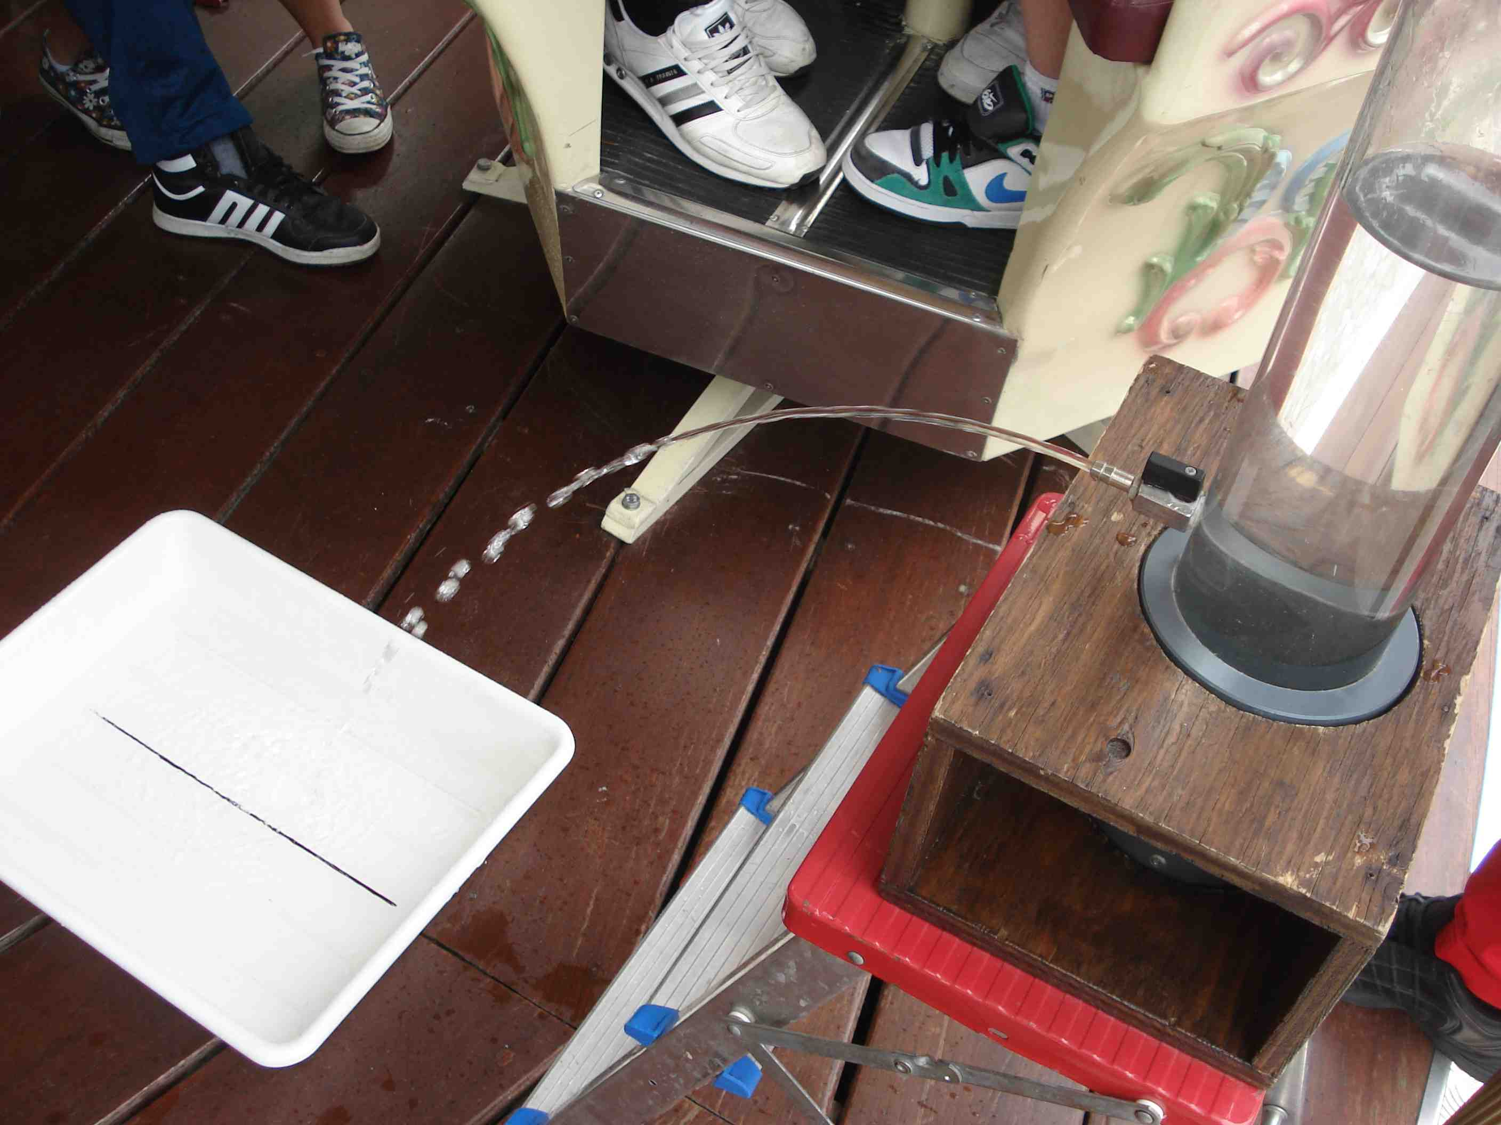
Image courtesy of Giovanni Pezzi
On the carousel, place the fountain on top of a step ladder and a basin in front of it, which has a straight line drawn across its bottom. Arrange it so that the jet of water will face away from the carousel’s centre, i.e. radially. Make sure that when you open the tap, the water will hit the line in the basin.
While the carousel stands still, the direction of the water jet is along a radius of the carousel’s platform. When it moves, the water begins to curve off in a lateral direction:
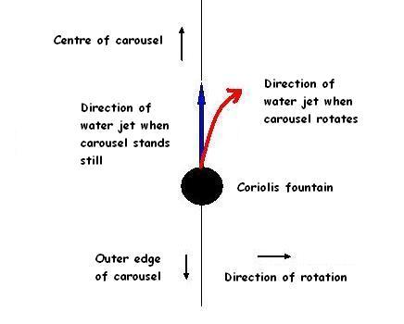
Image courtesy of Mirabilandia / Alessandro Foschi
A similar set of experiments was presented at Science on Stage 2005 on a smaller rotating platform^{w4}.

Web references
w1 – The US companies Vernier and Pasco offer dedicated measuring instruments for use in amusement parks, which come with a full set of instructions and activities. See:
www.vernier.com/cmat/datapark.html
www.pasco.com/physhigh/amusement-park-physics
w2 – Texas Instruments offers calculators and interfaces suitable for linking up to measuring instruments used on roller coasters and drop towers. See: http://education.ti.com/educationportal/sites/US/productDetail/us_cbl_2.html
w3 – For the relationship between atmospheric pressure and altitude, see the website of the atmospheric chemistry department of the Max-Planck-Institute for Chemistry in Mainz, Germany (www.atmosphere.mpg.de) or use the direct link: http://tinyurl.com/pressure-altitude
w4 – To learn more about the experiments on a small rotating platform and watch a video about them (in Italian), see: www.rcs.mi.cnr.it/scuola2.html

Reference
Unterman NA (2001) Amusement Park Physics: A Teacher’s Guide. Portland, ME, USA: J Weston Walch. ISBN: 9780825142642

