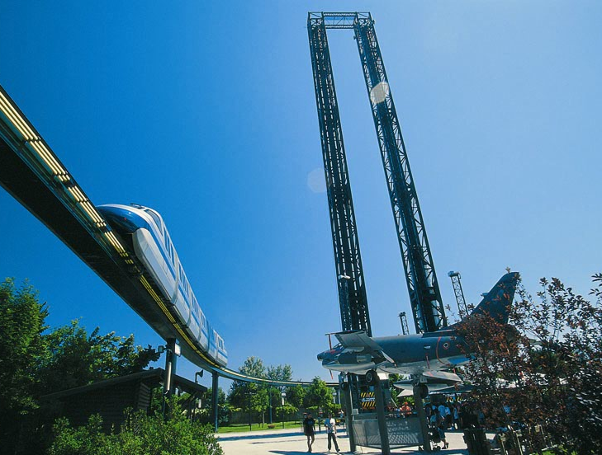
Drop towers:

DISCOVERY and COLUMBIA

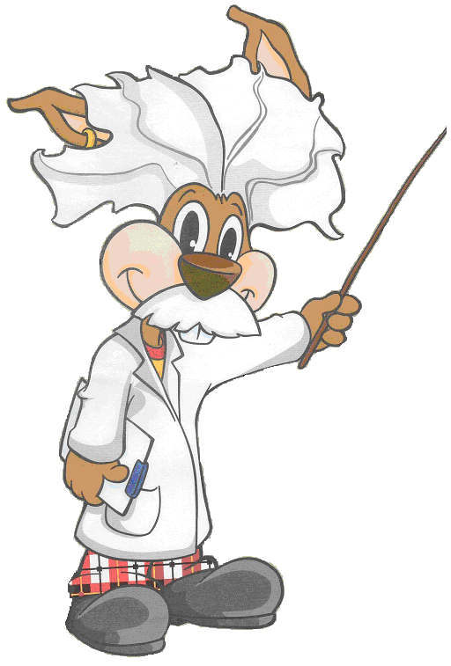 | Observations and measurements on board
Your sensations and the spring accelerometer

- For the two positions indicated by the arrows, note down changes to how heavy you felt during the first descent (Discovery) or ascent (Columbia).  (heavier, +; normal, =;  lighter, –; weightless, 0). | Which tower did you ride?  Discovery – Columbia  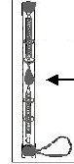    | - For the two positions indicated by the arrows, during the first descent (Discovery) or ascent (Columbia) record the mass of the accelerometer: was it fixed, above zero, or below zero?
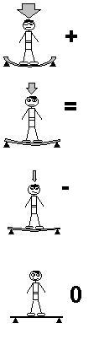 |  | Level  zero
- What is the maximum value that the accelerometer reached?
- What forces act on the mass of the accelerometer when it is at rest?

Roller coaster KATUN

 | 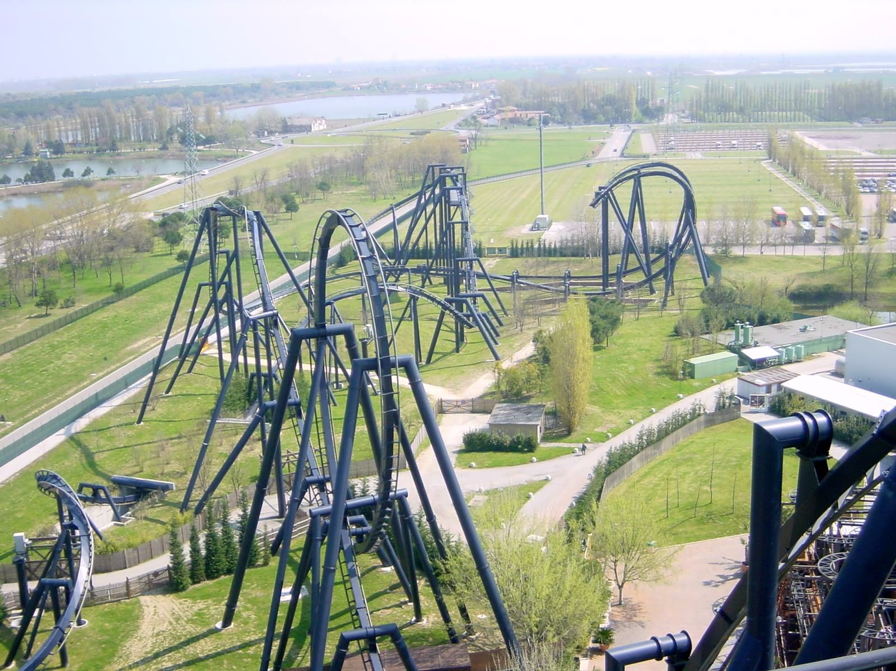 |  |  | Useful numbers  Length of train = 12.72 m  Departure angle = 25°  Highest point of ascent = 46 m  Height at start of descent = 43.5 m  Height of loop = 34 m  Length of track = 1200 m  Mass = 32 passengers x 75 kg = 2400 kg
 |  | Observations and measurements on board: your sensations
- During the ascent, in which direction(s) did you feel pushed?
- Forwards and down  - Backwards and down |  |  |  |  | - Sideways and down  - Up
- At the top of the ascent, how heavy did you feel?
Heavier than normal |  |  | Lighter than normal |  |  | Weightless | Normal
- At the beginning of the descent, how heavy did you feel?
Heavier than normal |  |  | Lighter than normal |  |  | Weightless | Normal
- At the end of the descent, how heavy did you feel?
Heavier than normal |  |  | Lighter than normal |  |  | Weightless | Normal
- In the vertical loop, in which direction did you feel pushed?  - Sideways  - To the inside  - To the outside  - Backwards |  |  |  |  |  | - What happened to your body during the  braking at the end of the ride?  - It moved forwards  - It moved sideways  - It moved back  - There were no sudden movements

 | - After the loop came a twist. How did this make you feel?
 | 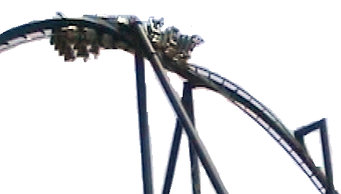 |  |  |  | Heavier |  | Lighter |  |  | Weightless |  | Normal
- The following images show the roller-coaster carriage at three different positions on the loop.
At each one, how did you feel?
 | 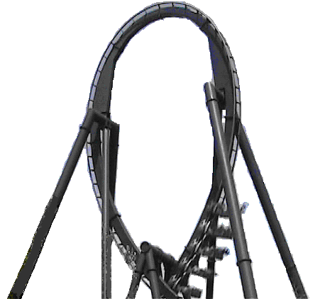 |  |  | Heavier |  | Lighter |  |  | Weightless |  |  |  | Normal
 | 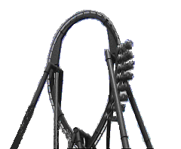 |  |  | Heavier |  | Lighter |  |  | Weightless |  |  |  | Normal
 | 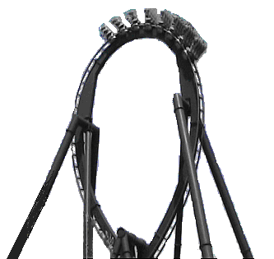 |  |  | Heavier |  | Lighter |  |  | Weightless |  |  |  | Normal
 |  |  | On the ground
- Draw a sketch of the roller coaster’s height profile, including the ascent, the loop
and the subsequent section (with the twist)

- During the first ascent, what best describes the motion of the train?
- Uniform angular velocity  - Varied |  |  |  |  |  |  |  | - Uniform velocity  - Uniform acceleration

Roller coaster ISPEED
Energy in action
- Specify which forms of energy (kinetic, gravitational potential, electric, etc.) are
transformed during the ride.

- At what point during the ride is the potential gravitational energy at its maximum? |  | - Specify at least three sources  of friction on the ride.
- At the start, the roller-coaster carriage acquires significant kinetic energy. What is its source?
- To describe the process of energy transformation at the indicated points of the ride, shade the bars of the histograms below as appropriate.
 | Top
Mid-ascent | 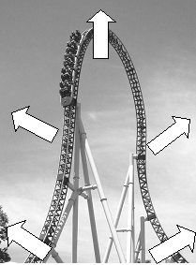 |  | Mid-descent
Start of ascent |  |  | End of first descent
- Determine the total mechanical energy of the roller-coaster carriage at the top of the first slope.
- Determine the required starting speed of the roller-coaster carriage on the ascent to arrive at the top.
- What is the minimum work that the driving motor has to exert at the start for the train to reach the top of the first slope? What is the minimum power that it has to develop?

Ferris wheel EUROWHEEL
Real-time measurements

Blaise Pascal (1623–1662), a French mathematician, physicist, philosopher and theologian, made important contributions to the study of liquids and, in particular, to the definition of the concept of pressure. |  | 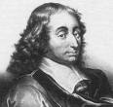
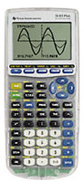
- Observe the graph of atmospheric pressure over time on the calculator's display and reproduce it here.
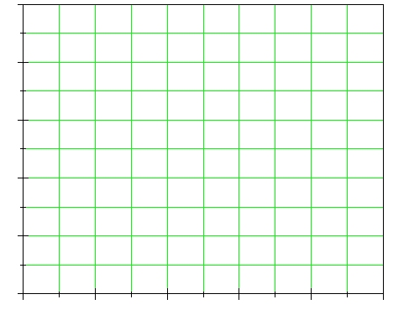
- Moving along the calculator's graph, find point A corresponding to the departure, and indicate it in the above sketch.
Which time point does it correspond to? Δt₁ = ……………….s
What is the value for the atmospheric pressure? p₁ = …………….….kPa

- Identify point A corresponding to the arrival and indicate it in the sketch.
Which time point does it correspond to? Δt₂ = ………………..s
What is the value for the atmospheric pressure? p₂ = ………….…….kPa

- How much time has passed between the two events? | Δt = t₂ – t₁ = ………..……..s
- Does this correspond to the wheel’s rotation period which you have timed?

The carousel
The pendulum’s movement
Preliminary measurements:

- Time the pendulum’s period when the carousel stands still.  Tp = ………………..s |  |  | 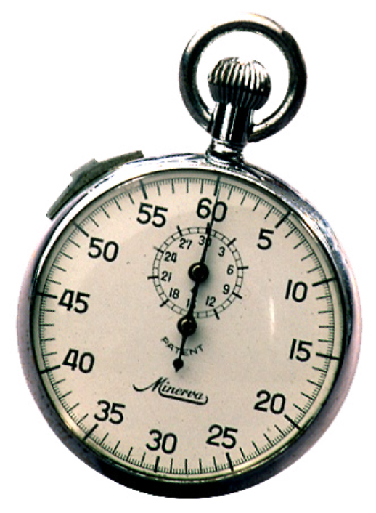 |  | - Time the rotation period of the carousel.  Tc = ……………….s
- Measure the pendulum’s length.  L =……………………m |  |  |  | - Calculate the pendulum’s length using the period formula ($T=2π\sqrt{L/g}$).  L =……………………m
- Compare the measured and calculated lengths. Which do you think is more precise and why?
Observing the pendulum’s swing:

- Mount the pendulum so that when the carousel stands still, its tip falls exactly in the centre of the goniometer (angle meter) below. When the carousel moves, you will see that the pendulum does not pass through the goniometer below. What explanation can you give for this? If you can, determine theoretically the amount of this deflection, i.e. the pendulum’s position of equilibrium with respect to the goniometer when the carousel is moving.

Position yourselves as in this diagram.  Follow the instructions. | 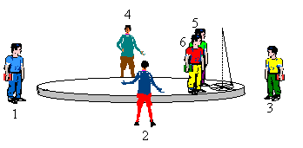
- Indicate the direction of the pendulum’s swing after each quarter turn from the point of view of the observer on the carousel.
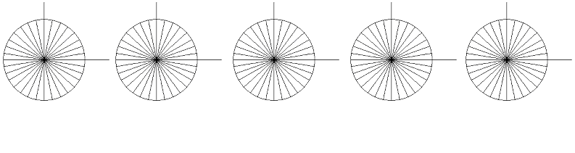
Initial Position after 1st quarter Position after 2nd quarter Position after 3rd quarter Position at the end
position turn of the carousel turn of the carousel turn of the carousel of the carousel’s turn
Indicate the direction of the pendulum’s swing when it passes from the point of view of the observer on the ground. |  | Centre of  carousel  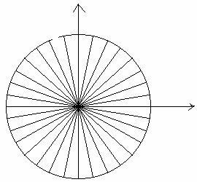  Direction of  carousel’s  turn |  |  |  | Mark with a cross where you have positioned yourself to observe the pendulum from outside.  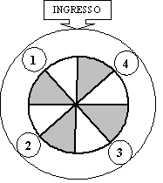
Observers on the ground. Position yourselves as indicated in the diagram and take a look at your observations noted on the graded circle.  - What happens to the pendulum’s plane of swing?  - It remains unchanged  - It turns in the same direction as the carousel  - It turns in the direction opposite to that of the carousel |  |  |  |  |  |  | 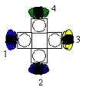
Observers on the carousel. Take a look at your observations noted on the graded circle.  - What happens to the pendulum’s plane of swing?  - It remains unchanged  - It turns in the same direction as the carousel  - It turns in the direction opposite to that of the carousel |  |  |  |  |  |  | 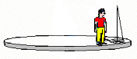
- Which observer sees the ‘true’ motion of the pendulum’s plane of swing?
- The observer on the ground
- The observer on the carousel
- Between the two they see a ‘real’ motion: the difference between the observations depends on the different reference systems of the observers
- Neither of the two

Water coaster NIAGARA

Find out….….how long the start section is, ….at which speed the boat moves
- The start section  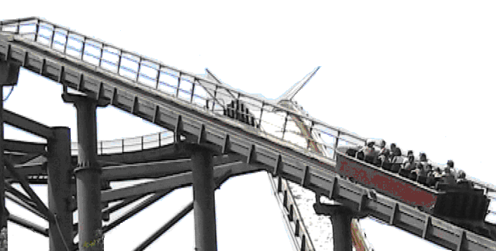  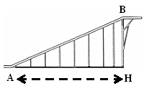 |  | Calculate the length (AH) of the base of the start section.  The distance between each pair of metal pillars is 7.620 m.
 |  | Determine the length of the start section of track (AB).
 |  | Measure the starting time of the boat. Start the stopwatch when the boat’s prow (front) begins to move and stop it when the prow reaches the last pillar.
 |  | Δt_{1AB} = ............s |  | Δt_{2AB} = ..............s |  |  | Δt_{3AB} = .........s
 |  | Average time |  | Δt_{AB} = …………s
 |  | Average speed of the boat |  | v_{AB} =………...m/s
- The circular section  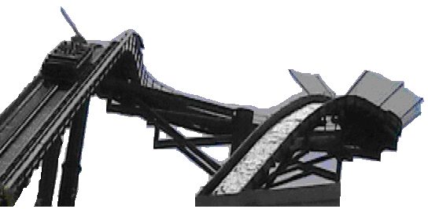 | Measure the time that the boat needs to pass through the circular section, from the moment at which the boat’s prow enters the section until the point at which it exits.
 | Δt_{1C} = .............s |  | Δt_{2C} = ................s |  |  |  | Δt_{3C} = ...........s
 | Average time |  | Δt_{C} = …………s
 | Calculate the length of the circular track. The boat traverses an angle of 250° on a circumference with a radius of 9.14 m |  |  |  |  |  | Δl_{circle} = …....m
 | Average speed of the boat |  | v_{C} = ………...m/s
- The descent  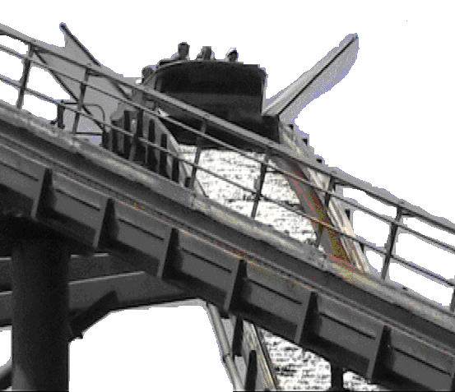 |  | Measure the time of the boat’s descent from the top to shortly before it hits the water. Start the stopwatch when the boat’s prow passes beneath the signpost at the end of the circular track.
 |  | Δt₁ = ................s |  | Δt₂ = ....................s |  | Δt₃ = ................s
 |  | Average time |  | Δt_{descent} = ……s
 |  | Average speed of the boat. The descent is 54.30 m long. |  |  | v_{descent} =…….. m/s

