Heater meals: redox reactions, passivation and local element

Background
You are a researcher for a scientific television programme. The producers of the show often receive questions from viewers, questions that are answered experimentally during the programme.
One of the questions sent in is:
“While browsing the Internet, I came across a product that caught my attention – self-heating meals. I read that individual meals are wrapped in a bag containing magnesium, and that if you pour salt water into this bag, the bag begins to inflate, steam is produced and the food heats up.
“Allegedly, a dangerous gas and a ‘lye’ are formed during the reaction. Can you tell me if this is true?
“Also, I have tried making such a bag myself, pouring salt water onto magnesium, but it didn’t really work. Where did I go wrong?”

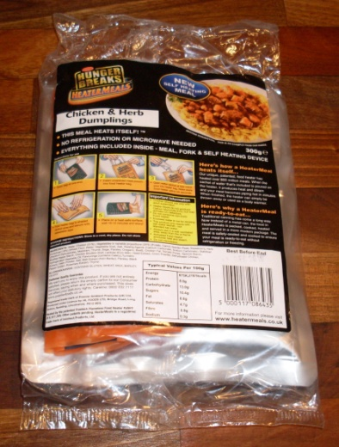
Image courtesy of Gregor von Borstel
As a television researcher, you are asked to investigate the reaction in the heater meal and to write a script for the presenter of the programme.

Instructions
Your task is to develop a script for the programme.
- Conduct experiments to identify which products are formed during the reaction. See note 1, overleaf, for details of how the heater meal works.
For safety reasons, the experiments will be planned together with the teacher and then performed in groups.
Speculate which chemical reaction supplies the energy required to heat the meal. Note that the television presenters will need concrete reaction equations.
Hint: the salt in the salt water is not important for the reaction equation.
- Using magnesium and salt water, try to perform the heater-bag reaction in a test tube. If the experiment does not work, explain why not (see note 2)
- How does the manufacturer solve this problem? (see note 3)
- Draw a storyboard (see note 4), a short cartoon sequence explaining the reactions in the local cell at the molecular level.
- Write up a script for the television presenter. Include a conclusion that focuses not only on the function of heater meals but also on wider related issues, e.g. ecological (disposable materials) or social (who might use this product, which was developed for the army?).
The whole class will pretend to be the team researching, producing and presenting the television programme. Present your manuscript to the team and explain how you would make an entertaining and instructional programme on the topic of heater meals.

Notes

1. Product description
Open the packaging and remove the contents, then place the unopened aluminium bag containing the meal into the ‘heating bag’ which contains a magnesium compound. Pour the contents of the small bag of liquid into the heating bag, fold the top of the bag over and close it with the tape strip provided. The bag will start to heat up. Wait 10-12 minutes and the meal will be hot and ready to eat.
Safety note: remove the meal carefully as the heater bag, salt water and meal will be hot (100 °C). Taking care not to burn yourself, pour the liquid down the sink; once cool, the heater bag can be safely disposed of in household waste and the rest of the packaging recycled.
(Translated from the supplier’s website (www.dauerbrot.de). Website accessed on 22.11.2010. Translation by Marlene Rau)

2. Passivation
Passivation denotes the formation of slow-reacting surfaces on normally very reactive metals, which prevents the underlying metal from corroding as quickly as normal. Passivation occurs with many reactive metals such as magnesium or aluminium, because the metals react to form an impermeable and strongly adhering surface layer of oxides or hydroxides. As a result, the metals are unaffected by chemicals with which they would otherwise react strongly - their behaviour is similar to that of noble metals such as gold.
Translated and adapted from www.chemgapedia.de/vsengine/popup/vsc/de/glossar/p/pa/passivierung.glos.html

3. Local cells
When two metals of different reactivity are in contact and are dipped into water or acid, the less reactive metal will corrode much faster than usual. This is because in such ‘local cells’, oxidation and reduction reactions occur in separate places.
For example, when in contact with a less reactive metal, magnesium forms magnesium cations (Mg²⁺) in water. The electrons released by the magnesium flow through the less reactive metal and into the water, leading to the formation of hydrogen (H₂) and hydroxide ions (OH⁻) at the surface of the less reactive metal, rather than on the magnesium surface. Therefore, a ‘protective layer’ of magnesium hydroxide cannot form on the magnesium, and there is no passivation.
This principle is used in self-heating meals: using a magnet, you can demonstrate that the heater bag contains iron as well as magnesium.

4. Storyboards
A storyboard is a sequence of drawings, typically with some directions and dialogue, representing the shots planned for a film or television. Since teamwork is required to produce a film, ideas are first collected on paper as drawings and texts. The resulting flow of images can be refined until filming starts, helping everyone involved to effectively communicate their ideas.
Overleaf is a possible design.

My storyboard
Project……………………………………………………….
Page number.......
………………………………………………...
………………………………………………...
………………………………………………...
………………………………………………...

