Student worksheet
One set of 14 strips represents the chromosomes from the mother (female) dragon. The other, differently coloured set, represents the chromosomes from the father (male) dragon.
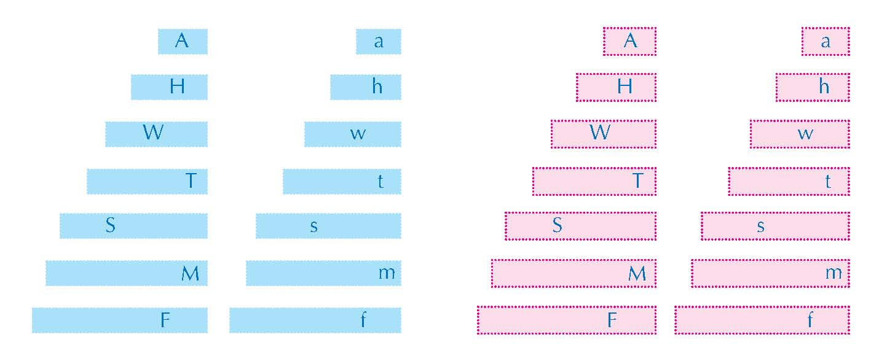Each chromosome strip has a letter, which may be either upper or lower case. The upper-case letters represent dominant alleles, and the lower-case letters represent recessive alleles. Each pair of letters codes for a trait. If at least one dominant allele (upper-case letter) is present, the dominant trait will occur (e.g. the dragon can breathe fire); the recessive trait (e.g. inability to breathe fire) will only occur if the dragon has two copies of the recessive allele.
- Sort the chromosomes so that they are matched into pairs of the same length and letter of the alphabet. You should have seven chromosome pairs for each colour (blue for male, pink for female).
The traits encoded by the letters are as follows:
- F and f represent whether or not the dragon breathes fire
- M and m represent the number of toes
- S and s represent the number of tail spikes
- T and t represent the colour of the tail
- A and a represent the colour of the body
- W and w represent the colour of the wings
- H and h represent whether or not the dragon has a horn.
- Take the longest pair of male chromosomes (blue) and the longest pair of female chromosomes (pink) and place them face down on your desk so that you cannot see the letters.
- Without turning the chromosomes over, pick one of each colour and put them together to form the chromosome pair for the baby dragon. Discard the remaining pair of chromosomes.
- Repeat steps 2 and 3, moving from the longest to the shortest chromosomes, until you have seven new chromosome pairs, each consisting of one pink and one blue strip.
- Turn over the seven pairs of chromosomes of the new baby dragon. For each pair, record the letter on the blue chromosome in the ‘Male gene’ column in Table 1 and the letter of the pink chromosome in the ‘Female gene’ column. Be sure you copy the letters exactly, noting whether they are upper or lower case.
- Return all the chromosomes to their proper bags.
- Record which alleles (letters) your dragon has for each trait, and enter them in the second column of Table 2. We refer to the two alleles inherited for a particular gene as the genotype (e.g. TT). The observable traits of an individual (e.g. a red tail) are known as the phenotype.
- Refer to Table 3 to determine which alleles are dominant or recessive for each trait, then enter the phenotype of your dragon in Table 2.
- Now you are ready to draw your baby dragon: colour and add the relevant body parts to the basic dragon picture (which can also be downloaded from the Science in School website^{w1}). See Table 3 for suggestions as to how the additional body parts can be drawn.

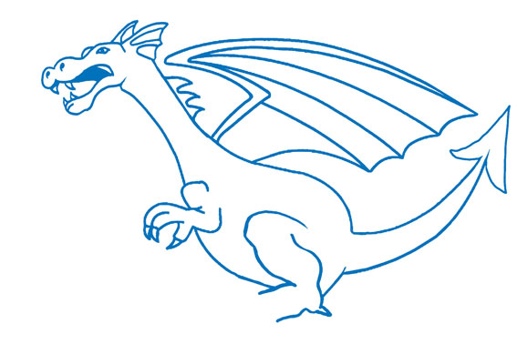
The basic dragon picture
Image courtesy of Nicola Graf

Male gene (blue) | Female gene (pink)
Table 1: The genes your dragon has inherited from its parents

Trait | Genotype | Phenotype
Fire/No fire (F/f)
Toes (M/m)
Spikes on tail (S/s)
Tail colour (T/t)
Wing colour (W/w)
Horn/no horn (H/h)
Body colour (A/a)
Table 2: Genotype and phenotype of your baby dragon

Genotype | Phenotype
FF or Ff | Breathes fire
ff | Does not breathe fire
MM or Mm | Four toes | 
mm | Three toes (all dragons have at least three toes) | 
SS or Ss | Five spikes on tail
ss | Four spikes on tail (all dragons have at least four tail spikes)
TT or Tt | Red tail
tt | Yellow tail
WW or Ww | Red wings
ww | Yellow wings
HH or Hh | Horn | 
hh | No horn | 
AA or Aa | Blue body and head
aa | Green body and head
Table 3: Translating the dragon genotype into the phenotype

Analysis
- Compare your dragon to other dragons around the room. What differences and similarities do you see?
- How do you explain these differences, given that the dragons all had the same parents?

