Building an atomic force microscope in school
Atomic force microscopy is a cutting-edge imaging technique used in the lab. Physics and chemistry teacher Philippe Jeanjacquot helps you take it to the classroom.

How to build the microscope
It took us about 2 years to develop the atomic force microscope (AFM), but with our instructions and software, you should be able to build it in about 2-3 hours per week over about 3 months.
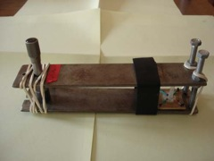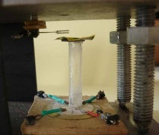
Our AFM: the sample is mounted on top of a glass tube, on a scanner moved in 3D via four quarters of a piezoelectric element (at the bottom of the right-hand image). A sharpened tungsten tip attached to a quartz tuning fork at resonance frequency is used to read out the sample’s surface height measurements as the current changes in the quartz tuning fork (top left of right-hand image). Both are attached via magnets to a stand with adjustable screws (left-hand image)
All images courtesy of Philippe Jeanjacquot
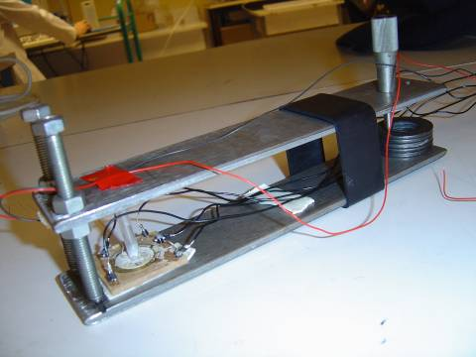
The first version of the AFM
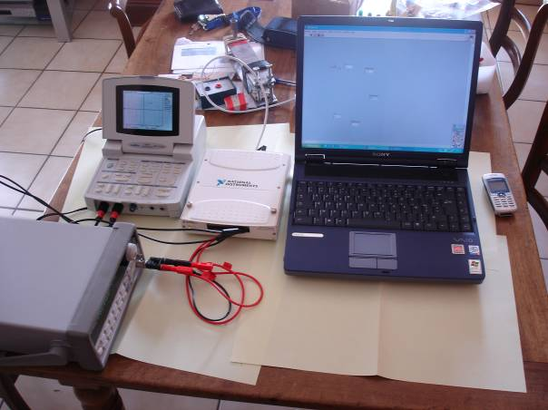
Our first setup (from left to right): the signal generator, the oscilloscope, the National Instruments (NI) DAQcard and the computer. In the background, you can see the actual microscope stand. To use the microscope, it needs to be placed on the floor – on top of a table, the vibrations are too strong

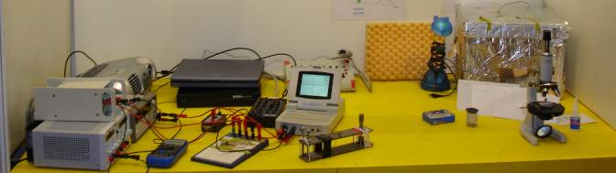
The full setup (from left to right): two power supplies, the signal generator with a projector for demonstrations (optional) on top, the NI DAQcard (in black) with the computer on top, the current card (the two small black boxes and one black and white box in the centre), the oscilloscope (with the screen) and the microscope stand. The small blue box is an optional instrument used to check the current. It is not part of the actual circuit / setup. On the right-hand side, you can see the microscope and glue we use for preparing the tungsten tips and an aluminium foil-covered cardboard box with insulating expanded polystyrene inside, which we used to isolate the microscope stand from vibrations and the electromagnetic field. Because we did not notice better performance when using the box and we realised that the current used is in fact strong enough and is not disturbed easily by further electromagnetic fields, we stopped using the box
It is essential to be accurate and careful when building the microscope. This is a good exercise for students. A lot of the time required is to practice manual skills for building some of the parts, which will probably not work the first time around.
You will need to build:
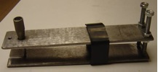 | A stand with two adjustable screws and a micrometer screw for fine tuning
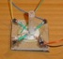 | A flat piezoelectric buzzer scanner with a glass tube to mount the sample
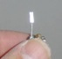 | A sensor with a quartz tuning fork and a tungsten tip
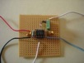 | A card to measure the current

The stand

Materials
- Two rectangular pieces of iron, each 30 x 5 cm long and 4-5 mm thick
- A metal drill with a 6 mm drill bit
- Two adjustable screws, 6 mm in diameter and 6 cm long
- A micrometre screw, 6 mm in diameter and 5 cm long, to allow the manual approach of the tip to the sample and to block the system once the approach has been carried out
- A metal cylinder, about 5 cm high and 1.5 cm in diameter, or a number of flat metal rings to support the micrometer screw
- A rubber band made from a mountain bike tyre: cut a 3-4 cm wide piece out from a 5 cm diameter tyre
- Small rubber bands to keep the contact between the stand and the micrometre screw

Procedure
- Into each iron rectangle, drill three holes – two at one end, for the adjustable screws, 1-1.5 cm away from the edges, and one at the other, for the micrometre screw, about 3 cm away from the end and centred.
It is important that the micrometre screw is far enough apart from the other screws so that you can fine-tune the distance between tip and sample well – a large turn of the micrometre screw will result in a much smaller movement of the tip.
- Fit in the three screws, so that the metal plates are kept at a distance of about 5 cm (see diagram below). Turning the micrometre screw by 1 µm should move the sample by 0.1 µm.
- Place the metal cylinder / metal rings below the micrometre screw to tighten it against them.
- Bind the metal plates together with the large rubber band, about 6-10 cm away from the two adjustable screws and the small rubber bands near the micrometre screw.
30 cm
5 cm
5 cm
3 cm

The scanner and sample holder
In our microscope, the sample is moved in three dimensions by a scanner consisting of a flat piezoelectric buzzer and a glass tube, on top of which the sample is placed. The piezoelectric buzzer will be split into four quarters. Applying different voltages to these quarters will result in different parts of the buzzer becoming thicker and thinner. The glass tube on top will translate this into movements along the X, Y and Z axes.

Materials
- A flat piezoelectric buzzer (sound transducer), for example from Conrad Electronics (www.conrad.com), product ID 751669. The operating voltage should be over 20 V and the size about 2 cm in diameter. You might need up to five, since they break easily at the building stage
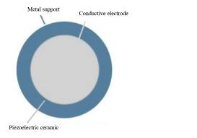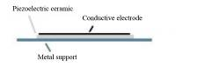
- A screwdriver
- A ruler and a pencil
- A box cutter / utility knife
- Silver conductive glue, for example Panacol® Elecolit 340 from Conrad Electronics France (www.conrad.fr), Code 065307-62
- Three differently coloured pieces of monoconducting electric wire, 0.34 mm in diameter and about 10 cm long, for example from Conrad Electronics France, Code 065065. Use colours that are different from the original cables of the buzzer so you can distinguish all five cables easily
- Strong glue (superglue) and more elastic glue (office glue)
- A square piece of strong cardboard, 4 x 4 cm and 5 mm thick
- A glass tube to obtain movements along the X and Y axes, 5-6 mm in diameter and 3 cm long, with 1 mm thick glass (2-3 are better as they sometimes break)
- A small piece of magnetic band (with glue on one side) for the sample holder, about 5 x 5 mm
- A 1 cm diameter flat, thin iron disk for the sample holder
- 2-3 strips of magnetic band to attach the scanner to the stand
- A lustre terminal
- A data acquisition card. It does not have to be fast; the AFM needs one analogue input for the Z position and two analogue outputs for the X and Y positions. Our card had additional digital inputs and outputs, which we do not need here. We used a National Instruments DAQcard (after testing several cards we finally used card #6009) with a voltage output +/-10 V, since we used the company’s LabVIEW software to create our programme to control the microscope and process the measurements. If you are happy to write your own programme, you may use a different card
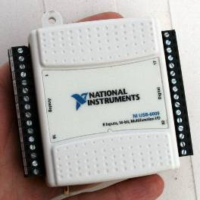
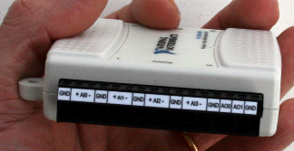
- A computer with a USB socket to connect the card to (the NI DAQcard works on most operating systems)
- A dedicated software programme to scan along the X / Y (sample surface direction) and Z axes (perpendicular to surface direction). The author developed a programme for Windows XP using National Instruments’ LabVIEW, which he offers to share with interested teachers. It will probably work on Windows 7. You can contact him in English or French at philippe.jeanjacquot@ac-lyon.fr
- A calibration sample. We had a sample kindly donated by Philippe Dumas, University of Marseilles, France. You may ask at your local university to borrow one.
- A high-power optical microscope. We used a microscope at the University of Marseilles for this purpose.

Procedure
- Remove the outer casing of the buzzer with a screwdriver.
- Measure out the piezo ceramic of the buzzer and divide it into four equal quarters using pencil lines. The accuracy of this step will determine the accuracy of the instrument. Make sure that the wire that is already attached to the piezo ceramic from the beginning comes to lie in the centre of one of the quarters.
- Cut the ceramic into four quarters using a box cutter (see image below). Be careful not to press too hard, or the ceramic will break. You will probably need to practise cutting before it works. Make sure you cut all the way through and really separate all four sections.
- Use silver conductive glue to attach three more coloured electric wires to the buzzer – so that there is now one wire to each of the four quarters of the buzzer. Make sure there is no silver glue in the central space – the four quarters need to be isolated from each other. When the silver glue has dried, put superglue on top for mechanical reasons.
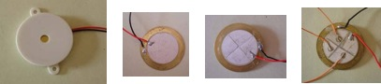

- Glue the cardboard square to the base of the buzzer (not to the ceramic!).
- Glue the strips of magnetic band to the cardboard square, at the bottom of everything.
- Glue the glass tube vertically onto the centre of the buzzer using the more elastic glue (the glass tube will be moved during the operation of the microscope), on the side on which the wires are attached. It is important that the glass tube is centred and does not touch the silver glue or the wires.
- Glue the small magnetic band to the top of the glass tube, and place the small disk on top as a sample holder.
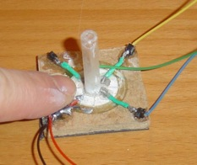
- Attach the five wires to the lustre terminal.
- Our NI DAQcard has two outputs (a card with three outputs would have been much more expensive). Connect each of the two outputs to two adjacent (not opposite!) quarters of the sensor; the other two outputs plus the base should be connected to the ground (see below).
Output 1
Output 2
Ground
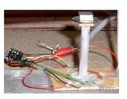
The piezoelectric buzzer will be used to move the sample along the X and Y (left / right, forwards / backwards) axes. Before the apparatus can be used, it has to be calibrated.
First, we will calibrate it along the X and Y axes.
- Place the scanner under the high-power optical microscope for the calibration process and place the calibration sample on the sample stand.
- Using the software, apply a voltage between two opposite quadrants of the piezoelectric buzzer (one quarter is at the same voltage as the base, the opposite one is e.g. 10 V higher). These will be the quadrants for the X axis. We used voltage between -10 V and +10 V. The thickness of one quadrant will increase and the thickness of the other quadrant will decrease. This will tilt the glass tube (and also the sample slightly), so the sample moves along the X axis (see image below).
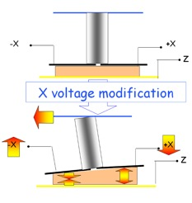
For the Y axis, the process is the same, but you will use the remaining two quadrants.
- Measure the maximal displacement in the X and Y directions. By applying 60 V between opposite quadrants, we got approximately 3 μm of scan displacement along the X and Y axes, so 1 V is equivalent to about 100 nm of displacement.

The sensor: the quartz tuning fork and tungsten tip
Instead of the AFM’s cantilever, tip and laser, we use a quartz tuning fork with a tungsten tip. The resonant frequency of the quartz tuning fork is used as a readout for how close the tip is to the sample’s surface – this enables us to analyse the surface structure.
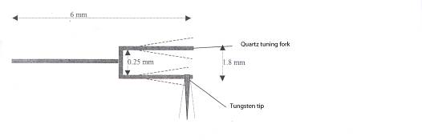

Materials
- Tungsten wire, 38 µm diameter
- An electrolyser (a beaker with 1 mol/l NaOh solution, a stand, a power supply, electric wires, a multimeter to measure the current) or a pair of scissors to sharpen the tip
- A quartz tuning fork crystal (in our experience, 20-30 quartz tuning forks are more appropriate, although you will eventually need only one, since they can easily break)
- A pair of tweezers
- A piece of expanded polystyrene
- A microscope with 10x magnification
- Strong glue (superglue) to attach the tip to the quartz tuning fork
- A very fine pair of wire cutters
- A small plastic box with two conductors – like a lustre without screws
- A small round magnet to attach the sensor to the stand
- Electric cable
- Welding equipment

Sharpening the tip
There are two ways to produce a sharp tungsten tip – either electrolytically, or using a pair of scissors. Each tip can be used only once, so you will need a substantial number of them.

With an electrolyser
This method takes rather a long time, but it produces a very sharp edge. In this process, the tungsten wire W_{(s)} dissolves into tungsten oxide at the meniscus (until the wire breaks in half), according to the following reaction: W_{(s)} + 2OH⁻ + 2H₂O WO₄²⁻ + 3H_{2(g)}
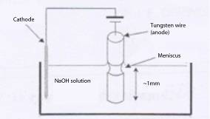
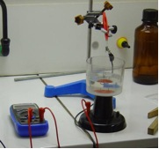
- Place the cathode into 1 mol/l NaOh solution.
- Place the tungsten wire into the solution as the anode.
- Apply 2 V at about 0.5 A.
- After about 10-20 minutes, the wire begins to shrink at the boundary between NaOH solution and air. It takes about 1 hour until the bottom part falls off. The tip will be about one atom thin.
- When the tip is sharpened, cut the wire short to be about 1 cm long.
Safety note: use gloves, a lab coat, safety glasses and a fume hood. See also the general safety note online: www.scienceinschool.org/safety

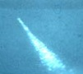
Sharpened tip

With a pair of scissors
Alternatively, you can sharpen the tip with a pair of scissors. We used this simpler and faster method. The tip will be sufficiently sharp to obtain an image at a resolution of 10 nm: cut off a piece of wire 1 cm long while holding the wire with a pair of tweezers. The tip should not be too heavy, otherwise it will not vibrate sufficiently during the experiment. This requires some skill and training.

Building the sensor
If the quartz tuning fork comes in a casing, this has to be removed with two pairs of tweezers (see image below).
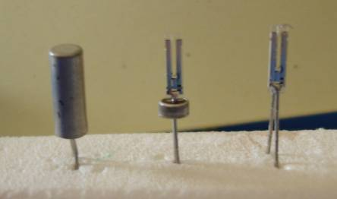
The tuning fork has to be freed from its capsule (diameter 2 mm). Stick the wires into a piece of expanded polystyrene and remove the casing with two pairs of tweezers. Make sure you do not touch the quartz crystal
- Place the expanded polystyrene stand with one quartz tuning fork under the microscope.
- Place a small dot of glue onto one of the tips of the tuning fork. You may use a tungsten tip to do this, so the dot is nice and small.
- Use a pair of tweezers to place a sharpened tungsten tip in the glue, with a 5 mm overhang on either side of the tuning fork tip. When the glue has set, use the wire cutters to remove the piece of the tungsten wire between the two tips of the tuning fork. For the orientation of the tip on the tuning fork, see the images below.
- Keep the tuning fork with the tungsten tip attached stuck into a piece of expanded polystyrene (see image above) until needed. We glued the tip onto the tuning fork the day before using the instrument, so the glue could set properly.

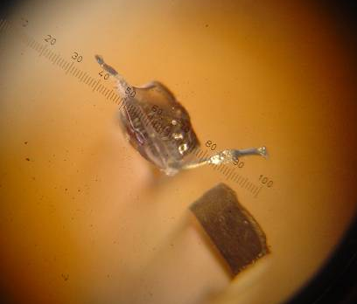
The tungsten tip is attached to the quartz tuning fork. You are looking onto the two tips of the tuning fork. The tungsten tip that is glued to the upper tip of the fork is L-shaped – ideally, it should be straight, pointing to the upper left in this image. The scale is in micrometres
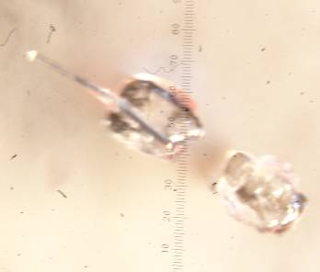
In this image the positioning of the tungsten tip is much better
- Glue the small magnet to the conducts box.
- Weld the cable to the conducts box.
- For use, the tuning fork will be plugged with its two wires into the conducts box.

The card to measure the current

Materials
- A circuit board
- A 1 MΩ resistor
- An amplifier (TL81)
- A -15 V;0;+15 V DC power supply
- Monoconducting electric wire (as for the sensor)
- Welding equipment

Procedure
With this card we will measure currents in the µA range. Build the card according to the diagram below.
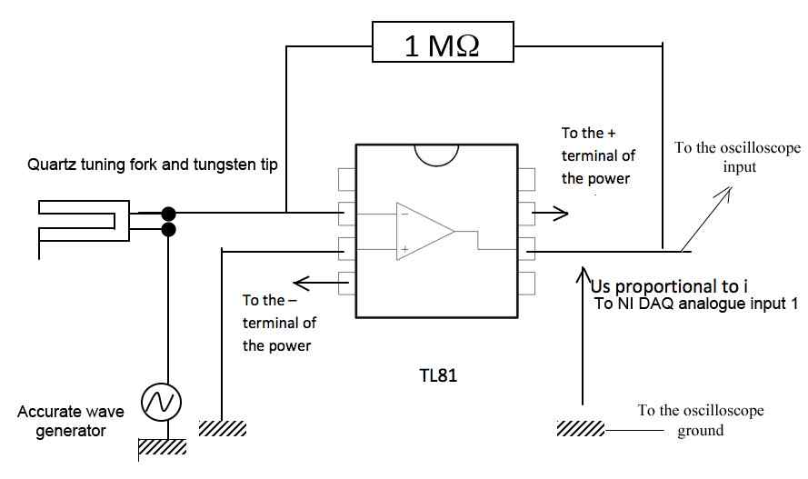
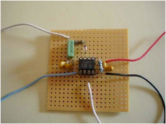

Weld the amplifier onto the circuit board. Connect the amplifier’s V_{CC}⁻ pin to the negative terminal of the power supply and its V_{CC}⁺ pin to the positive terminal of the same power supply. Connect the pin of the amplifier’s inverting input to a wire. This will lead to the tuning fork. Connect the amplifier’s non-inverting input to the ground. Connect the amplifier’s output pin to the input of the data acquisition card / computer.

Calibrating the sensor
Before each measurement, the sensor has to be newly calibrated.

Materials
- The stand
- The scanner
- A calibration sample with a regular surface structure at known intervals. We used a quantum box which was kindly donated by Georges Bremond of INSA Lyon, France (material sciences department). You may want to contact your local university about one
- The sensor (the tuning fork, and the conducts box with magnet and cables attached)
- The card to measure the current
- An accurate signal wave generator (the signal frequency has to be close to 32 000 Hz and the accuracy has to be about 1 Hz)
- An oscilloscope
- The computer
- The data acquisition card
- Cables (for use with electronic components, we used ones with a cross-section of 0.14 mm²)
- A dedicated software programme that can change the sensor voltage for movements along the X and Y axes, perform a scan along these axes, and measure and record the voltage at the output of the current measuring card. The software offered by the author (see above) fulfils these specifications.

Procedure
- Unscrew the adjustable screws and micrometre screws slightly, to make space for attaching the scanner and sensor. You do not need to remove the rubber bands for this.
- With its magnet, attach the scanner to the bottom of the stand, near the two adjustable screws. Align it with the metal pieces of the stand.
- Open the adjustable screws to make sure you are far enough away and don’t break the tip. Plug the tuning fork with its two wires into the conducts box of the sensor. Then, with its magnet, attach the sensor to the top of the stand, above the scanner. Turn everything to hang below the top metal part of the stand.
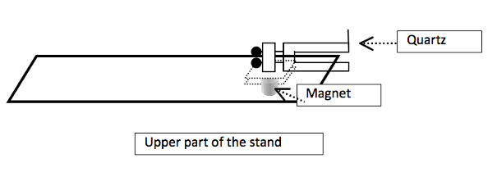
- Connect the signal wave generator and current measuring card to the sensor according to the following diagram.
- Connect the output of the current measuring card to the oscilloscope and the input of the data acquisition card, in parallel.
- Connect the output of the data acquisition card to the scanner.
- Connect the data acquisition card to the computer.
- Using a pair of tweezers, place the calibration sample on the sample holder.
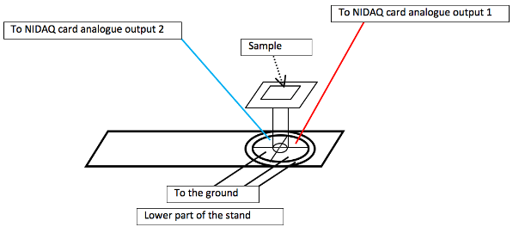
- Using the signal wave generator, place the sensor in a resonant state. The diagram below shows the wave generator’s signal frequency – which is also the quartz crystal’s frequency – (on the X axis) as seen on the oscilloscope against the current flowing through the quartz tuning fork (on the Y axis). The resonance frequency is that at which the current reaches its maximum.
Quartz tuning fork
Tungsten tip
Oscilloscope
I (A)
- Use the micrometre screw to move the tungsten tip downwards along the Z axis, slowly approaching the sample from about 1 mm away and getting closer: the maximum of the curve on the oscilloscope decreases (see diagram below). Take your time, or you will break the tip.
Oscilloscope
F (Hz)
I (A)
Sample position
- When the oscilloscope signal has decreased to half the maximum of the curve you started with (on the Y axis), the tip is close enough to the sample, so you can start the scan (see ‘Performing a measurement’, below).
- You can then compare your own scan of the calibration sample to the known distances of the surface features of the sample, to identify which current corresponds to which Z axis position. At the same time, you can also confirm your resolution in the X and Y directions.

Alternative solution
There are two ways to measure the Z position:
One option is to maintain the Z voltage of the scanner at a constant value (so you do not move the base of the buzzer). In this case, the current across the quartz tuning fork changes with the thickness of the sample at each position. We have decided to use this option, because it is simple to use, and our first measurements of the calibration sample corresponded to those expected. A potential problem is that you may lose the exact values for deep ‘valleys’ and the needle may run into very high ‘mountains’. In practice, we measured only ‘flat’ surfaces with Z values of less than 1 µm with our setup.
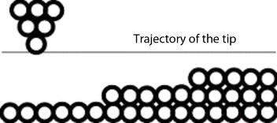
The other option is to maintain the Z distance between the tip and surface constant during measurement, by maintaining the current across the quartz tuning fork at a constant value with the help of a regulation loop attached to the sensor. In this case, the position of the sample on the Z axis is linked to the Z voltage of the scanner, so the movements of the sensor and sample holder along the Z axis have to be calibrated, as well as those along the X and Y axes.
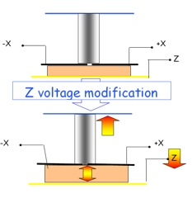
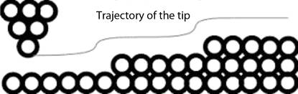
This did not work well for us, so we chose the first option.

How to prepare a sample
We only measured calibrated samples, so we already knew the expected results. Unfortunately, we did not proceed to the stage of measuring unknown samples.
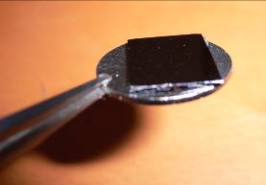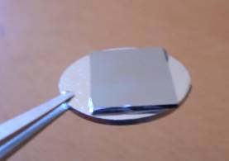
A quantum box with a side length of about 1 cm. At some angles, light will be reflected

How to perform a measurement

Location
You will need to find a virtually vibration-free basement room with minimal air current to set up the microscope, otherwise the tungsten tip will break when attempting to take a picture. To prevent vibrations, we used an inflated inner tube of a wheelbarrow wheel on the floor (the inner tube of a 24” mountain bike would also do), covered it with a plate of laminated wood (2 cm thick), and then placed the instrument on top.
When taking a picture (which only takes a few seconds), you need to stand completely still.

Instrument sensitivity
The maximum resolution along the X and Y axes is about 50-60 nm. The resolution along the Z axis is lower.
The resolution of a commercial AFM is below 1 nm.

Procedure
- Assemble the microscope as for the calibration (see above).
- Clean the small iron disk of the sample holder and place the sample on top of it (you may use glue). Then place the iron disk on the magnet on top of the glass tube and switch on the signal generator and oscilloscope.
- Apply about 2 V to the quartz crystal and change the signal generator frequency from 31 500 Hz upwards and observe the signal on the oscilloscope. When the frequency gets near the resonance value, the signal will be strongly amplified. The frequency has to be exactly at the resonance frequency value (near 32 000 Hz), otherwise the current will not be strong enough for the Z axis measurement.
- Using the micrometre screw, you can then slowly approach the tip to the sample surface. The current will decrease when the tip gets closer to the surface and the Z distance is small enough, because van der Waals forces make it more difficult for the tip to keep its oscillation. We chose to work at half the maximum intensity, to allow for Z distances (currents) both up and down from here.
- The scan can begin. This is automated via the software and takes only a few seconds.
- The data is stored in a table: for each X axis step, we have a row; for each Y axis step, we have a column; and the Z axis position is the value in each cell of the table.
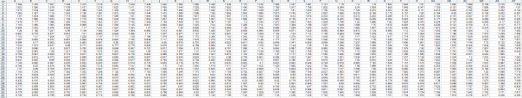
The full table for one scan
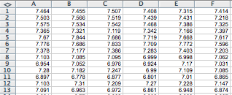
Section of the table
- Using e.g. Microsoft Excel, you can translate your results into a graph.
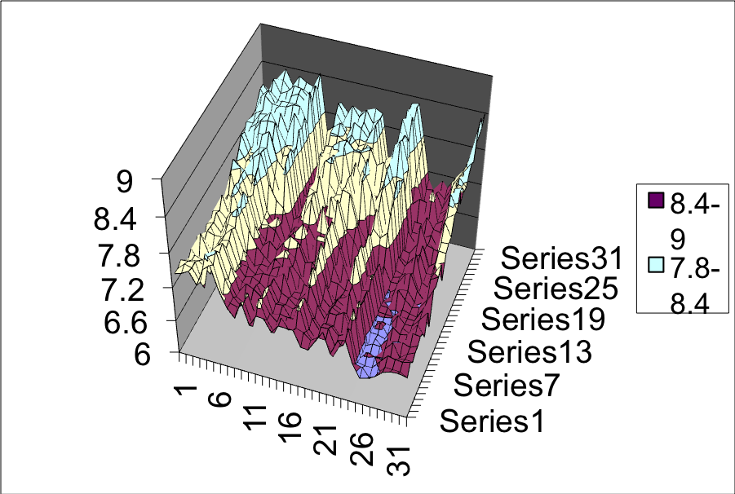
Our scan of part of the quantum box. The X and Y axes are about 150-200 nm long. 1 unit along the Z axis corresponds to about 50 nm
- Stop everything and turn off the instruments.
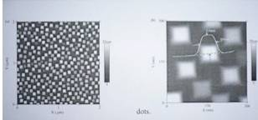
Height contrast AFM image of the quantum box (Ge dots) (taken with a commercial AFM by Bremond et al., LPM INSA Lyon). The left-hand image corresponds to a 300 x 300 nm sample

Acknowledgements
The author is grateful to Philippe Dumas, Research Director at GPEC Marseille, Mr Cadete Santos Aires and Mr Genet from CNRS Lyon, as well as Mr Bremond, Research Director, INSA Lyon.

Author information
Philippe Jeanjacquot, physics and chemistry teacher
Lycée polyvalent Chaplin Becquerel
Décines
France
philippe.jeanjacquot@ac-lyon.fr

