Activity sheet 1: Carbon dioxide in exhaled air
Using different colours, show what makes up the air in these clouds.

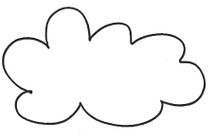
Fresh air
Exhaled air
Carry out the following experiment:
- Take two glass containers and ﬁll each with 200 ml water.
- Add 20 drops of 10% potash lye to both containers.
- Clean the pipette in the sink or a glass with fresh tap water.
- Add 20 drops of indicator and stir it with a straw.

What are we trying to investigate with this experiment?

- One person in the group should breathe through a straw, using strong breaths, into one of the containers.
Write down what happens and why.

